2026. 01

제조데이터 표준 활용 가이드(열전도식 건조기)
AAS표준(IEC 63278-1:2023)을 중심으로


목 차

I. AAS 개요 4
1. AAS 개념 4
2. AAS 구성요소 6
3. AAS 작성 요구사항 9
4. AAS 작성 유의사항 11
5. AAS 모델링 13
II. 장비 개요 16
1. 열전도식 건조기의 정의 및 종류 16
III. AAS 참조모델 22
1. AAS 참조모델 개요 22
2. AAS 참조모델 세부 구성 22
3. AAS 참조모델 근거자료 22
IV.AAS 참조모델 활용 방법 128
1. 참조모델 활용 128
2. 신규 AAS 작성 및 수정 128
3. AAS 모델(템플릿)을 실제 제품별 AAS 인스턴스로 전환 135
4. 건식 표면처리 공정 AAS 참조모델 활용 시나리오 140

표 목차

표 1 ISO/IEC 표준 제정 절차 5
표 2 AAS 모델링 절차 13
표 3 AAS 모델링에 사용한 서브 모델과 버전 14
표 4 열전도식 건조기 작동 주기 17
표 5 참조모델의 Submodels 개요 24

그림 목차

그림 1 SCI 4.0의 주요 워킹 그룹 및 국제협력 4
그림 2 AASX Package Explorer로 나타낸 6축 로봇의 AAS 6
그림 3 AAS, submodel, submodel collection, property의 관계 7
그림 4 IRDI를 사용한 식별자 7
그림 5 URI, URL의 구조 8
그림 6 ecl@ss 홈페이지 9
그림 7 CDD 홈페이지 9
그림 8 데이터 수집 플랫폼에서 사용하는 URI 형식 12
그림 9 AAS 모델링 절차 14
그림 10 열전도식 건조기 예시 16
그림 11 ISO 18434-1 19
그림 12 ASTM E145 19
그림 13 IEC 60335-2-45 20
그림 13 ISO 287 20
그림 14 eCl@ss 15-21-12-04 Industrial dryer (improvement) 21
그림 15 열전도식 건조기 참조모델 구성 22
그림 16 eCl@ss(15-21-12-04) 참조 23
그림 17 AASX PackageExplorer 다운로드 경로 128
그림 18 AASX Package Explorer 파일 실행 초기화면 129
그림 19 활성화된 Edit 모드 129
그림 20 Edit 모드 활성화 단계 130
그림 21 AAS 생성 130
그림 22 AAS 정보 131
그림 23 IDTA SubmodelTemplate 다운로드 131
그림 24 IDTA SubmodelTemplate 파일 열기 132
그림 25 Template 이용 Submodel 생성 133
그림 26 동일한 방법으로 추가한 3종의 Submodel 133
그림 27 Submodel 생성 134
그림 28 SubmodelCollection 생성 134
그림 29 SubmodelCollection 정보 135
그림 30 Property 생성 135
그림 31 AssetInformation의 kind 변경 136
그림 32 AssetInformation의 globalAssetId 입력 136
그림 33 AssetInformation의 assetType 입력 137
그림 34 Submodel 인스턴스 137
그림 35 Property 인스턴스 138
그림 36 AAS 인스턴스 변환 전 화면 138
그림 37 AAS 인스턴스 변환 후 화면 139
그림 38 건식 표면처리 공정 (플라즈마 전처리→마그네트론 스퍼터→열처리) 140
그림 39 실시간 공정 가시화 및 가동 상태 모니터링 141
그림 40 박막 품질 이력 추적 및 디지털 제품 여권(DPP) 생성 142
그림 41 AI 기반 장비 예지보전 및 잔여 수명 예측 142
그림 42 공정 조건 최적화 및 레시피 피드백 제어 143
그림 43 유지보수 효율화를 위한 디지털 문서 및 도면 활용 144
그림 44 에너지 효율 분석 및 탄소 발자국 관리 145

I. AAS 개요

1. AAS 개념
가. Industrie 4.0
○ Industrie 4.0은 유연하고 효율적인 생산을 위해 정보통신기술(ICT)을 활용하여 산업용 장비와 공정을 네트워크화하는 ‘산업 부문의 디지털 전환’ 전략을 말하며, 이러한 Industrie 4.0의 목표는 사이버 물리시스템(CPS: Cyber Physical System) 기술 및 제품 시장에서의 우위를 확보하는 것이다.

○ Industrie 4.0을 구현하기 위해서는 표준화가 핵심적으로 중요하다. Industrie 4.0은 도메인, 계층 경계 및 생애 주기 단계에 걸쳐 전례 없는 시스템 통합을 요구한다. 독일은 RAMI 4.0 (Reference Architecture Model Industrie 4.0)을 통해 국제 표준화 과정에서 모델을 제공하고 있으며, 이를 통해 재빠른 표준화를 바탕으로 국제적 협력을 촉진하는 역할을 수행하고 있다.

○ 이러한 Industrie 4.0을 실현하기 위한 핵심 요소 기술로 AAS가 주목받고 있다.

○ 관련 기구
- 16년 하노버 박람회에서 독일 산업계 표준화 기관인 Bitkom(Bundesverband Informationswirtschaft, Telekommunikation und neue Medien e. V.), DIN(DeutscheInstitut für Normung e. V) 등이 “SCI(Standardization Council Induestire) 4.0” 이니셔티브 설립을 발표하였다. 해당 표준화위원회는 Industry 4.0 관련 표준화를 시작하고 국내 및 국제적으로 표준을 조정하는 것을 목표로 한다.

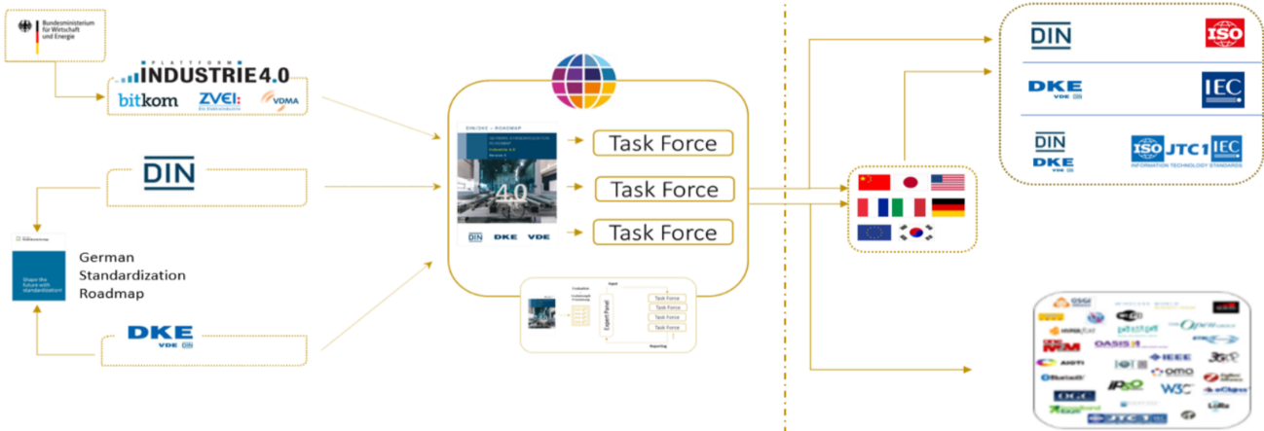
그림 1 SCI 4.0의 주요 워킹 그룹 및 국제협력

- ISO는 1947년에 설립된 국제표준화기구로, 다양한 산업 및 기술 분야에서 전 세계적으로 일관성 있고 호환 가능한 표준을 개발하는 것을 목표로 하는 비영리 기구이다. ISO는 ISO정관(Statute) 제2조에 명기된 바와 같이 상품 및 서비스의 국제적 교환을 촉진하고, 지적, 과학적, 기술적, 경제적 활동 분야에서의 협력 증진을 위하여 세계의 표준화 및 관련 활동의 발전을 촉진시키는데 있다. 이러한 목적 달성을 위하여, ISO는 표준 및 관련 활동의 세계적인 조화를 촉진시키기 위한 조치를 취하며 국제표준을 개발, 발간하며 해당 표준이 세계적으로 사용되도록 조치를 취하고, 표준화 사업에 관한 연구를 통해 타 국제기구와 협력한다.
- IEC(International Electrotechnical Commission)는 1906년에 설립된 비영리 국제 표준화 기구로, 전기 및 전자 기술 분야에서 표준에 대한 준수 확인 등과 같은 표준화에 대한 제반 현안 및 관련 사항에 대한 국제간 협력을 촉진하여 국제간의 이해를 증진시키는 것을 목적으로 한다. IEC의 표준화 작업은 ISO와 공동으로 제정한 ISO/IEC Directive에 따라 이루어지므로 아래 표와 같이 ISO의 표준화 작업 절차와 대동소이하다. 다만 질의단계 문서를 ISO에서는 DIS라 부르는 반면 IEC는 CDV라 부르는 점이 다르다. 기타 특이 사항은 Directive의 IEC 부속서에 설명되어 있다.

표 1 ISO/IEC 표준 제정 절차
프로젝트 단계 | 관 련 문 서
 | 명 칭 | 약 어
0 예비단계 | 예비 작업 항목 | PWI
1 제안단계 | 신규 작업 항목 제안 | NP
2 준비단계 | 작업 초안 | WD
3 위원회단계 | 위원회안 | CD
4 질의단계 | 질의안/투표용 위원회안 | DIS/CDV
5 승인단계 | 최종 국제표준안 | FDIS
6 출판단계 | 국제표준 | IS

나. AAS 개념
○ Asset Administration Shell(AAS)은 물리적 자산을 디지털로 표현하여 정보와 동작을 표준화하고 통합 관리하는 구조이다. 이 개념은 자산의 전체 라이프사이클 동안 설계, 제조, 유지보수, 폐기에 이르는 모든 데이터를 디지털화하여 관리함으로써 상호운용성과 데이터 교환을 지원하는 데 중점을 둔다. 특히, AAS는 다양한 자산의 상태, 특성 및 동작을 디지털 트윈 형태로 구현하여, 실시간 모니터링 및 최적화를 가능하게 하고, 정보의 일관성과 신뢰성을 높이며, 다른 시스템과의 통합을 용이하게 한다. 이를 통해 제조 및 운영의 효율성을 향상시키고, Industrie 4.0의 핵심 기술로 자리 잡고 있다.

○ IEC 63278-1에서는 자산의 표준화된 디지털 표현 구조인 AAS를 정의한다. IEC 63278-1은 AAS의 목적을 ‘두 개 이상의 소프트웨어 애플리케이션이 정보를 교환하고, 교환된 정보를 신뢰할 수 있고 안전한 방식으로 상호 활용할 수 있도록 하는 것’이라고 명시하고 있다.

○ AAS를 보다 원활하게 제작하기 위해 AASX Package Explorer라는 오픈소스 소프트웨어 툴이 AAS 표준과 함께 개발이 진행되고 있다. 이후 버전에 따라 형식 및 기능이 달라질 수 있다. 아래 그림은 AASX Package Explorer를 활용하여 AAS를 표현한 하나의 사례이다.

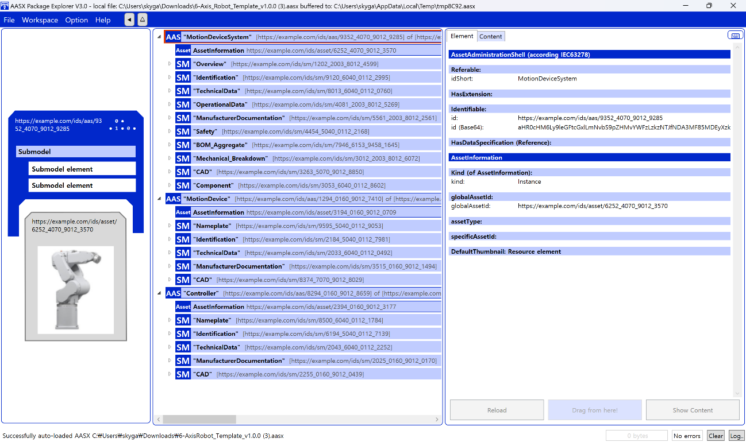
그림 2 AASX Package Explorer로 나타낸 6축 로봇의 AAS

2. AAS 구성요소
가. Submodel
○ Submodel은 물리적 자산이 가지는 다양한 특성을 표현하는 데이터 모음이다. 모든 AAS는 하나 이상의 submodel로 구성되며, submodel을 구분하기 위한 지정된 기준은 존재하지 않는다.

나. Property
○ Property는 자산의 고유한 특성을 기술하는 요소이다. 모든 Property는 고유 식별자를 가지며, 같은 의미로 일관되게 해석될 수 있어야 한다. Property의 고유성 보장을 위해 적어도 하나의 고유한 명칭과 ID를 부여하며, 도메인 내에서는 동일한 의미로만 정의되어야 한다.

다. Collection
○ Collection은 유사한 특징을 가지는 여러 Submodel Element들을 그룹화한 모음이다. 특정 submodel 내에서 유사한 특성을 공유하는 property들이 모여 하나의 collection을 구성하며, submodel의 관리와 데이터 구조화에 유용하게 사용된다.

○ AAS와 submodel, collection, property의 관계는 아래 그림과 같이 나타낼 수 있다.
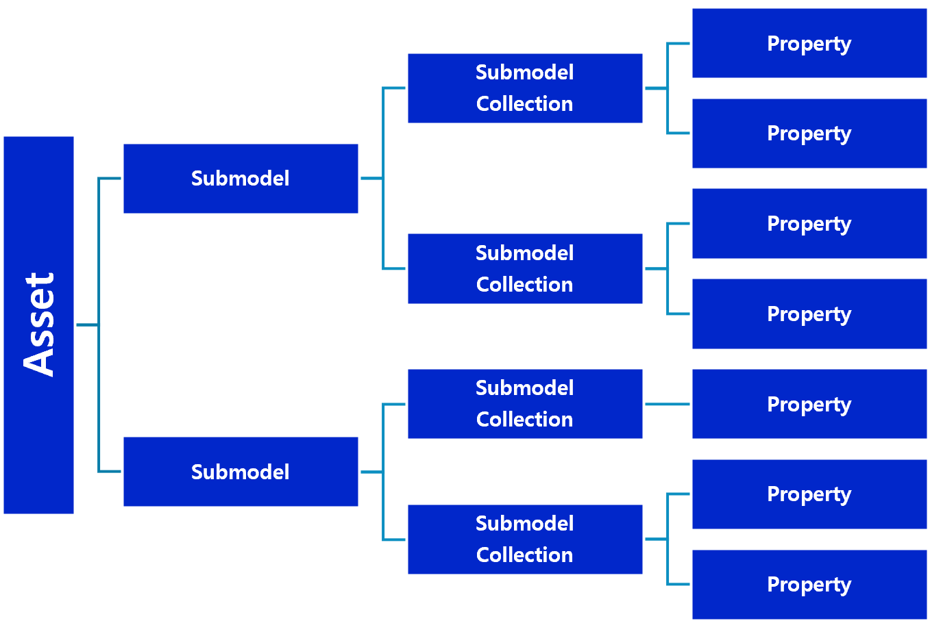
그림 3 AAS, submodel, submodel collection, property의 관계

라. AAS Identifier
○ 모든 AAS는 다른 AAS와 구분되어야 하며, 상호 데이터 교환 및 인터페이스가 가능해야 한다.
○ IRDI
- IRDI(International Registration Data Identifier)는 국제적으로 공인된 데이터 사전(CDD, eCl@ss 등)에서 관리하는 국제 등록 식별자로, 각 기관에 의해 부여된 식별자이기 때문에 전 세계적으로 고유한 식별자임이 보장된다. 아래의 그림은 ISO 29002-5에 따른 IRDI의 구조를 나타낸다.

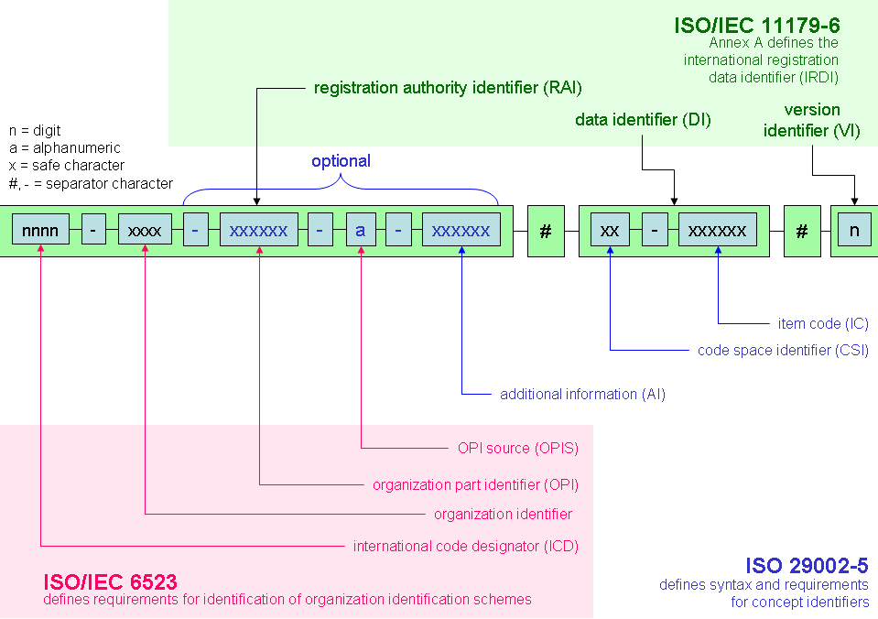
그림 4 IRDI를 사용한 식별자
○ URI
- URI(Uniform Resource Identifier)는 계층적으로 경로를 지정할 수 있는 구조로, 공인된 기관에 의해 식별자가 부여되지 않더라도 전 세계적으로 고유한 식별자를 정의할 수 있다. IRDI로 정의할 수 없는 property, submodel, AAS 등의 식별자에는 일반적으로 URI를 사용한다. 보통 인터넷에서 많이 사용되고 있는 식별자인 URL(Uniform Resource Locators)도 URI의 일종이다.

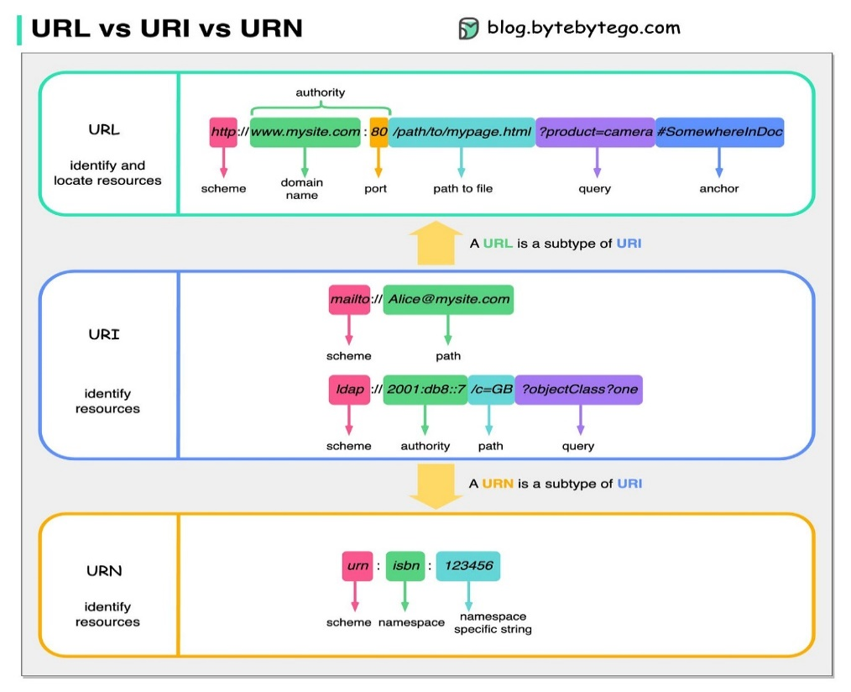
그림 5 URI, URL의 구조

마. Semantic
○ Semantic은 데이터의 의미와 해석을 보장하는 요소로, 사람이든 기계든 동일한 의미로 이해할 수 있도록 정의된다. 하나의 property는 도메인 내에서 하나의 의미로만 정의되며, eCl@ss, CDD 등 데이터 사전에 등록된 고유한 의미를 통해 일관된 semantic을 갖는다.

○ eCl@ss
- eCl@ss는 전 세계 다양한 산업의 제품, 서비스, 소재, 시스템을 분류하고 기술하는 데 사용되는 ISO/IEC 규격 제품 데이터 표준으로, 데이터에 대한 메타데이터와 사람과 기계 모두 이해 할 수 있는 통일된 언어를 제공한다.

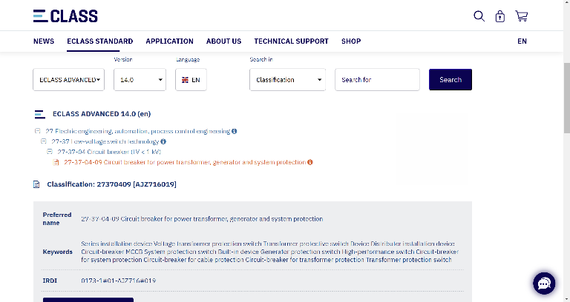
그림 6 ecl@ss 홈페이지

○ CDD (Common Data Dictionary)
- IEC 61360 공통 데이터 사전(CDD)은 전기 전자 산업 전반에서 사용되는 공통의 용어 및 개념을 저장하는 저장소로, IEC 국제표준이나 업계 표준 등을 기반으로 일반적으로 사용하는 용어 및 개념을 정의하고 있다.

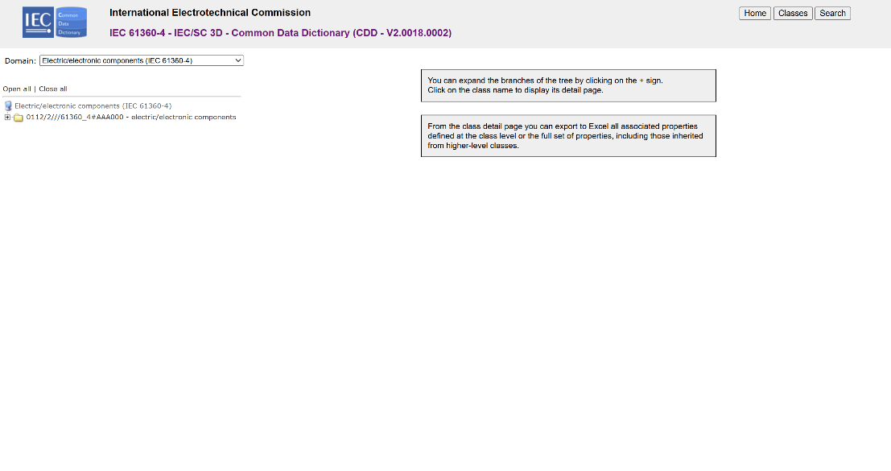
그림 7 CDD 홈페이지

바. Concept Description
○ Concept Description이란 개념 사전을 구성하는 개별 항목들을 의미하며, AAS에서 사용되는 하나의 property에 연결된 property의 semantic을 의미한다. 개념사전은 AAS의 모든 property들이 가지는 semantic의 집합으로, 마치 사전처럼 모든 property의 정의와 형식, 단위 등을 표현한다. AAS의 모든 property는 Concept Description을 통해 의미가 정의되고. CDD, eCl@ss와 같은 데이터베이스에서 제공하는 표준 데이터 형식에 기반하여, property의 의미와 정의, 단위 등을 설명하는 사전 역할을 한다.

3. AAS 작성 요구사항
가. AAS의 필수 구성요소
○ 하나의 AAS는 하나 이상의 submodel로 구성되어야 한다. AAS를 구성하는 submodel에 대한 리스트를 제한하거나 필수 submodel을 규정하지는 않고 있지만, 일반적으로 사용되는 submodel에 대한 가이드라인을 기준으로 몇 가지 주요 submodel을 요약할 수 있다. 주요 submodel은 아래와 같다.

나. 주요 submodel
○ Identification submodel
- Identification submodel은 AAS의 기본이 되는 submodel로, AAS 표준에서 필수로 지정되지는 않았으나 모든 AAS가 반드시 가져야 하는 submodel이다. 자산을 식별하기 위한 고유 번호, 자산에 대한 설명, 판매 정보, 제조 정보 등 다양한 정보를 포함하며, 포함되는 정보에 대한 제한은 없다.

○ Digital Nameplate submodel
- Digital Nameplate submodel은 자산의 물리적인 명판(Nameplate)을 디지털 형태로 표준화하여 표현하는 submodel이다. submodel에는 제조사명, 제품 명칭, 시리얼 번호, 제조 연도, 버전 정보 등 자산의 핵심 식별 정보와 사양 정보가 포함된다. 이 submodel은 IEC 61406 표준을 따르며, 자산의 전 생애주기에 걸쳐 명확한 정보를 제공하여 이력 관리 등을 용이하게 한다.

○ Technical data submodel
- Technical data submodel은 자산의 기술적인 특징과 매개변수를 의미하는 기술사양 정보를 포함한다. 일반적으로 해당 submodel에 포함된 데이터들은 제조 현장으로부터 실시간으로 수집되지 않는 데이터들이다.

○ Operational data submodel
- Operational data submodel은 제조 현장에서 실시간으로 수집되는 동작 정보를 포함하며, 실제 공정 또는 제조 설비에서 수집되는 데이터를 의미한다. 해당 submodel의 명칭이 반드시 ‘Operational Data’일 필요는 없다. 그러나 일반적인 정보들의 경우, ‘Operational Data’라는 명칭을 사용하여 실시간 데이터를 다룬다는 점을 명확히 하는 것이 권장된다.

○ HandoverDocumentation submodel
- HandoverDocumentation submodel은 자산과 함께 제공되는 사용 설명서, 설치 매뉴얼, 인증서, 절차서 등 문서 정보를 구조화하여 제공하는 서브모델이다. VDI 2770 표준 기반으로 문서 식별, 버전, 분류, 파일 경로 등을 포함하여, 장비 인수(handover) 및 유지보수 시 필요한 공식 문서를 AAS 형태로 전달하기 위해 사용된다.

○ HierarchicalStructresEnablingBoM submodel
- HierarchicalStructures(Enabling BoM) submodel은 자산의 구성요소(부품·모듈) 관계를 구조적으로 표현하는 Bill of Materials(BoM) 역할을 한다. 상위 장비에서 하위 컴포넌트로 이어지는 계층 구조(hierarchy)를 AAS로 기술하며, 장비 구성의 추적성, 관리, 유지보수 계획 수립 등을 지원한다.

○ HeatingProcessCapability submodel
- HeatingProcessCapability submodel은 열전도식 건조 장비의 가열 정밀도 및 건조 품질 유지 능력을 정의하는 서브모델이다. 열판 온도 균일도, 잔류 수분량, 열응답 시간 등의 품질 지표를 포함하며, 산업용 가열 기기의 온도 안정성 및 소재별 건조 상태 평가 기준(예: ISO 18434-1, ASTM E145, ISO 287)을 만족하기 위한 공정 능력 정보를 제공한다. 이를 통해 최적의 건조 프로파일을 유지하고 소재의 열적 변형 방지 및 에너지 효율 관리를 위한 디지털 기초 데이터를 제공한다.

○ PredictiveMaintenance submodel
- PredictiveMaintenance submodel은 생산 시스템 및 관련 소프트웨어의 예지 보전(Predictive Maintenance) 구현에 필요한 정보를 정의하는 서브모델이다. OPC Foundation 표준 기반의 잔존 수명(RUL) 예측값과 예측에 사용된 AI 모델의 유형 및 상세 사양을 구조화하여 관리한다. 또한 예측의 유효성을 결정하는 경계 조건과 임계점 도달 전후의 단계별 알림 체계를 포함하여, 설비 고장 예방 및 정비 시점 최적화를 위한 디지털 기초 데이터를 제공한다.

○ AIModelNameplate submodel
- AIModelNameplate submodel은 자산에 적용된 AI 모델의 식별 정보와 기술적 사양을 표준화된 형태로 제공하는 서브모델이다. 모델의 버전, 저장 경로, 학습 방법(지도/비지도 학습 등)과 같은 기본 관리 정보뿐만 아니라, 입력 데이터의 유형(이미지, 오디오 등) 및 출력 차원의 의미를 포함한 모델의 입출력 구조를 상세히 기술한다. 또한 프레임워크, 프로그래밍 언어, 하이퍼파라미터 등 모델의 아키텍처 정보와 학습 결과(Plots)를 포함하여, AI 모델의 투명성을 확보하고 자산 내에서 AI 모델의 원활한 운용 및 유지보수를 지원하는 디지털 기초 데이터를 제공한다.

○ AssetInterfacesDescription submodel
- AssetInterfacesDescription submodel은 자산의 데이터 송수신을 위한 HTTP, Modbus, MQTT 등 주요 프로토콜별 통신 사양을 정의하는 서브모델이다. 각 인터페이스의 접속 지점(Endpoint)과 보안 체계(OAuth2, API Key 등) 및 데이터 입출력 메타데이터를 구조화하여 관리한다. 이를 통해 이기종 시스템 간의 상호운용성을 확보하고, 자산 데이터에 대한 안전하고 표준화된 접근 경로를 제공하는 디지털 기초 데이터 역할을 수행한다.

4. AAS 작성 유의사항
○ eCl@ss, CDD 등에서 적절한 Semantics가 정의되지 않은 경우
- AAS의 모든 property는 semantic이 필요하지만, 반드시 eCl@ss/CDD 등에 정의된 semantic을 사용해야 하는 것은 아니다. AAS는 고유한 식별자를 활용하여 모든 property의 의미가 유일하게 정의되고 구분되는 것을 요구한다. 따라서 eCl@ss/CDD 등에 적절한 semantic이 없을 경우 자체적으로 이를 정의하여 사용해야 한다.
- 자체적으로 semantic을 정의하는 경우 URI 형식의 식별자를 사용하여야 한다. URI를 사용할 경우에는 아래의 형식을 따라야 한다.

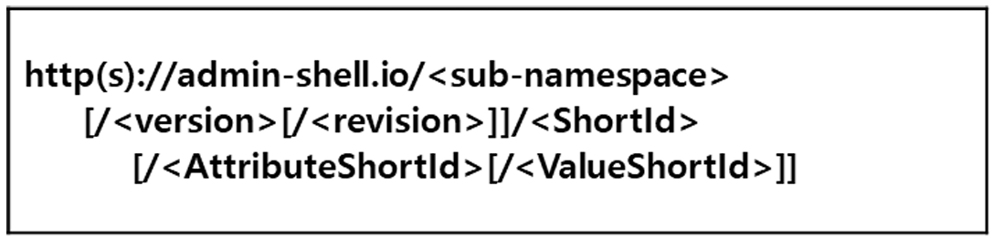
그림 8 데이터 수집 플랫폼에서 사용하는 URI 형식

○ eCl@ss/CDD에 정의된 Semantics의 단위나 데이터 타입이 다른 경우
- property의 semantic은 해당 semantic이 정의하고 있는 모든 사항을 그대로 적용하는 경우에만 의미가 있으므로, 데이터 타입, 단위 등이 다른 경우 역시 별도로 semantic을 정의하여야 한다.

5. AAS 모델링
○ AAS를 구현 및 활용하기 위해 일반적으로 아래 표와 그림과 같은 절차를 따른다.

표 2 AAS 모델링 절차
순서 | 단계 | 설명
1 | 목표 설정 | 시스템 요구사항을 분석하고 활용 여부에 대해 파악한다
2 | 대상 탐색 | 모델링할 자산에 대해 충분히 이해한 상태에서 정보 수집한다
3 | Asset 설계 | 수집된 정보에 따라 Asset의 구조를 정의, 모델링한다
4 | AAS 설계 | 설계한 Asset을 기반으로 AAS를 설계한다. 여기서 설계한 AAS는 AAS를 구성하는 Asset, Submodel, Property 같은 요소들로 이뤄진다
5 | AAS 구현 | AAS 모델링 툴을 활용하여 실제 패키지 형태의 파일로 생성하며, AAS에 포함되는 모든 Submodel, Property와 같은 요소에 고유 ID (Semantics)가 부여되어야 한다
6 | 시스템 구현 및 검증 | 작성된 AAS 모델을 다양한 포맷으로 변환하고 시스템을 구현 및 검증한다

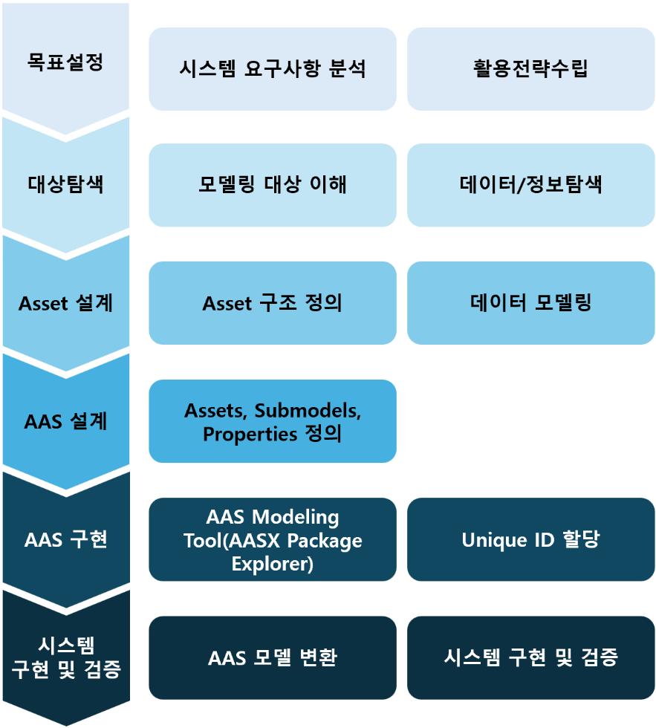
그림 9 AAS 모델링 절차

○ 본 가이던스에서 AAS 모델링을 위해 활용한 서브모델 표준 관련 버전 정보는 아래 표와 같다.

표 3 AAS 모델링에 사용한 서브 모델과 버전
Submodel명 | 설명 | 내용 예시 | 비고
Identification | 제품과 제조사에 대한 일반적인 정보 | Asset ID,  제조사 이름 | AasxPackageExplorer  Submodel Plugin
DigitalNameplate for industrial equipment | 제품에 대한 분류 정보, 제조사 정보 등 제품에 대한 기본 정보. 제품의 인증 마킹 정보 등이 포함 | 시리얼번호, 제조 날짜,  인증마크 | IDTA 02006-3-0  Submodel_Digital Nameplate
TechnicalData | 제품의 기술적인 사양서, 데이터시트 정보 | 기술적 사양, 기능적 특성 | IDTA 02003-1-2  Submodel_TechnicalData
OperationalData | 자산의 운영 및 성능에 대한 실시간 데이터 및 상태 정보를 포함 | 실시간 상태 정보,  성능 데이터
Hierarchical  Structures enabling  Bills of Material | 컴포넌트의 조합으로 구성된 제품의 계층적 구성을 포함한 정보 | 물리적 구성 요소, BoM | IDTA 02011-1-1  Submodel_HierarchicalStructures  EnablingBoM
Handover  Documentation | 제품의 브로셔, 설치/시운전/유지보수 매뉴얼 등 다양한 문서 정보 | 사용자 매뉴얼,  제품 카탈로그 | IDTA 02004-2-0  Submodel_HandoverDocumentation
HeatingProcess  Capability | 열전도식 건조 공정 능력 정보 | 열판 온도 균일도, 잔류 수분량, 열응답 시간 등 | ISO 18434-1, ASTM E145, ISO 287 등 참조
PredictiveMaintenance | 생산 시스템, 소프트웨어의 예지보전 정보 | 잔존 수명 예측값, AI 모델 유형 | IDTA 02048-1-0  Predictive Maintenance
AIModelNameplate | AI 모델의 식별 정보 및 기술적 사양 | 학습 방법, 데이터 유형, 아키텍쳐 정보 | IDTA 02060-1-0  Artificial Intelligence Model  Namplate
AssetInterfaces  Description | 자산의 통신 사양 정의 | 접속 지점, 보안 체계 구조, 데이터 전송 형식 | IDTA 02017-1-0  Asset Interfaces Description

○ 본 가이던스에서 IRDI 부여를 위해 활용한 규격 버전 정보는 다음과 같다.

- Eclass v15 (2024.11 릴리즈)
- Eclass v14 (2023.11 릴리즈, v15에서 검색되지 않는 경우 v14 사용함)
  - 링크: ECLASS Basic & Advanced Content Search - ECLASS

- IEC CDD v2.0018.0002
  - IEC 61360-4 링크: IEC - Common Data Dictionary (CDD)

II. 장비 개요

1. 열전도식 건조기의 정의 및 종류
열전도식 건조기는 가열된 히팅 플레이트(Heating Plate)와 기판 사이의 직접적인 접촉 또는 근접 열전달을 통해 소재 표면의 수분이나 잔류 용제를 증발시키는 산업 장비이다. 열전달 방식에 따라 단면 가열 방식과 양면 가열 방식으로 구분되며, 이송 구조에 따라 컨베이어(Conveyor) 타입과 롤투롤(Roll-to-Roll) 타입으로 분류된다. 또한 대기압 상태의 일반 건조기와 용제 회수 및 산화 방지를 위한 진공 건조기로 구분되기도 한다.↵

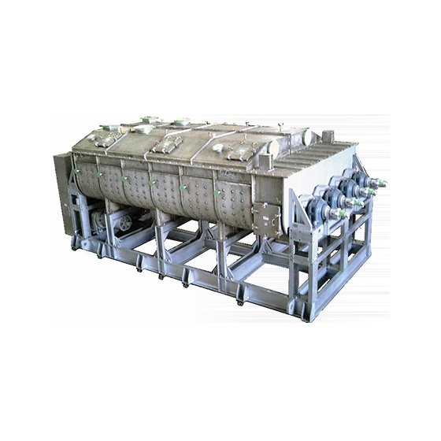
그림 10 열전도식 건조기 예시

열전도식 건조기는 고효율 열전달을 통해 소재의 변형을 최소화하면서 신속하게 건조를 완료하는 핵심 장비이다. 디스플레이 패널, 이차전지 전극 공정, 인쇄 전자 등 정밀한 온도 제어가 필요한 분야에서 필수적으로 사용되며, 최근에는 에너지 소비 최적화와 열분포 균일성 제어 기술의 발전으로 생산 수율과 에너지 효율이 동시에 향상되고 있다.

가. 열전도식 건조기 핵심 기능
열전도식 건조기는 가열된 히팅 플레이트(Heating Plate)의 열에너지를 기판에 직접 전달하여 표면의 잔류 수분이나 용제를 신속하게 증발시키고, 소재 내부의 열적 평형을 유도하여 균일한 건조 상태를 만드는 핵심 기능을 수행한다. 히터의 설정 온도, 열판 간의 간격(Gap), 이송 속도, 냉각 속도 등의 공정 파라미터를 정밀하게 제어하여 건조 효율을 극대화하고 소재의 열적 손상을 방지한다.

나. 열전도식 건조기 주요 특징
열전도식 건조기는 대기 대류 방식에 비해 열전달 효율이 매우 높아 건조 시간을 단축할 수 있으며, 기판 전체에 걸쳐 균일한 온도 분포를 유지하여 열팽창에 따른 소재 변형을 최소화하는 것이 핵심 강점이다. 현대의 열전도식 건조기는 다채널 온도 센서와 PID 제어 시스템을 통해 열판의 위치별 온도를 실시간으로 모니터링하고 미세하게 보정할 수 있다. 또한, 에너지 절감형 히팅 구조를 채택하여 전력 소모를 최적화하며, 소재의 두께와 열용량에 따라 맞춤형 승온 및 냉각 프로파일(Thermal Profile)을 적용할 수 있다.

다. 열전도식 건조기 작동 원리
열전도식 건조기는 다음과 같은 주기로 작동한다.

표 4 열전도식 건조기 작동 주기
순 서 | 설 명
(1) 기판 투입 및 예열 | 전처리 공정을 마친 기판이 건조 챔버 내로 이송되며 설정 온도로 예열된 열판에 안착
(2) 접촉 가열(건조) | 열판으로부터 전달되는 전도열을 통해 기판 표면의 수분 및 용제를 증발시켜 제거
(3) 온도 유지 및 균일화 | 일정 시간 동안 기판 온도를 유지하여 소재 전체의 수분 함량을 목표치 이내로 관리
(4) 냉각 및 배출 | 건조가 완료된 기판을 서서히 냉각시켜 열 충격을 방지한 후 후속 공정으로 배출

라. 열전도식 건조기 주요 구성 요소
○ 가열 시스템(Heating System)
기판에 열에너지를 공급하는 핵심 구성품이다. 고정밀 히팅 플레이트, 전기 히터, 온도 센서(RTD/Thermocouple)로 구성되며, 열판의 표면 평탄도와 온도 균일성을 유지한다. 이를 통해 기판 전면에 걸쳐 얼룩 없는 고품질 건조 결과물을 생성한다.

○ 온도 제어 시스템(Temperature Control System)
건조 내부의 온도를 정밀하게 관리하는 시스템이다. 멀티 채널 PID 제어기 및 전력 제어 유닛(SCR)을 포함하며, 실시간 온도 데이터를 바탕으로 히터 출력을 조절하여 설정 온도와의 편차를 최소화하고 공정 안정성을 확보한다.

○ 이송 및 핸들링 시스템(Substrate Handling System)
기판을 열판 위로 안착시키거나 이송하는 시스템이다. 이송 롤러 또는 컨베이어, 리프트 핀(Lift Pin), 구동 모터로 구성되며, 기판의 손상을 방지하면서 열판과의 접촉 시간을 정확하게 제어하여 일정한 건조 품질을 유지한다.

○ 배기 및 안전 시스템(Exhaust & Safety System)
건조 과정에서 발생하는 수증기나 용제 증기를 외부로 배출하는 시스템이다. 배기 팬, 댐퍼, 가스 감지 센서로 구성되며, 챔버 내의 습도를 조절하고 과열 방지 장치를 통해 장비와 작업자의 안전을 보장한다.

마. 표준화 근거 자료
열전도식 건조기는 다양한 산업 표준을 준수하여 설계 및 제작된다. 이는 장비의 안전성 확보, 데이터의 일관된 관리, 그리고 산업 내 상호운용성을 위한 기반이 된다. 본 장비와 관련된 주요 표준화 근거 자료는 다음과 같다.

○ ISO 18434-1
기계 상태 모니터링 및 진단을 위한 적외선 열화상 측정 표준이다. 건조 공정 중 또는 완료 후 기판의 표면 온도 분포를 시각화하고 분석하는 기준으로 참조되며, 열판의 열분포 균일성(Uniformity)을 정량적으로 평가하여 건조 품질을 검증하는 근거를 제공한다.

○ ASTM E145
산업용 건조 오븐 및 가열 장비의 사양에 관한 표준이다. 열전도식 건조기의 온도 유지 정밀도 및 시간당 환기/배기 효율을 평가하는 기준으로 활용되며, 장비가 설정 온도 범위 내에서 얼마나 안정적으로 작동하는지 성능을 정의하는 기술적 근거가 된다.

○ ISO 287 / IEC 60335-2-45
소재의 잔류 수분 측정(ISO 287) 및 산업용 가열 기기의 안전/성능(IEC 60335-2-45)에 관한 표준이다. 건조 후 최종 제품의 수분 함량이 목표치에 도달했는지 평가하는 시험 방법을 규정하며, 전기 가열 시스템의 제어 신뢰성과 과열 방지 등 장비 운영의 안전성과 성능을 동시에 보장하는 기준으로 활용된다.

○ ECLASS Standard
산업 전반에서 제품 및 기술 사양을 분류하기 위한 국제 표준 데이터 사전이다. 열전도식 건조기는 이 체계를 통해 ‘Industrial dryer (improvement)' (ECLASS 15-21-12-04) 또는 관련 가열 설비로 식별된다. 또한 열판 면적, 최대 가열 온도, 온도 제어 분해능 등 장비의 다양한 기술 사양에 대해 공통의 용어와 식별자를 제공하여 시스템 간 데이터 교환 시 의미론적 명확성을 보장한다.

바. 열전도식 건조기 표준화 참고자료
○ ISO 18434-1 (상태 모니터링 및 진단 - 적외선 열화상)
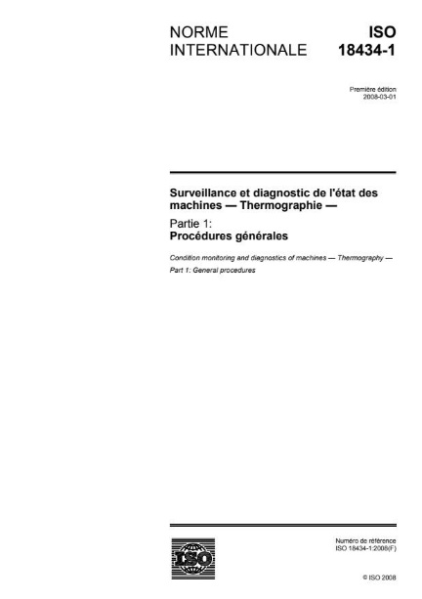
그림 11 ISO 18434-1

○ ASTM E145 (중력 대류 및 강제 환기식 오븐 사양)
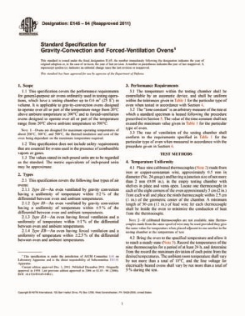
그림 12 ASTM E145

○ IEC 60335-2-45
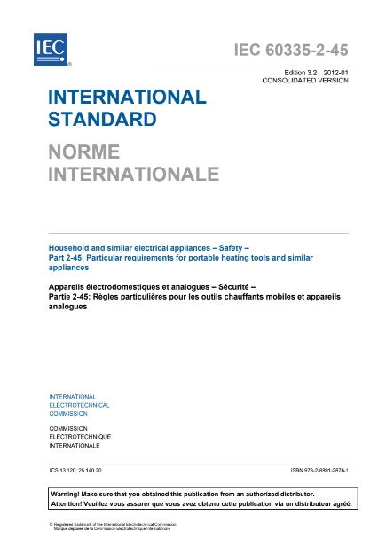
그림 13 IEC 60335-2-45

○ ISO 287 (종이 및 보드 - 수분 함량 측정)

그림 13 ISO 287

○ eCl@ss Standard – Search eCl@ss Contents
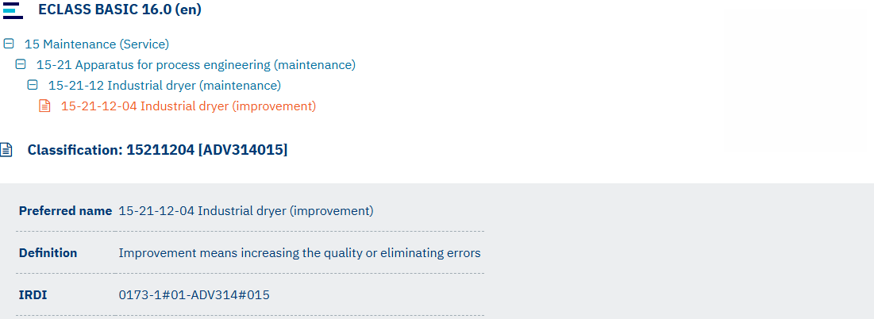
그림 14 eCl@ss 15-21-12-04 Industrial dryer (improvement)

III. AAS 참조모델

1. AAS 참조모델 개요
○ AAS 참조모델이란 AAS에 익숙하지 않은 사용자들을 위해 AAS 작성을 돕기 위해 만들어진 AAS 모델이다.
○ AAS는 데이터를 발생시키는 개체를 대상으로 작성할 수 있으므로 하나의 AAS 하위에 여러 AAS가 존재할 수 있다.
○ 본 가이드라인에서는 앞서 소개한 장비인 열전도식 건조기를 대상으로 구현한 AAS 모델을 참조 모델로 소개한다.

2. AAS 참조모델 세부 구성
○ 열전도식 건조기 참조모델의 전체구조는 아래 <그림 24>과 같이 정의하였다. 필수적인 성격을 띠는 4가지 submodel 외에 4가지의 submodel을 추가하여 총 8가지의 submodel로 구성된다.

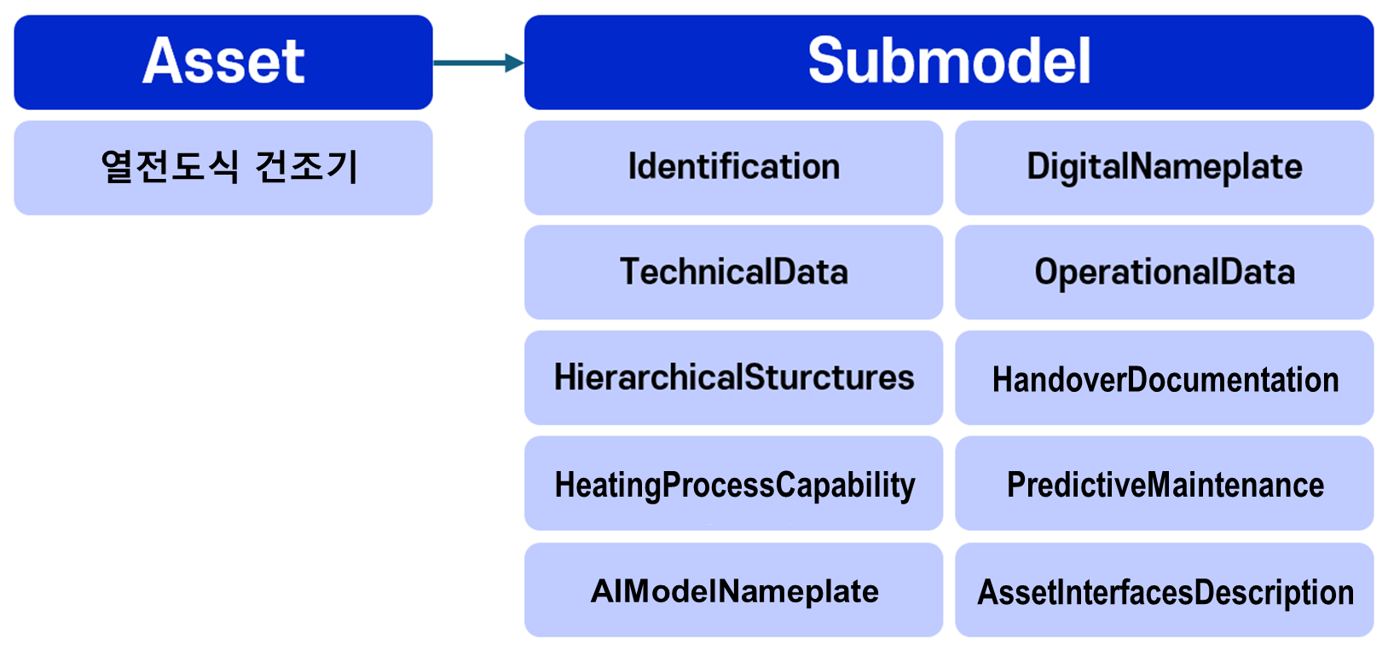
그림 15 열전도식 건조기 참조모델 구성

3. AAS 참조모델 근거자료

○ AAS 참조모델의 경우 Property 등의 Semantic ID를 부여하기 위해 eCl@ss를 근거로 하여 모델링을 수행하였다.

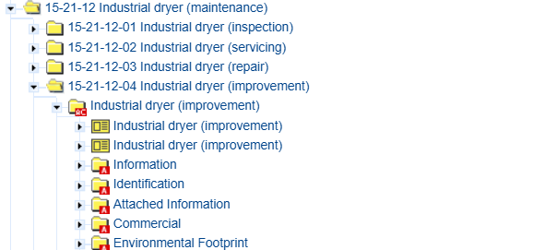
그림 16 eCl@ss(15-21-12-04) 참조
○ 각 submodel의 주요 내용은 아래 아래 표와 같이 구성된다.

표 5 참조모델의 Submodels 개요
Submodel명 | 설명 | 내용 예시 | 비고
Identification | 제품과 제조사에 대한 일반적인 정보 | Asset ID,  제조사 이름 | AasxPackageExplorer  Submodel Plugin
DigitalNameplate for industrial equipment | 제품에 대한 분류 정보, 제조사 정보 등 제품에 대한 기본 정보. 제품의 인증 마킹 정보 등이 포함 | 시리얼번호, 제조 날짜,  인증마크 | IDTA 02006-3-0  Submodel_Digital Nameplate
TechnicalData | 제품의 기술적인 사양서, 데이터시트 정보 | 기술적 사양, 기능적 특성 | IDTA 02003-1-2  Submodel_TechnicalData
OperationalData | 자산의 운영 및 성능에 대한 실시간 데이터 및 상태 정보를 포함 | 실시간 상태 정보,  성능 데이터
Hierarchical  Structures enabling  Bills of Material | 컴포넌트의 조합으로 구성된 제품의 계층적 구성을 포함한 정보 | 물리적 구성 요소, BoM | IDTA 02011-1-1  Submodel_HierarchicalStructures  EnablingBoM
Handover  Documentation | 제품의 브로셔, 설치/시운전/유지보수 매뉴얼 등 다양한 문서 정보 | 사용자 매뉴얼,  제품 카탈로그 | IDTA 02004-2-0  Submodel_HandoverDocumentation
Material  Management | 분말 관리 특화 서브모델 | 분말 기술스펙 정보, 추적성 정보 | ISO 3923-1  ASTM B213 등 참조
PredictiveMaintenance | 생산 시스템, 소프트웨어의 예지보전 정보 | 잔존 수명 예측값, AI 모델 유형 | IDTA 02048-1-0  Predictive Maintenance
AIModelNameplate | AI 모델의 식별 정보 및 기술적 사양 | 학습 방법, 데이터 유형, 아키텍쳐 정보 | IDTA 02060-1-0  Artificial Intelligence Model  Namplate
AssetInterfaces  Description | 자산의 통신 사양 정의 | 접속 지점, 보안 체계 구조, 데이터 전송 형식 | IDTA 02017-1-0  Asset Interfaces Description

가. identification submodel의 하위 Property는 다음과 같이 구성된다.
idShort: | Identification
Class: | Submodel
semanticId: | https://www.hsu-hh.de/aut/aas/identification
Parent: | Identification
Explanation: | -
[SME type]  idShort | semanticId  Description@en | [valueType]  example | card.
[Prop]  ManufacturerName | 0173-1#02-AAO677#004  Manufacturer name Legally valid designation of the natural or judicial person which is directly responsible for the design, production, packaging and labeling of a product in respect to its being brought into circulation abc | [String]  ExampleCompany Co., Ltd. | 0..1
[Prop]  ManufacturerId01 | 0173-1#02-AAY812#003  ManufacturerId01 Internationally unique identification number for the manufacturer of the device or the product and for the physical location - | [String]  8801234000017 | 0..1
[Prop]  ManufacturerIdProvider | 0173-1#02-AAP796#006  ManufacturerIdProvider DUNS-no., supplier number, or other number as identifier of an offeror or supplier of the identification - | [String]  123456789 | 0..1
[Prop]  ManufacturerTypId | 0173-1#02-AAO676#005  Manufacturer article number unique product identifier of the manufacturer - | [String]  04912345123457 | 0..1
[Prop]  ManufacturerTypName | 0173-1#02-AAW338#003  Manufacturer product designation Short description of the product (short text) - | [String]  abcdefg | 0..1
[Prop]  ManufacturerTypDescription | 0173-1#02-AAU734#003  ManufacturerTypDescription Description of the product, it's technical features and implementation if needed - | [MLP]  C-Frame crank press | 0..1
[Prop]  SupplierName | 0173-1#02-AAO735#005  SupplierName Name of supplier which provides the customer with a product or a service - | [String]  ExampleCompany Co., Ltd. | 0..1
[Prop]  SupplierId | 0173-1#02-AAY813#003  SupplierId Internationally unique identification number for the supplier of the device or the product and for the physical location - | [String]  8805678000453 | 0..1
[Prop]  SupplierIdProvider | https://www.smart-factory.kr/ids/cd/SupplierIdProvider/1/0  SupplierIdProvider The unique identifier for the supplier. - | [String]  123456789 | 0..1
[Prop]  SupplierTypId | 0173-1#02-AAO736#006  SupplierTypId Unique product order identifier of the supplier - | [String]  04912345123457 | 0..1
[Prop]  SupplierTypName | 0173-1#02-AAM551#004  SupplierTypName Short description of the product - | [String]  abcdefg | 0..1
[Prop]  SupplierTypDescription | 0173-1#02-AAU730#003  SupplierTypDescription Description of the product, it's technical features and implementation if needed - | [String]  abcdefg | 0..1
[Prop]  TypClass | 0173-1#02-AAU731#003  TypClass Class of type or category - | [String]  00-00-00-00 | 0..1
[Prop]  ClassificationSystem | https://www.smart-factory.kr/ids/cd/ClassificationSystem/1/0  ClassificationSystem System used to categorize products or information. - | [String]  ECLASS | 0..1
[Prop]  SecondaryKeyTyp | https://www.smart-factory.kr/ids/cd/SecondaryKeyTyp/1/0  SecondaryKeyTyp Type of key used for additional data categorization - | [String]  CategoryCode | 0..1
[File]  TypThumbnail | https://www.smart-factory.kr/ids/cd/TypThumbnail/1/0  TypThumbnail Small preview image representing a type or category - | [File]  thumbnail(ExampleCompany).png | 0..1
[Prop]  AssetId | https://www.smart-factory.kr/ids/cd/AssetId/1/0  AssetId A unique identifier for an asset - | [String]  id | 0..1
[Prop]  InstanceId | https://www.smart-factory.kr/ids/cd/InstanceId/1/0  InstanceId A unique code for an instance or version of an asset - | [String]  id | 0..1
[Prop]  ChargeId | 0173-1#02-AAQ196#003  Batch number Number assigned by the manufacturer of a material to identify the manufacturer's batch - | [String]  BATCH-2099-01-0017 | 0..1
[Prop]  SecondaryKeyInstance | https://www.smart-factory.kr/ids/cd/SecondaryKeyInstance/1/0  SecondaryKeyInstance An additional unique identifier for an asset instance - | [String]  2099-00042 | 0..1
[Prop]  ManufacturingDate | 0173-1#02-AAR972#004  ManufacturingDate Date from which the production and / or development process is completed or from which a service is provided completely - | [String]  2099-01-01 | 0..1
[Prop]  DeviceRevision | https://www.smart-factory.kr/ids/cd/DeviceRevision/1/0  DeviceRevision An updated version of Device - | [String]  Rev.02 | 0..1
[Prop]  SoftwareRevision | https://www.smart-factory.kr/ids/cd/SoftwareRevision/1/0  SoftwareRevision An updated version of Software - | [String]  1.4.2 | 0..1
[Prop]  HardwareRevision | https://www.smart-factory.kr/ids/cd/HardwareRevision/1/0  HardwareRevision A modified version or modification of Hardware for Problem correction - | [String]  HW-Rev.03 | 0..1
[File]  QrCode | https://www.smart-factory.kr/ids/cd/QrCode/1/0  QrCode A two-dimensional barcode that stores information, easily scannable by smartphones and other devices - | [File]  qrcode.png | 0..1
[SMC]  ContactInfo01 | https://www.smart-factory.kr/ids/cd/ContactInfo01/1/0  ContactInfo01 Basic contact information of a responsible person - | [-] | 0..1
[File]  CompanyLogo | https://www.smart-factory.kr/ids/cd/CompanyLogo/1/0  CompanyLogo A symbol made up of text and images that identifies a business - | [String]  ExampleCompany.png | 0..1
[Prop]  URL | 0173-1#02-AAO694#003  URL Stated as link to a home page. The home page is the starting page or table of contents - | [String]  ExampleCompany.com | 0..1

idShort: | ContactInfo01
Class: | SubmodelElementCollection
semanticId: | https://www.smart-factory.kr/ids/cd/ContactInfo01/1/0
Parent: | ContactInfo01
Explanation: | -
[SME type]  idShort | semanticId  Description@en | [valueType]  example | card.
[Prop]  Name | 0173-1#02-AAO677#004  Manufacturer name Legally valid designation of the natural or judicial person which is directly responsible for the design, production, packaging and labeling of a product in respect to its being brought into circulation - | [String]  ExampleCompany Co., Ltd. | 0..1
[Prop]  Role | https://www.smart-factory.kr/ids/cd/Role/1/0  Role The specific part or function they have in the context - | [String]  Headquarters | 0..1
[SMC]  PhysicalAddress | https://www.smart-factory.kr/ids/cd/PhysicalAddress/1/0  PhysicalAddress Basic physical address information. - | [-]  5 elements | 0..1
[Prop]  Email | https://www.smart-factory.kr/ids/cd/Email/1/0  Email The electronic mailing address - | [String]  contact@ExampleCompany.com | 0..1
[Prop]  URL | 0173-1#02-AAO694#003  URL Stated as link to a home page. The home page is the starting page or table of contents - | [String]  https://www.ExampleCompany.com | 0..1
[Prop]  Phone | https://www.smart-factory.kr/ids/cd/Phone/1/0  Phone The telephone contact number - | [String]  +82-2-123-1234 | 0..1
[Prop]  Fax | https://www.smart-factory.kr/ids/cd/Fax/1/0  Fax The number used for sending/receiving documents electronically - | [String]  +82-2-123-1235 | 0..1

idShort: | PhysicalAddress
Class: | SubmodelElementCollection
semanticId: | https://www.smart-factory.kr/ids/cd/PhysicalAddress/1/0
Parent: | PhysicalAddress
Explanation: | -
[SME type]  idShort | semanticId  Description@en | [valueType]  example | card.
[Prop]  CountryCode | 0173-1#02-AAO730#003  CountryCode Agreed upon symbol for unambiguous identification of a country - | [String]  KR | 0..1
[Prop]  Street | https://www.smart-factory.kr/ids/cd/Street/1/0  Street The street part of an address - | [String]  123 Example Street | 0..1
[Prop]  PostalCode | https://www.smart-factory.kr/ids/cd/PostalCode/1/0  PostalCode The code for mail delivery within their area - | [String]  12345 | 0..1
[Prop]  City | https://www.smart-factory.kr/ids/cd/City/1/0  City The city part of an address - | [String]  Example City | 0..1
[Prop]  StateCounty | https://www.smart-factory.kr/ids/cd/Role/1/0  Role The specific part or function they have in the context - | [String]  Example City | 0..1

나. DigitalNameplate submodel의 하위 SubmodelCollection, Property는 다음과 같이 구성된다.
idShort: | DigitalNameplate
Class: | Submodel
semanticId: | https://admin-shell.io/idta/nameplate/3/0/Nameplate
Parent: | DigitalNameplate
Explanation: | Contains the nameplate information attached to the product@en
[SME type]  idShort | semanticId  Description@en | [valueType]  example | card.
[Prop]  URIOfTheProduct | 0173-1#02-AAY811#001  URI of the product unique global identification of the product using an universal resource identifier (URI) - | [String]  https://www.smart-factory.kr/ids/asset/MachinePress/1/0 | 1
[MLP]  ManufacturerName | 0112/2///61987#ABA565#009  ManufacturerName legally valid designation of the natural or judicial person which is directly responsible for the design, production, packaging and labeling of a product in respect to its being brought into circulation - | [String]  Example Company@en | 1
[MLP]  ManufacturerProductDesignation | 0112/2///61987#ABA567#009  ManufacturerProductDesignation short description of the product (short text), third or lowest level of a 3 level manufacturer specific product hierarchy - | [String]  abcdef@en | 1
[SMC]  AddressInformation | https://admin-shell.io/zvei/nameplate/1/0/ContactInformations/AddressInformation  AddressInformation Note: this set of information is defined by SMT drop-in Note: this set of information is defined by SMT drop-in "Address Information" | [-]  4 elements | 1
[MLP]  ManufacturerProductRoot | 0112/2///61360_7#AAS011#001  ManufacturerProductRoot top level of a 3 level manufacturer specific product hierarchy - | [String]  abcdef@en | 0..1
[MLP]  ManufacturerProductFamily | 0112/2///61987#ABP464#002  ManufacturerProductFamily second level of a 3 level manufacturer specific product hierarchy - | [String]  abcdef@en | 0..1
[Prop]  ManufacturerProductType | 0112/2///61987#ABA300#008  ManufacturerProductType characteristic to differentiate between different products of a product family or special variants - | [String]  abcdef | 0..1
[Prop]  OrderCodeOfManufacturer | 0112/2///61987#ABA950#008  OrderCodeOfManufacturer unique combination of numbers and letters issued by the manufacturer that is used to identify the device for ordering - | [String]  0000001 | 1
[Prop]  ProductArticleNumberOfManufacturer | 0112/2///61987#ABA581#007  ProductArticleNumberOfManufacturer unique product identifier of the manufacturer - | [String]  MachinePress | 0..1
[Prop]  SerialNumber | 0112/2///61987#ABA951#009  SerialNumber unique combination of numbers and letters used to identify the device once it has been manufactured - | [String]  12345678 | 0..1
[Prop]  YearOfConstruction | 0112/2///61987#ABP000#002  YearOfConstruction year in which the manufacturing process is completed - | [String]  2099-01-01 | 0..1
[Prop]  DateOfManufacture | 0112/2///61987#ABB757#007  DateOfManufacture date when an item was manufactured - | [Date]  2099-01-01 | 0..1
[Prop]  HardwareVersion | 0112/2///61987#ABA926#008  HardwareVersion version of the hardware supplied with the device - | [String]  1.0 | 0..1
[Prop]  FirmwareVersion | 0112/2///61987#ABA302#006  FirmwareVersion version of the firmware supplied with the device - | [String]  1.0 | 0..1
[Prop]  SoftwareVersion | 0112/2///61987#ABA601#008  SoftwareVersion version of the software used by the device - | [String]  1.0 | 0..1
[Prop]  CountryOfOrigin | 0112/2///61987#ABP462#001  CountryOfOrigin country where the product was manufactured Note: Country codes defined accord. to DIN EN ISO 3166-1 alpha-2 codes | [String]  Republic of Korea | 0..1
[Prop]  UniqueFacilityIdentifier | https://admin-shell.io/idta/nameplate/3/0/UniqueFacilityIdentifier  UniqueFacilityIdentifier unique string of characters for the identification of locations or buildings involved in a product’s value chain or used by actors involved in a product’s value chain - | [String]  FAC-2099-001 | 0..1
[File]  CompanyLogo | 0112/2///61987#ABP463#001  CompanyLogo a graphic mark used to represent a company, an organisation or a product - | [File]  /aasx/Logo.png | 0..1
[SML]  Markings | 0173-1#01-AGZ673#001  Markings Collection of product markings Note: CE marking is declared as mandatory according to EU Blue Guide | [-]  3 elements | 0..1
[SMC]  AssetSpecificProperties | 0173-1#01-AGZ672#001  Asset specific Properties Group of properties that are listed on the asset's nameplate and are grouped based on guidelines - | [-]  0 elements | 0..1

idShort: | AddressInformation
Class: | SubmodelElementCollection
semanticId: | https://admin-shell.io/zvei/nameplate/1/0/ContactInformations/AddressInformation
Parent: | AddressInformation
Explanation: | Note: this set of information is defined by SMT drop-in "Address Information"@en
[SME type]  idShort | semanticId  Description@en | [valueType]  example | card.
[MLP]  Street | 0173-1#02-AAO128#002  street street name and house number Note: see also [IRDI] 0112/2///61987#ABA286#001 street. Mandatory property according to EU Machine Directive 2006/42/EC | [String]  123 Example Street@en | 1
[MLP]  Zipcode | 0173-1#02-AAO129#002  zip code ZIP code of address Note: see also [IRDI] 0112/2///61987#ABA281#001 ZIP/Postal code. Mandatory property according to EU Machine Directive 2006/42/EC. Recommendation: property declaration as MLP is required by its semantic definition. As the property value is language independent, users are recommended to provide maximal 1 string in any language of the user’s choice. | [String]  12345@en | 1
[MLP]  CityTown | 0173-1#02-AAO132#002  city/town town or city Note: see also [IRDI] 0112/2///61987#ABA129#001 city/town. Mandatory property according to EU Machine Directive 2006/42/EC. | [String]  Example City@en | 1
[MLP]  NationalCode | 0173-1#02-AAO134#002  national code code of a country Note: see also [IRDI] 0112/2///61360_4#ADA005#001 country code. country codes defined accord. to DIN EN ISO 3166-1 alpha-2 codes. Mandatory property according to EU Machine Directive 2006/42/EC. Recommendation: property declaration as MLP is required by its semantic definition. As the property value is language independent, users are recommended to provide maximal 1 string in any language of the user’s choice. | [String]  KR@en | 1

idShort: | Markings
Class: | SubmodelElementList
semanticId: | 0173-1#01-AGZ673#001
Parent: | Markings
Explanation: | Note: CE marking is declared as mandatory according to EU Blue Guide@en
[SME type]  idShort | semanticId  Description@en | [valueType]  example | card.
[SMC]  - | 0173-1#01-AGZ673#001  Markings Collection of product markings Note: see also [IRDI] 0112/2///61987#ABH515#003 Certificate or approval Note: CE marking is declared as mandatory according to the Blue Guide of the EU-Commission | [-]  6 elements | -
[SMC]  - | 0173-1#01-AGZ673#001  Markings Collection of product markings Note: see also [IRDI] 0112/2///61987#ABH515#003 Certificate or approval Note: CE marking is declared as mandatory according to the Blue Guide of the EU-Commission | [-]  6 elements | -
[SMC]  - | 0173-1#01-AGZ673#001  Markings Collection of product markings Note: see also [IRDI] 0112/2///61987#ABH515#003 Certificate or approval Note: CE marking is declared as mandatory according to the Blue Guide of the EU-Commission | [-]  6 elements | -

idShort: | -
Class: | SubmodelElementCollection
semanticId: | 0173-1#01-AGZ673#001
Parent: | -
Explanation: | Note: see also [IRDI] 0112/2///61987#ABH515#003 Certificate or approval Note: CE marking is declared as mandatory according to the Blue Guide of the EU-Commission @en
[SME type]  idShort | semanticId  Description@en | [valueType]  example | card.
[Prop]  MarkingName | https://admin-shell.io/zvei/nameplate/2/0/Nameplate/Markings/Marking/MarkingName  common name of the marking Note: see also [IRDI] 0173-1#02-BAB392#015 certificate/approval valueId with ECLASS enumeration IRDI is preferable, e.g. [IRDI] 0173-1#07-DAA603#004 for CE. If no IRDI available, string value can also be accepted. Note: CE marking is declared as mandatory according to Blue Guide of the EU-Commission | [String]  0173-1#07-DAA603#004 | 1
[Prop]  DesignationOfCertificateOrApproval | 0112/2///61987#ABH783#001  identifier of certificate, approval, declaration or license alphanumeric character sequence identifying a certificate or approval Note: Approval identifier, reference to the certificate number, to be entered without spaces | [String]  Declaration of Conformity | 0..1
[Prop]  IssueDate | https://admin-shell.io/zvei/nameplate/2/0/Nameplate/Markings/Marking/IssueDate  Date, at which the specified certificate is issued Note: format by lexical representation: CCYY-MM-DD Note: to be specified to the day | [String]  2099-01-01 | 0..1
[Prop]  ExpiryDate | https://admin-shell.io/zvei/nameplate/2/0/Nameplate/Markings/Marking/ExpiryDate  Date, at which the specified certificate expires Note: see also ([IRDI] 0173-1#02-AAO997#001 Validity date Note: format by lexical representation: CCYY-MM-DD Note: to be specified to the day | [String]  2099-01-01 | 0..1
[File]  MarkingFile | https://admin-shell.io/zvei/nameplate/2/0/Nameplate/Markings/Marking/MarkingFile  conformity symbol of the marking - | [File]  /aasx/ce_marking.png | 1
[Prop]  MarkingAdditionalText | https://admin-shell.io/zvei/nameplate/2/0/Nameplate/Markings/Marking/MarkingAdditionalText  where applicable, additional information on the marking in plain text, e.g. the ID-number of the notified body involved in the conformity process Note: see also [IRDI] 0173-1#02-AAM954#002 details of other certificate | [String]  Declaration of Conformity | 0..*

idShort: | -
Class: | SubmodelElementCollection
semanticId: | 0173-1#01-AGZ673#001
Parent: | -
Explanation: | Note: see also [IRDI] 0112/2///61987#ABH515#003 Certificate or approval Note: CE marking is declared as mandatory according to the Blue Guide of the EU-Commission @en
[SME type]  idShort | semanticId  Description@en | [valueType]  example | card.
[Prop]  MarkingName | https://admin-shell.io/zvei/nameplate/2/0/Nameplate/Markings/Marking/MarkingName  common name of the marking Note: see also [IRDI] 0173-1#02-BAB392#015 certificate/approval valueId with ECLASS enumeration IRDI is preferable, e.g. [IRDI] 0173-1#07-DAA603#004 for CE. If no IRDI available, string value can also be accepted. Note: CE marking is declared as mandatory according to Blue Guide of the EU-Commission | [String]  0173-1#07-DAA603#004 | 1
[Prop]  DesignationOfCertificateOrApproval | 0112/2///61987#ABH783#001  identifier of certificate, approval, declaration or license alphanumeric character sequence identifying a certificate or approval Note: Approval identifier, reference to the certificate number, to be entered without spaces | [String]  Declaration of Conformity | 0..1
[Prop]  IssueDate | https://admin-shell.io/zvei/nameplate/2/0/Nameplate/Markings/Marking/IssueDate  Date, at which the specified certificate is issued Note: format by lexical representation: CCYY-MM-DD Note: to be specified to the day | [String]  2099-01-01 | 0..1
[Prop]  ExpiryDate | https://admin-shell.io/zvei/nameplate/2/0/Nameplate/Markings/Marking/ExpiryDate  Date, at which the specified certificate expires Note: see also ([IRDI] 0173-1#02-AAO997#001 Validity date Note: format by lexical representation: CCYY-MM-DD Note: to be specified to the day | [String]  2099-01-01 | 0..1
[File]  MarkingFile | https://admin-shell.io/zvei/nameplate/2/0/Nameplate/Markings/Marking/MarkingFile  conformity symbol of the marking - | [File]  /aasx/ce_marking.png | 1
[Prop]  MarkingAdditionalText | https://admin-shell.io/zvei/nameplate/2/0/Nameplate/Markings/Marking/MarkingAdditionalText  where applicable, additional information on the marking in plain text, e.g. the ID-number of the notified body involved in the conformity process Note: see also [IRDI] 0173-1#02-AAM954#002 details of other certificate | [String]  Declaration of Conformity | 0..*

idShort: | -
Class: | SubmodelElementCollection
semanticId: | 0173-1#01-AGZ673#001
Parent: | -
Explanation: | Note: see also [IRDI] 0112/2///61987#ABH515#003 Certificate or approval Note: CE marking is declared as mandatory according to the Blue Guide of the EU-Commission @en
[SME type]  idShort | semanticId  Description@en | [valueType]  example | card.
[Prop]  MarkingName | https://admin-shell.io/zvei/nameplate/2/0/Nameplate/Markings/Marking/MarkingName  common name of the marking Note: see also [IRDI] 0173-1#02-BAB392#015 certificate/approval valueId with ECLASS enumeration IRDI is preferable, e.g. [IRDI] 0173-1#07-DAA603#004 for CE. If no IRDI available, string value can also be accepted. Note: CE marking is declared as mandatory according to Blue Guide of the EU-Commission | [String]  0173-1#07-DAA603#004 | 1
[Prop]  DesignationOfCertificateOrApproval | 0112/2///61987#ABH783#001  identifier of certificate, approval, declaration or license alphanumeric character sequence identifying a certificate or approval Note: Approval identifier, reference to the certificate number, to be entered without spaces | [String]  Declaration of Conformity | 0..1
[Prop]  IssueDate | https://admin-shell.io/zvei/nameplate/2/0/Nameplate/Markings/Marking/IssueDate  Date, at which the specified certificate is issued Note: format by lexical representation: CCYY-MM-DD Note: to be specified to the day | [String]  2099-01-01 | 0..1
[Prop]  ExpiryDate | https://admin-shell.io/zvei/nameplate/2/0/Nameplate/Markings/Marking/ExpiryDate  Date, at which the specified certificate expires Note: see also ([IRDI] 0173-1#02-AAO997#001 Validity date Note: format by lexical representation: CCYY-MM-DD Note: to be specified to the day | [String]  2099-01-01 | 0..1
[File]  MarkingFile | https://admin-shell.io/zvei/nameplate/2/0/Nameplate/Markings/Marking/MarkingFile  conformity symbol of the marking - | [File]  /aasx/ce_marking.png | 1
[Prop]  MarkingAdditionalText | https://admin-shell.io/zvei/nameplate/2/0/Nameplate/Markings/Marking/MarkingAdditionalText  where applicable, additional information on the marking in plain text, e.g. the ID-number of the notified body involved in the conformity process Note: see also [IRDI] 0173-1#02-AAM954#002 details of other certificate | [String]  Declaration of Conformity | 0..*

다. TechnicalData submodel의 하위 SubmodelCollection, Property는 다음과 같이 구성된다.
idShort: | TechnicalData
Class: | Submodel
semanticId: | 0173-1#01-AHX837#002
Parent: | TechnicalData
Explanation: | Submodel containing technical data of the asset and associated product classificatons@en,Teilmodell, das die technischen Daten des Assets und die zugehörigen Produktklassifizierungen enthält@de
[SME type]  idShort | semanticId  Description@en | [valueType]  example | card.
[SMC]  GeneralInformation | https://admin-shell.io/sandbox/SG2/TechnicalData/GeneralInformation/1/1  General information General information, for example ordering and manufacturer information - | [-]  6 elements
[SML]  Product  Classifications | 0173-1#02-ABK162#002  Product classifications Product classifications by association of product classes with common classification systems - | [-]  1 elements
[SMC]  FurtherInformation | https://admin-shell.io/ZVEI/TechnicalData/FurtherInformation/1/1  FurtherInformation Further information on the product, the validity of the information provided and this data record. Further information on the product, the validity of the information provided and this data record. | [-]  2 elements
[SMC]  TechnicalProperties | 0173-1#02-ABK164#002  Further information Further information on the product, the validity of the information provided and this data record - | [-]  8 elements

idShort: | GeneralInformation
Class: | SubmodelElementCollection
semanticId: | https://admin-shell.io/sandbox/SG2/TechnicalData/GeneralInformation/1/1
Parent: | GeneralInformation
Explanation: | -
[SME type]  idShort | semanticId  Description@en | [valueType]  example | card.
[Prop]  ManufacturerName | 0173-1#02-AAO677#004  Manufacturer name Legally valid designation of the natural or judicial person which is directly responsible for the design, production, packaging and labeling of a product in respect to its being brought into circulation - | [String]  Example Company | 1
[File]  CompanyLogo | 0173-1#02-ABI776#002  Company logo Imagefile for logo of the company provided in common format (.png, .jpg) - | [File]  /aasx/Logo.png | 0..1
[MLP]  Manufacturer  ProductDesignation | 0173-1#02-AAW338#003  Manufacturer product designation Short description of the product (short text) - | [String]  abcdef@en | 1
[Prop]  Manufacturer  ArticleNumber | 0173-1#02-AAO676#005  Manufacturer article number unique product identifier of the manufacturer - | [String]  A123-456 | 1
[Prop]  ManufacturerOrderCode | 0173-1#02-AAO227#004  Manufacturer order code by manufactures issued unique combination of numbers and letters used to identify the device for ordering - | [String]  EEA-EX-200-S/47-Q3 | 1
[SML]  ProductImages | 0173-1#02-ABM220#001  Product images Pictorial representations of the product also related to different applications - | [-]  1 elements

idShort: | ProductImages
Class: | SubmodelElementList
semanticId: | 0173-1#02-ABM220#001
Parent: | ProductImages
Explanation: | -
[SME type]  idShort | semanticId  Description@en | [valueType]  example | card.
[SMC]  - | 0173-1#02-ABM220#001  Product images Pictorial representations of the product also related to different applications - | [-]  2 elements | -

idShort: | -
Class: | SubmodelElementCollection
semanticId: | 0173-1#02-ABM220#001
Parent: | -
Explanation: | -
[SME type]  idShort | semanticId  Description@en | [valueType]  example | card.
[File]  ImageFile | 0173-1#02-ABK291#002  Product image Picture of the product (low resolution) 72 dpi / rgb (GIF or JPG) - | [-]  Abcde.jpg
[MLP]  ImageNote | 0173-1#02-ABL423#001  Image note Notes or explanations about the image provided - | [-]  Notes or explanations about the image provided@en

idShort: | ProductClassifications
Class: | SubmodelElementList
semanticId: | 0173-1#02-ABK162#002
Parent: | ProductClassifications
Explanation: | -
[SME type]  idShort | semanticId  Description@en | [valueType]  example | card.
[SMC]  - | 0173-1#02-ABK162#002  Product classifications Product classifications by association of product classes with common classification systems - | [-]  7 elements | -

idShort: | -
Class: | SubmodelElementCollection
semanticId: | 0173-1#02-ABK162#002
Parent: | -
Explanation: | -
[SME type]  idShort | semanticId  Description@en | [valueType]  example | card.
[Prop]  ClassificationSystem | 0173-1#02-ABL424#001  Classification system Reference to the scheduled collection of abstract concepts that are used to distinguish and order objects - | [String]  ECLASS
[Prop]  ClassificationSystemVersion | 0173-1#02-AAR710#003  Version of the classification system Referenced state of the published classification system - | [String]  15.0
[Prop]  ClassificationSystemUrl | https://admin-shell.io/IDTA/TechnicalData/ProductClassifications/ProduktClassification/ClassificationSystemUrl/2/0  Classification system URL Classification system URL - | [String]  Abcde.com
[Prop]  ProductClassId | 0173-1#02-ABG776#003  Product class ID Class of the associated product or industrial equipment in the classification system. According to the notation of the system (IRDI) - | [String]  abcde
[Prop]  ProductClassCodedName | 0173-1#02-ABK128#002  Product Class Coded Name Unique class code in a classification hierarchy - | [String]  abcde
[MLP]  ProductClassName | 0173-1#02-ABK273#002  Product class name Name of product class in the used classification system - | [-]  Name@en
[Ref]  ReferenceToTechnicalPropertyArea | 0173-1#02-ABL358#002  Reference to technical property area Reference to technical property area - | [-]  abcde

idShort: | FurtherInformation
Class: | SubmodelElementCollection
semanticId: | https://admin-shell.io/ZVEI/TechnicalData/FurtherInformation/1/1
Parent: | FurtherInformation
Explanation: | Further information on the product, the validity of the information provided and this data record.@en
[SME type]  idShort | semanticId  Description@en | [valueType]  example | card.
[MLP]  TextStatement | https://admin-shell.io/ZVEI/TechnicalData/TextStatement/1/1  Text Statement Statement by the manufacturer in text form, e.g. scope of validity of the statements, scopes of application, conditions of operation. Note: Whenever possible, a multi-language definition is preferred Statement by the manufacturer in text form, e.g. scope of validity of the statements, scopes of application, conditions of operation. | [-]  -
[Prop]  ValidDate | https://admin-shell.io/ZVEI/TechnicalData/ValidDate/1/1  Valid Date Denotes a date on which the data specified in the Submodel was valid from for the associated asset. Note: Often this date will be the date of the last update of the corresponding data, that are the source for the technical properties section in the master data system. Denotes a date on which the data specified in the Submodel was valid from for the associated asset. | [Date]

idShort: | TechnicalProperties
Class: | SubmodelElementCollection
semanticId: | 0173-1#02-ABK164#002
Parent: | TechnicalProperties
Explanation: | -
[SME type]  idShort | semanticId  Description@en | [valueType]  example | card.
[Prop]  ProcessType | https://www.smart-factory.kr/ids/cd/ProcessType/1/0  Process Type Process type classification (e.g., Batch or Inline). Process type (Batch / Inline) | [String]  Batch | 0..1
[Prop]  HeatingMethod | https://www.smart-factory.kr/ids/cd/HeatingMethod/1/0  Heating Method Heating method used by the equipment (e.g., Hot Plate, Roll, or Jacket). Heating method (Hot Plate / Roll / Jacket) | [String]  Hot plate | 0..1
[Prop]  MaxOperatingTemperature | https://www.smart-factory.kr/ids/cd/MaxOperatingTemperature/1/0  Max Operating Temperature Maximum operating temperature of the equipment under designed conditions. Max operating temperature | [Float]  999 | 0..1
[Prop]  TransferSpeedRange | https://www.smart-factory.kr/ids/cd/TransferSpeedRange/1/0  Transfer Speed Range Adjustable range of transfer speed (applicable for Inline process type). Transfer speed range (Process type: Inline) | [String]  0 to 100 | 0..1
[Prop]  EffectiveDryingArea | https://www.smart-factory.kr/ids/cd/EffectiveDryingArea/1/0  Effective Drying Area Effective drying area representing the substrate contact area. Effective drying area (Substrate contact area) | [Float]  1 | 0..1
[Prop]  HeatingZoneCount | https://www.smart-factory.kr/ids/cd/HeatingZoneCount/1/0  Heating Zone Count Number of heating zones used for precision temperature control. Number of Heating Zones (for precision control) | [Int]  3 | 0..1
[Prop]  WarmUpTime | https://www.smart-factory.kr/ids/cd/WarmUpTime/1/0  Warm Up Time Preheating time required until the target temperature is reached. Preheating time until target temperature is reached | [int]  2 | 0..1
[Prop]  MaterialConductivity | https://www.smart-factory.kr/ids/cd/MaterialConductivity/1/0  Material Conductivity Thermal conductivity of the heating plate or roll material. Thermal Conductivity of Heating Plate/Roll | [Float]  100 | 0..1

라. OperationalData submodel의 하위 SubmodelCollection, Property는 다음과 같이 구성된다.
idShort: | OperationalData
Class: | Submodel
semanticId: | -
Parent: | OperationalData
Explanation: | -
[SME type]  idShort | semanticId  Description@en | [valueType]  example | card.
[Prop]  Timestamp | https://www.smart-factory.kr/ids/cd/Timestamp/1/0  Time stamp time stamp - | [String]  2026-02-04T09:00:00+09:00 | 0..1
[SMC]  BatchData | https://www.smart-factory.kr/ids/cd/BatchData/1/0  BatchData Data collection of the batch. - | [-]  8 elements | 0..1
[SMC]  MonitoringData | https://www.smart-factory.kr/ids/cd/MonitoringData/1/0  Monitoring Data A collection of monitoring data - | [-]  4 elements | 0..1

idShort: | BatchData
Class: | SubmodelElementCollection
semanticId: | https://www.smart-factory.kr/ids/cd/BatchData/1/0
Parent: | BatchData
Explanation: | -
[SME type]  idShort | semanticId  Description@en | [valueType]  example | card.
[Prop]  BatchID | https://www.smart-factory.kr/ids/cd/BatchID/1/0  Batch ID Unique identifier assigned to a production batch for traceability. - | [String]  BATCH-20260204-001 | 0..1
[Prop]  StartTime | https://www.smart-factory.kr/ids/cd/StartTime/1/0  Start Time Timestamp indicating when the batch process started. - | [String]  2026-02-04T09:00:00+09:00 | 0..1
[Prop]  EndTime | https://www.smart-factory.kr/ids/cd/EndTime/1/0  End Time Timestamp indicating when the batch process ended. - | [String]  2026-02-04T09:00:00+09:00 | 0..1
[Prop]  BatchCumulativeEnergyUsage | https://www.smart-factory.kr/ids/cd/BatchCumulativeEnergyUsage/1/0  Batch Cumulative Energy Usage Total accumulated energy consumption during the execution of the batch. - | [Float]  12.8 | 0..1
[Prop]  UnitweightEnergyUsage | https://www.smart-factory.kr/ids/cd/UnitweightEnergyUsage/1/0  Unit Weight Energy Usage Energy consumption per unit weight of product produced during the batch. - | [Float]  0.42 | 0..1
[SMC]  Setting | https://www.smart-factory.kr/ids/cd/Setting/1/0  Setting A collection of configurable process parameter setpoints used to control equipment operation. - | [-]  5 elements | 0..1
[SMC]  ProductionInformation | https://www.smart-factory.kr/ids/cd/ProductionInformation/1/0  Production Information A collection of production-related identifiers and key figures, including order, lot, product information, quantities, and downtime records. - | [-]  8 elements | 0..1
[SMC]  Threshold | https://www.smart-factory.kr/ids/cd/Threshold/1/0  Threshold A collection of upper and lower threshold values used for process monitoring and control. - | [-]  10 elements | 0..1

idShort: | Setting
Class: | SubmodelElementCollection
semanticId: | https://www.smart-factory.kr/ids/cd/Setting/1/0
Parent: | Setting
Explanation: | -
[SME type]  idShort | semanticId  Description@en | [valueType]  example | card.
[Prop]  CurrentTransferSpeed | https://www.smart-factory.kr/ids/cd/CurrentTransferSpeed/1/0  Current Transfer Speed Configured transfer speed setpoint for the material or product during operation. - | [Float]  1.25 | 0..1
[Prop]  ZoneTemperature | https://www.smart-factory.kr/ids/cd/ZoneTemperature/1/0  Zone Temperature Configured temperature setpoint for a heating or drying zone. - | [Float]  85.0 | 0..1
[Prop]  PlateContactPressure | https://www.smart-factory.kr/ids/cd/PlateContactPressure/1/0  Plate Contact Pressure Configured contact pressure setpoint between the heating plate and the material. - | [Float]  145.0 | 0..1
[Prop]  ExhaustAirFlow | https://www.smart-factory.kr/ids/cd/ExhaustAirFlow/1/0  Exhaust Air Flow Configured exhaust air flow rate setpoint for the drying process. - | [Float]  65.0 | 0..1
[Prop]  HeaterOutputPower | https://www.smart-factory.kr/ids/cd/HeaterOutputPower/1/0  Heater Output Power Configured output power setpoint of the heater used in the drying process. - | [Float]  120.0 | 0..1

idShort: | ProductionInformation
Class: | SubmodelElementCollection
semanticId: | https://www.smart-factory.kr/ids/cd/ProductionInformation/1/0
Parent: | ProductionInformation
Explanation: | -
[SME type]  idShort | semanticId  Description@en | [valueType]  example | card.
[Prop]  OrderNumber | https://www.smart-factory.kr/ids/cd/OrderNumber/1/0  Order Number Identifier of the production order associated with the current production record. - | [String]  ORD-20260204-001 | 0..1
[Prop]  LotNumber | https://www.smart-factory.kr/ids/cd/LotNumber/1/0  Lot Number Identifier of the production lot for traceability. - | [String]  LOT-20260204-A | 0..1
[Prop]  ProductType | https://www.smart-factory.kr/ids/cd/ProductType/1/0  Product Type Product type or category associated with the current production record. - | [String]  Standard | 0..1
[Prop]  ProductCode | https://www.smart-factory.kr/ids/cd/ProductCode/1/0  Product Code Unique product code or identifier used for production and traceability. - | [String]  PRD-STD-001 | 0..1
[Prop]  ProductionQuantity | https://www.smart-factory.kr/ids/cd/ProductionQuantity/1/0  Production Quantity Quantity of products produced within the current production record. - | [Integer]  120 | 0..1
[Prop]  TotalOperationTime | https://www.smart-factory.kr/ids/cd/TotalOperationTime/1/0  Total Operation Time Accumulated operating time of the equipment for the current production record. - | [Float]  3.75 | 0..1
[Prop]  DowntimeCause | https://www.smart-factory.kr/ids/cd/DowntimeCause/1/0  Downtime Cause Cause or reason code describing why downtime occurred. - | [String]  abcde | 0..1
[Prop]  Downtime | https://www.smart-factory.kr/ids/cd/Downtime/1/0  Downtime Accumulated downtime duration for the current production record. - | [Float]  0.5 | 0..1

idShort: | Threshold
Class: | SubmodelElementCollection
semanticId: | https://www.smart-factory.kr/ids/cd/Threshold/1/0
Parent: | Threshold
Explanation: | -
[SME type]  idShort | semanticId  Description@en | [valueType]  example | card.
[Prop]  CurrentTransferSpeedUpperlimit | https://www.smart-factory.kr/ids/cd/CurrentTransferSpeedUpperlimit/1/0  Current Transfer Speed Upper Limit Upper threshold limit for the current transfer speed. - | [Float]  1.50 | 0..1
[Prop]  CurrentTransferSpeedLowerlimit | https://www.smart-factory.kr/ids/cd/CurrentTransferSpeedLowerlimit/1/0  Current Transfer Speed Lower Limit Lower threshold limit for the current transfer speed. - | [Float]  0.80 | 0..1
[Prop]  ZoneTemperatureUpperlimit | https://www.smart-factory.kr/ids/cd/ZoneTemperatureUpperlimit/1/0  Zone Temperature Upper Limit Upper threshold limit for the temperature of a heating zone. - | [Float]  95.0 | 0..1
[Prop]  ZoneTemperatureLowerlimit | https://www.smart-factory.kr/ids/cd/ZoneTemperatureLowerlimit/1/0  Zone Temperature Lower Limit Lower threshold limit for the temperature of a heating zone. - | [Float]  70.0 | 0..1
[Prop]  PlateContactPressureUpperlimit | https://www.smart-factory.kr/ids/cd/PlateContactPressureUpperlimit/1/0  Plate Contact Pressure Upper Limit Upper threshold limit for the contact pressure between the plate and the material. - | [Float]  6.0 | 0..1
[Prop]  PlateContactPressureLowerlimit | https://www.smart-factory.kr/ids/cd/PlateContactPressureLowerlimit/1/0  Plate Contact Pressure Lower Limit Lower threshold limit for the contact pressure between the plate and the material. - | [Float]  3.0 | 0..1
[Prop]  ExhaustAirFlowUpperlimit | https://www.smart-factory.kr/ids/cd/ExhaustAirFlowUpperlimit/1/0  Exhaust Air Flow Upper Limit Upper threshold limit for the exhaust air flow rate. - | [Float]  1200.0 | 0..1
[Prop]  ExhaustAirFlowLowerlimit | https://www.smart-factory.kr/ids/cd/ExhaustAirFlowLowerlimit/1/0  Exhaust Air Flow Lower Limit Lower threshold limit for the exhaust air flow rate. - | [Float]  800.0 | 0..1
[Prop]  HeaterOutputPowerUpperlimit | https://www.smart-factory.kr/ids/cd/HeaterOutputPowerUpperlimit/1/0  Heater Output Power Upper Limit Upper threshold limit for the heater output power. - | [Float]  15.0 | 0..1
[Prop]  HeaterOutputPowerLowerlimit | https://www.smart-factory.kr/ids/cd/HeaterOutputPowerLowerlimit/1/0  Heater Output Power Lower Limit Lower threshold limit for the heater output power. - | [Float]  5.0 | 0..1

idShort: | MonitoringData
Class: | SubmodelElementCollection
semanticId: | https://www.smart-factory.kr/ids/cd/MonitoringData/1/0
Parent: | MonitoringData
Explanation: | -
[SME type]  idShort | semanticId  Description@en | [valueType]  example | card.
[SMC]  EnvironmentInformation | https://www.smart-factory.kr/ids/cd/EnvironmentInformation/1/0  Environment Information A collection of environmental measurement values describing the ambient conditions around the equipment. - | [-]  4 elements | 0..1
[SMC]  EquipmentStatus | https://www.smart-factory.kr/ids/cd/EquipmentStatus/1/0  Equipment Status A collection of equipment status - | [-]  7 elements | 0..1
[SMC]  MaterialInformation | https://www.smart-factory.kr/ids/cd/MaterialInformation/1/0  Material Information A collection of material identifiers, classification, inventory information, and related defect/alarm status records. - | [-]  8 elements | 0..1
[SMC]  Sensorhealth | https://www.smart-factory.kr/ids/cd/Sensorhealth/1/0  Sensor Health A collection of metadata and status information describing the health condition of a sensor. - | [-]  4 elements | 0..1

idShort: | EnvironmentInformation
Class: | SubmodelElementCollection
semanticId: | https://www.smart-factory.kr/ids/cd/EnvironmentInformation/1/0
Parent: | EnvironmentInformation
Explanation: | -
[SME type]  idShort | semanticId  Description@en | [valueType]  example | card.
[Prop]  MeasurementTemperature | https://www.smart-factory.kr/ids/cd/MeasurementTemperature/1/0  Measurement Temperature Measured ambient temperature in the environment surrounding the equipment. - | [Float]  20.0 | 0..1
[Prop]  MeasurementHumidity | https://www.smart-factory.kr/ids/cd/MeasurementHumidity/1/0  Measurement Humidity Measured relative humidity of the ambient environment. - | [Float]  35.0 | 0..1
[Prop]  MeasurementNoiseLevel | https://www.smart-factory.kr/ids/cd/MeasurementNoiseLevel/1/0  Measurement Noise Level Measured ambient noise level in the environment surrounding the equipment. - | [Float]  68.0 | 0..1
[Prop]  MeasurementLightLevel | https://www.smart-factory.kr/ids/cd/MeasurementLightLevel/1/0  Measurement Light Level Measured ambient illumination level in the environment surrounding the equipment. - | [Float]  550.0 | 0..1

idShort: | EquipmentStatus
Class: | SubmodelElementCollection
semanticId: | https://www.smart-factory.kr/ids/cd/EquipmentStatus/1/0
Parent: | EquipmentStatus
Explanation: | -
[SME type]  idShort | semanticId  Description@en | [valueType]  example | card.
[Prop]  OperationType | https://www.smart-factory.kr/ids/cd/OperationType/1/0  Operation Type Type of operation currently executed by the equipment, such as automatic, manual, or maintenance mode. - | [String]  Automatic | 0..1
[Prop]  PowerStatus | https://www.smart-factory.kr/ids/cd/PowerStatus/1/0  Power Status Status indicating whether the equipment power is on, off, or in a standby state. - | [String]  On | 0..1
[Prop]  SafetyInterlockStatus | https://www.smart-factory.kr/ids/cd/SafetyInterlockStatus/1/0  Safety Interlock Status Status of the safety interlock system indicating whether safety conditions are satisfied. - | [String]  Satisfied | 0..1
[Prop]  OperationAvailabilityStatus | https://www.smart-factory.kr/ids/cd/OperationAvailabilityStatus/1/0  Operation Availability Status Status indicating whether the equipment is available for operation or not. - | [String]  Available | 0..1
[Prop]  RecipeInformation | https://www.smart-factory.kr/ids/cd/RecipeInformation/1/0  Recipe Information Identifier or reference to the recipe configuration currently applied to the equipment. - | [String]  RECIPE-STD-01 | 0..1
[SMC]  HeaterInformation | https://www.smart-factory.kr/ids/cd/HeaterInformation/1/0  Heater Information A collection of identification, operational status, and abnormality information related to the heater. - | [-]  8 elements | 0..1
[SMC]  ConsumableInformation | https://www.smart-factory.kr/ids/cd/ConsumableInformation/1/0  Consumable Information A collection of identifiers and descriptive information related to consumable items used by the equipment. - | [-]  4 elements | 0..1

idShort: | HeaterInformation
Class: | SubmodelElementCollection
semanticId: | https://www.smart-factory.kr/ids/cd/HeaterInformation/1/0
Parent: | HeaterInformation
Explanation: | -
[SME type]  idShort | semanticId  Description@en | [valueType]  example | card.
[Prop]  HeaterID | https://www.smart-factory.kr/ids/cd/HeaterID/1/0  Heater ID Identifier of the heater. - | [String]  abcde | 0..1
[Prop]  HeaterAlarmMessage | https://www.smart-factory.kr/ids/cd/HeaterAlarmMessage/1/0  Alarm Message Human-readable alarm message related to material handling or material status. - | [String]  Null | 0..1
[Prop]  OperationStatus | https://www.smart-factory.kr/ids/cd/OperationStatus/1/0  Operation Status Current operational state of the heater, such as running, stopped, or standby. - | [String]  Running | 0..1
[Prop]  HealthStatus | https://www.smart-factory.kr/ids/cd/HealthStatus/1/0  Health Status Overall health condition of the heater based on diagnostics or monitoring results. - | [String]  Normal | 0..1
[Prop]  AbnormalityDetectionStatus | https://www.smart-factory.kr/ids/cd/AbnormalityDetectionStatus/1/0  Abnormality Detection Status Status indicating whether an abnormal condition has been detected in the heater. - | [String]  NotDetected | 0..1
[Prop]  AbnormalityCause | https://www.smart-factory.kr/ids/cd/AbnormalityCause/1/0  Abnormality Cause Description or code identifying the cause of a detected abnormality in the heater. - | [String]  None | 0..1
[Prop]  HeaterAlarmStatus | https://www.smart-factory.kr/ids/cd/HeaterAlarmStatus/1/0  Alarm Status Status indicating whether a material-related alarm is active or cleared. - | [String]  Cleared | 0..1
[Prop]  HeaterAlarmCode | https://www.smart-factory.kr/ids/cd/HeaterAlarmCode/1/0  Alarm Code Code identifying the specific material-related alarm condition. - | [String]  ALM-0000 | 0..1

idShort: | ConsumableInformation
Class: | SubmodelElementCollection
semanticId: | https://www.smart-factory.kr/ids/cd/ConsumableInformation/1/0
Parent: | ConsumableInformation
Explanation: | -
[SME type]  idShort | semanticId  Description@en | [valueType]  example | card.
[Prop]  ConsumableID | https://www.smart-factory.kr/ids/cd/ConsumableID/1/0  Consumable ID Unique identifier assigned to a consumable item for tracking and management. - | [String]  abcde | 0..1
[Prop]  ConsumableDescription | https://www.smart-factory.kr/ids/cd/ConsumableDescription/1/0  Consumable Description Textual description providing details about the consumable item. - | [String]  Standard heating element used for continuous operation | 0..1
[Prop]  ConsumableName | https://www.smart-factory.kr/ids/cd/ConsumableName/1/0  Consumable Name Human-readable name of the consumable item. - | [String]  HeatingElement | 0..1
[Prop]  ReplacementDate | https://www.smart-factory.kr/ids/cd/ReplacementDate/1/0  Replacement Date Date or timestamp indicating when the consumable item was last replaced. - | [String]  2025-12-15 | 0..1

idShort: | MaterialInformation
Class: | SubmodelElementCollection
semanticId: | https://www.smart-factory.kr/ids/cd/MaterialInformation/1/0
Parent: | MaterialInformation
Explanation: | -
[SME type]  idShort | semanticId  Description@en | [valueType]  example | card.
[Prop]  MaterialID | https://www.smart-factory.kr/ids/cd/MaterialID/1/0  Material ID Unique identifier assigned to the material for tracking and traceability. - | [String]  MAT-20260204-001 | 0..1
[Prop]  MaterialAlarmMessage | https://www.smart-factory.kr/ids/cd/MaterialAlarmMessage/1/0  Alarm Message Human-readable alarm message related to material handling or material status. - | [String]  Material supply level below minimum threshold | 0..1
[Prop]  MaterialType | https://www.smart-factory.kr/ids/cd/MaterialType/1/0  Material Type Classification or type of the material (e.g., raw material, consumable, or product-related material). - | [String]  RawMaterial | 0..1
[Prop]  InventoryQuantity | https://www.smart-factory.kr/ids/cd/InventoryQuantity/1/0  Inventory Quantity Quantity of the material available in inventory. - | [int]  250 | 0..1
[Prop]  DefectStatus | https://www.smart-factory.kr/ids/cd/DefectStatus/1/0  Defect Status Status indicating whether the material is defective or nonconforming. - | [String]  NonDefective | 0..1
[Prop]  DefectDescription | https://www.smart-factory.kr/ids/cd/DefectDescription/1/0  Defect Description Description providing details about the material defect or nonconformance. - | [String]  No defect detected during inspection | 0..1
[Prop]  MaterialAlarmStatus | https://www.smart-factory.kr/ids/cd/MaterialAlarmStatus/1/0  Alarm Status Status indicating whether a material-related alarm is active or cleared. - | [String]  Cleared | 0..1
[Prop]  MaterialAlarmCode | https://www.smart-factory.kr/ids/cd/MaterialAlarmCode/1/0  Alarm Code Code identifying the specific material-related alarm condition. - | [String]  ALM-0000 | 0..1

idShort: | Sensorhealth
Class: | SubmodelElementCollection
semanticId: | https://www.smart-factory.kr/ids/cd/Sensorhealth/1/0
Parent: | Sensorhealth
Explanation: | -
[SME type]  idShort | semanticId  Description@en | [valueType]  example | card.
[Prop]  SensorID | https://www.smart-factory.kr/ids/cd/SensorID/1/0  ID Unique identifier of the sensor within the system. - | [String]  SENSOR-001 | 0..1
[Prop]  SensorStatus | https://www.smart-factory.kr/ids/cd/SensorStatus/1/0  Status Current health status of the sensor (e.g., OK, Warning, Fault, Offline). - | [String]  OK | 0..1
[Prop]  SensorName | https://www.smart-factory.kr/ids/cd/SensorName/1/0  Name Human-readable name of the sensor. - | [String]  Temp_Sensor_1 | 0..1
[Prop]  SensorDescription | https://www.smart-factory.kr/ids/cd/SensorDescription/1/0  Description Additional description providing context about the sensor or its status. - | [String]  Primary temp sensor | 0..1

마. HandoverDocumentation submodel의 하위 SubmodelCollection, Property는 다음과 같이 구성된다.
idShort: | HandoverDocumentation
Class: | Submodel
semanticId: | 0173-1#01-AHF578#003
Parent: | HandoverDocumentation
Explanation: | The Submodel defines a set meta data for the handover of documentation from the manufacturer to the operator for industrial equipment@en
[SME type]  idShort | semanticId  Description@en | [valueType]  example | card.
[SML]  Documents | 0173-1#02-ABI500#003  Documents (handover documentation) Information for a document identity - | [-]  1 elements | 1
[SML]  Entities | https://admin-shell.io/vdi/2770/1/0/EntitiesForDocumentation  Entities Entities for documentation - | [-]  1 elements | 0..1

idShort: | Documents
Class: | SubmodelElementList
semanticId: | 0173-1#02-ABI500#003
Parent: | Documents
Explanation: | -
[SME type]  idShort | semanticId  Description@en | [valueType]  example | card.
[SMC]  - | 0173-1#02-ABI500#003  Documents (handover documentation) Information for a document identity This SubmodelElementCollection holds the information for a VDI 2770 Document entity | [-]  4 elements | 1..*

idShort: | -
Class: | SubmodelElementCollection
semanticId: | 0173-1#02-ABI500#003
Parent: | -
Explanation: | This SubmodelElementCollection holds the information for a VDI 2770 Document entity@en
[SME type]  idShort | semanticId  Description@en | [valueType]  example | card.
[SML]  DocumentIds | 0173-1#02-ABI501#003  Document identifiers Set of document identifiers for the document. One ID in this collection should be used as a preferred ID - | [-]  1 elements | 1
[SML]  DocumentClassifications | 0173-1#02-ABI502#003  Document classification Information about a document classification entity - | [-]  1 elements | 1
[SML]  DocumentVersions | 0173-1#02-ABI503#003  DocumentVersions Information elements of individual Document Version entities - | [-]  1 elements | 1
[SML]  DocumentedEntities | https://admin-shell.io/vdi/2770/1/0/Document/DocumentedEntities  Documented Entities Documented Entities - | [-]  1 elements | 0..1

idShort: | DocumentIds
Class: | SubmodelElementList
semanticId: | 0173-1#02-ABI501#003
Parent: | DocumentIds
Explanation: | -
[SME type]  idShort | semanticId  Description@en | [valueType]  example | card.
[SMC]  - | 0173-1#02-ABI501#003  Document identifiers Set of document identifiers for the document. One ID in this collection should be used as a preferred ID This SubmodelElementCollection holds the information for a VDI 2770 Document entity | [-]  3 elements | 1

idShort: | -
Class: | SubmodelElementCollection
semanticId: | 0173-1#02-ABI501#003
Parent: | -
Explanation: | This SubmodelElementCollection holds the information for a VDI 2770 Document entity@en
[SME type]  idShort | semanticId  Description@en | [valueType]  example | card.
[Prop]  DocumentDomainId | 0173-1#02-ABH994#003  Document domain id Identification of the domain in which the given DocumentId is unique. The domain ID can e.g., be the name or acronym of the providing organisation - | [String]  https://domain.com | 1
[Prop]  DocumentIdentifier | 0173-1#02-AAO099#004  DocumentIdentifier alphanumeric character sequence uniquely identifying a document - | [String]  XF90-884 | 1
[Prop]  DocumentIsPrimary | 0173-1#02-ABH995#003  DocumentIsPrimary Flag indicating that a DocumentId within a collection of at least two DocumentId`s is the ‘primary’ identifier for the document. This is the preferred ID of the document (commonly from the point of view of the owner of the asset) - | [Boolean]  true | 0..1

idShort: | DocumentClassifications
Class: | SubmodelElementList
semanticId: | 0173-1#02-ABI502#003
Parent: | DocumentClassifications
Explanation: | -
[SME type]  idShort | semanticId  Description@en | [valueType]  example | card.
[SMC]  - | 0173-1#02-ABI502#003  Document classification Information about a document classification entity Set of information for describing the classification of the Document according to a ClassificationSystem | [-]  3 elements | 1..*

idShort: | -
Class: | SubmodelElementCollection
semanticId: | 0173-1#02-ABI502#003
Parent: | -
Explanation: | Set of information for describing the classification of the Document according to a ClassificationSystem@en
[SME type]  idShort | semanticId  Description@en | [valueType]  example | card.
[Prop]  ClassId | 0173-1#02-ABH996#003  Class identifyer Unique ID of the document class within a classficationsystem - | [String]  03-02 | 1
[MLP]  ClassName | 0173-1#02-ABJ219#002  Class name Name of the class in the classification system - | [String]  Operation@en | 1
[Prop]  ClassificationSystem | 0173-1#02-ABH997#003  Classification system Identification of the classification system - | [String]  VDI2770:2020 | 1

idShort: | DocumentVersions
Class: | SubmodelElementList
semanticId: | 0173-1#02-ABI503#003
Parent: | DocumentVersions
Explanation: | -
[SME type]  idShort | semanticId  Description@en | [valueType]  example | card.
[SMC]  - | 0173-1#02-ABI503#003  DocumentVersions Information elements of individual Document Version entities - | [-]  15 elements | 1..*

idShort: | -
Class: | SubmodelElementCollection
semanticId: | 0173-1#02-ABI503#003
Parent: | -
Explanation: | -
[SME type]  idShort | semanticId  Description@en | [valueType]  example | card.
[SML]  Language | 0173-1#02-AAN468#008  Language of document Language style of the document - | [Property]  en | 1
[Prop]  Version | 0173-1#02-AAP003#005  Document version Design that partly deviates from the previous - | [String]  V1.2 | 1
[MLP]  Title | 0173-1#02-ABG940#003  Document name Name of the document - | [String]  Examplary title@en | 1
[MLP]  Subtitle | 0173-1#02-ABH998#003  Subtitle List of language-dependent subtitles of the document - | [String]  Examplary subtitle@en | 0..1
[MLP]  Description | 0173-1#02-AAN466#004  Document description Plain text characterizing the content of the document - | [String]  Abstract@en | 1
[MLP]  KeyWords | 0173-1#02-ABH999#003  Keywords List of language-dependent keywords of the document - | [String]  Examplary keywords@en | 0..1
[Prop]  StatusSetDate | 0173-1#02-ABI000#003  Document status set date Date when the document status was set - | [Date]  2020-02-06 | 1
[Prop]  StatusValue | 0173-1#02-ABI001#003  Document status Each document version represents a point in time in the document life cycle. This status value refers to the milestones in the document life cycle. The following two values should be used for the application of this guideline: InReview (under review), Released (released) - | [String]  Released | 1
[Prop]  OrganizationShortName | 0173-1#02-ABI002#003  Organization Short Name Short name of the organization - | [String]  Example company | 1
[Prop]  OrganizationOfficialName | 0173-1#02-ABI004#003  Organization official name Official name of the organization of the author of the document - | [String]  Example company Ltd. | 1
[SML]  RefersToEntities | 0173-1#02-ABK288#002  Reference to other documents Forms a generic refers to-relationship to another document or document version. They have a loose relationship - | [-] | 0..1
[SML]  BasedOnReferences | 0173-1#02-ABK289#002  Based on other documents Forms a based on-relationship to another document or document version. Typically states, that the content of the document bases on another document (e.g. specification requirements). Both have a strong relationship - | [-] | 0..1
[SML]  TranslationOfEntities | 0173-1#02-ABK290#002  Translation of other document Forms a translation of-relationship to another document or document version. Both have a strong relationship - | [-] | 0..1
[SML]  DigitalFiles | 0173-1#02-ABK126#002  Digital file MIME-Type, file name and file contents given by the file SubmodelElement - | [-] | 1
[File]  PreviewFile | 0173-1#02-ABK127#002  Preview file Provides a preview image of the Document Version, e.g. first page, in a commonly used image format and low resolution - | [File]  *.jpg | 0..1

idShort: | Language
Class: | SubmodelElementList
semanticId: | 0173-1#02-AAN468#008
Parent: | Language
Explanation: | -
[SME type]  idShort | semanticId  Description@en | [valueType]  example | card.
[Prop]  - | 0173-1#02-AAN468#008  Language of document Language style of the document - | [String]  en | 1

idShort: | RefersToEntities
Class: | SubmodelElementList
semanticId: | 0173-1#02-ABK288#002
Parent: | RefersToEntities
Explanation: | -
[SME type]  idShort | semanticId  Description@en | [valueType]  example | card.
[Ref]  - | 0173-1#02-ABK288#002  Reference to other documents Forms a generic refers to-relationship to another document or document version. They have a loose relationship - | [-] | 1..*

idShort: | BasedOnReferences
Class: | SubmodelElementList
semanticId: | 0173-1#02-ABK289#002
Parent: | BasedOnReferences
Explanation: | -
[SME type]  idShort | semanticId  Description@en | [valueType]  example | card.
[Ref]  - | 0173-1#02-ABK289#002  Based on other documents Forms a based on-relationship to another document or document version. Typically states, that the content of the document bases on another document (e.g. specification requirements). Both have a strong relationship - | [-] | 1..*

idShort: | TranslationOfEntities
Class: | SubmodelElementList
semanticId: | 0173-1#02-ABK290#002
Parent: | TranslationOfEntities
Explanation: | -
[SME type]  idShort | semanticId  Description@en | [valueType]  example | card.
[Ref]  - | 0173-1#02-ABK290#002  Translation of other document Forms a translation of-relationship to another document or document version. Both have a strong relationship - | [-] | 1..*

idShort: | DigitalFiles
Class: | SubmodelElementList
semanticId: | 0173-1#02-ABK126#002
Parent: | DigitalFiles
Explanation: | -
[SME type]  idShort | semanticId  Description@en | [valueType]  example | card.
[File]  - | 0173-1#02-ABK126#002  Digital file MIME-Type, file name and file contents given by the file SubmodelElement - | [-] | 1..*

idShort: | DocumentedEntities
Class: | SubmodelElementList
semanticId: | https://admin-shell.io/vdi/2770/1/0/Document/DocumentedEntities
Parent: | DocumentedEntities
Explanation: | -
[SME type]  idShort | semanticId  Description@en | [valueType]  example | card.
[Ref]  - | https://admin-shell.io/vdi/2770/1/0/Document/DocumentedEntity  DocumentedEntity Reference for the documented entities - | [-] | 1..*

idShort: | Entities
Class: | SubmodelElementList
semanticId: | https://admin-shell.io/vdi/2770/1/0/EntitiesForDocumentation
Parent: | Entities
Explanation: | -
[SME type]  idShort | semanticId  Description@en | [valueType]  example | card.
[Ent]  - | https://admin-shell.io/vdi/2770/1/0/EntityForDocumentation  Entity States that the described Entity is an important entity for documentation of the superordinate Asset of the Asset Administration Shell. - | [-]  - | 1..*

바. PredictiveMaintenance submodel의 하위 SubmodelCollection, Property는 다음과 같이 구성된다.
idShort: | PredictiveMaintenance
Class: | Submodel
semanticId: | https://admin-shell.io/idta/SubmodelTemplate/PredictiveMaintenance/1/0
Parent: | PredictiveMaintenance
Explanation: | The Submodel Predictive Maintenance is a collection of properties to provide information for predictive maintenance use cases. It is intended to use this submodel in sub-systems of production lines to describe predictive maintenance relevant topics for the sub-system, as well as to use this submodel in predictive maintenance software applications@en,Das Teilmodell Predictive Maintenance stellt Informationen für Anwendungsfälle von Predictive Maintenance bereit. Dieses Teilmodell ist für Sub-Systeme von Produktionslinien vorgesehen, um Predictive Maintenance relevante Informationen für das Sub-System zu beschreiben sowie für Software-Anwendungen für vorausschauende Wartung@de
[SME type]  idShort | semanticId  Description@en | [valueType]  example | card.
[SMC]  Remaining  UsefulLifePrediction | https://admin-shell.io/idta/PredictiveMaintenance/RemainingUsefulLifePrediction/1/0  Remaining useful life prediction Information about remaining useful life (RUL) prediction in the context of predictive maintenance Information about remaining useful life (RUL) prediction in the context of predictive maintenance | [-]  7 elements | 0..1

idShort: | RemainingUsefulLifePrediction
Class: | SubmodelElementCollection
semanticId: | https://admin-shell.io/idta/PredictiveMaintenance/RemainingUsefulLifePrediction/1/0
Parent: | RemainingUsefulLifePrediction
Explanation: | Information about remaining useful life (RUL) prediction in the context of predictive maintenance@en,Informationen über die Prognose der nutzbaren Restlebensdauer (RUL) im Kontext der vorausschauenden Wartung@de
[SME type]  idShort | semanticId  Description@en | [valueType]  example | card.
[Ent]  RemainingUsefulLifetime | https://admin-shell.io/idta/PredictiveMaintenance/RemainingUsefulLifetime/1/0  RemainingUsefulLifetime Life time Remaining useful life time, bades on Lifetime model of OPC Foundation (https://reference.opcfoundation.org/DI/v104/docs/10) | [-]  - | 0..1
[Prop]  RemainingUsfulLifeDateTime | https://admin-shell.io/idta/PredictiveMaintenance/RemainingUsfulLifeDateTime/1/0  time stamp (date and time) mark attributed to an instant by means of a specified timescale, expressed as a date and a time mark attributed to an instant by means of a specified timescale, expressed as a date and a time | [DateTime]  2026-06-30T18:00:00+09:00 | 0..1
[Range]  ConfidenceInterval | https://admin-shell.io/idta/PredictiveMaintenance/ConfidenceInterval/1/0  Confidence interval confidence interval, measured in the unit of the predicted value confidence interval, measured in the unit of the predicted value | [-]  0.85  0.95 | 0..1
[SML]  ListRULBoundaryConditions | https://admin-shell.io/idta/PredictiveMaintenance/ListRULBoundaryConditions/1/0  List of boundary conditions of remaining useful life prediction List of boundary conditions for which remaining useful life has been predicted List of boundary conditions for which remaining useful life has been predicted | [-]  1 elements | 0..1
[SMC]  PredictionModelInformation | https://admin-shell.io/idta/PredictiveMaintenance/PredictionModelInformation/1/0  Prediction model information Information about the model for RUL prediction relevant in the context of predictive maintenance Information about the model for RUL prediction relevant in the context of predictive maintenance | [-]  3 elements | 0..1
[SML]  ListPreAlerts | https://www.smart-factory.kr/ids/cd/ListPreAlerts/1/0  ListPreAlerts List for defining pre-alerts which should be raised before remaining useful life is exceeded List for defining pre-alerts which should be raised before remaining useful life is exceeded | [-]  1 elements | 0..1
[SMC]  AlertAfterExceedingRemainingUsableLife | https://admin-shell.io/idta/PredictiveMaintenance/AlertAfterExceedingRemainingUsableLife/1/0  Alert after exceeding remaining useful life Alert information which should be triggered or displayed after exceeding remaining useful life Alert information which should be triggered or displayed after exceeding remaining useful life | [-]  2 elements | 0..1

idShort: | RemainingUsefulLifetime
Class: | Entity
semanticId: | https://admin-shell.io/idta/PredictiveMaintenance/RemainingUsefulLifetime/1/0
Parent: | RemainingUsefulLifetime
Explanation: | Remaining useful life time, bades on Lifetime model of OPC Foundation (https://reference.opcfoundation.org/DI/v104/docs/10)@en,Verbleibende Betriebszeit in Anlehnung an Lifetime model der OPC Foundation (https://reference.opcfoundation.org/DI/v104/docs/10)@de
[SME type]  idShort | semanticId  Description@en | [valueType]  example | card.
[Prop]  IndicationType | https://admin-shell.io/idta/PredictiveMaintenance/IndicationType/1/0  Type of duration Type of wear-relevant duration, e.g. time, cycles, distance, etc. Type of wear-relevant duration, e.g. time, cycles, distance, etc. | [String]  time | 0..1
[Prop]  DurationValue | https://admin-shell.io/idta/PredictiveMaintenance/DurationValue/1/0  Duration value Value of duration in the wear relevant unit, e.g. time, operation cycles, distance, etc. Value of duration in the wear relevant unit, e.g. time, operation cycles, distance, etc. | [Double]  720.0 | 0..1
[Prop]  EngineeringUnit | https://admin-shell.io/idta/PredictiveMaintenance/EngineeringUnit/1/0  Unit of the duration Wear relevant physical unit, e.g. time, operation cycles, distance, etc. Wear relevant physical unit, e.g. time, operation cycles, distance, etc. | [String]  h | 0..1
[Prop]  StartValue | https://admin-shell.io/idta/PredictiveMaintenance/StartValue/1/0  Start value of duration Starting value from which the duration is measured in the wear-relevant unit, e.g. time, cycles, distance, etc. Starting value from which the duration is measured in the wear-relevant unit, e.g. time, cycles, distance, etc. | [Double]  0.0 | 0..1
[Prop]  StartDateTime | https://admin-shell.io/idta/PredictiveMaintenance/StartDateTime/1/0  Start datetime of the duration Start date and time from which the duration is measured Start date and time from which the duration is measured | [DateTime]  2026-02-01T00:00:00+09:00 | 0..1
[Prop]  Description | https://admin-shell.io/idta/PredictiveMaintenance/Description/1/0  Description of the duration Description of the wear duration information Description of the wear duration information | [String]  RUL | 0..1

idShort: | ListRULBoundaryConditions
Class: | SubmodelElementList
semanticId: | https://admin-shell.io/idta/PredictiveMaintenance/ListRULBoundaryConditions/1/0
Parent: | ListRULBoundaryConditions
Explanation: | List of boundary conditions for which remaining useful life has been predicted@en,Liste der Randbedingungen unter denen die nutzbare Restlebensdauer prognostiziert wurde@de
[SME type]  idShort | semanticId  Description@en | [valueType]  example | card.
[SMC]  - | https://admin-shell.io/idta/PredictiveMaintenance/RULCondition/1/0  Boundary condition for remaining useful life prediction Boundary condition for which remaining useful life has been predicted Boundary condition for which remaining useful life has been predicted | [-]  9 elements | 1

idShort: | -
Class: | SubmodelElementCollection
semanticId: | https://admin-shell.io/idta/PredictiveMaintenance/RULCondition/1/0
Parent: | -
Explanation: | Boundary condition for which remaining useful life has been predicted@en,Randbedingung unter der die nutzbare Restlebensdauer prognositiziert wurde@de
[SME type]  idShort | semanticId  Description@en | [valueType]  example | card.
[Prop]  ConditionName | 0173-1#02-AAV958#001  StatusConditionName Name of the asset's state, highlighting deviations from normal operations or reduced lifespan. Name of the indicator (process value, KPI, material property, asset property) describing a boundary condition for which RUL prediction is valid. | [String]  BearingTemperature | 0..1
[Prop]  IsBoundaryConditionUsedInModel | https://admin-shell.io/idta/PredictiveMaintenance/IsBoundaryConditionUsedInModel/1/0  Condition is used in RUL model If this boundary condition is used in the model for RUL prediction true, else false If this boundary condition is used in the model for RUL prediction true, else false | [Boolean]  true | 0..1
[Prop]  BoundaryValueRange | https://admin-shell.io/idta/PredictiveMaintenance/BoundaryValueRange/1/0  Indicator value range Value range of the indicator (process value, KPI, material property, asset property) describing a boundary condition for which RUL prediction is valid. Value range of the indicator (process value, KPI, material property, asset property) describing a boundary condition for which RUL prediction is valid. | [Double]  60.0 | 0..1
[Prop]  BoundaryEngineeringUnit | https://admin-shell.io/idta/PredictiveMaintenance/BoundaryEngineeringUnit/1/0  Unit of the indicator Engineering Unit of the boundary condition indicator Engineering Unit of the boundary condition indicator | [String]  degC | 0..1
[Range]  DriftInfoAIModel | https://admin-shell.io/idta/PredictiveMaintenance/DriftInfoAIModel/1/0  Drift information Drift information of AI model Drift information of AI model | [-]  -0.02  0.03 | 0..1
[Prop]  MeanValue | https://admin-shell.io/idta/PredictiveMaintenance/MeanValue/1/0  Mean value Mean value of the distribution of indicator values Mean value of the distribution of indicator values | [Double]  70.0 | 0..1
[Prop]  Standarddeviation | https://admin-shell.io/idta/PredictiveMaintenance/Standarddeviation/1/0  Standard deviation Standard deviation of the distribution of indicator values Standard deviation of the distribution of indicator values | [Double]  5.0 | 0..1
[Prop]  Skewness | https://admin-shell.io/idta/PredictiveMaintenance/Skewness/1/0  Skewness Skewness of the distribution of indicator values Skewness of the distribution of indicator values | [Double]  0.1 | 0..1
[Prop]  BoundaryDescription | https://admin-shell.io/idta/PredictiveMaintenance/BoundaryDescription/1/0  Description of the boundary of a RUL prediction condition Description of the boundary of a RUL prediction condition Description of the boundary of a RUL prediction condition | [String]  Valid operating range under which the remaining useful life prediction is applicable | 0..1

idShort: | PredictionModelInformation
Class: | SubmodelElementCollection
semanticId: | https://admin-shell.io/idta/PredictiveMaintenance/PredictionModelInformation/1/0
Parent: | PredictionModelInformation
Explanation: | Information about the model for RUL prediction relevant in the context of predictive maintenance@en,Informationen über das Modell zur Prognose der RUL im Kontext der vorausschauenden Wartung@de
[SME type]  idShort | semanticId  Description@en | [valueType]  example | card.
[Prop]  ModelType | https://admin-shell.io/idta/PredictiveMaintenance/ModelType/1/0  Model type Model type as an enumerated value: physical based methods, data-driven methods, hybrid methods Model type as an enumerated value: physical based methods, data-driven methods, hybrid methods | [String]  data-driven methods | 0..1
[Prop]  ModelDescription | https://admin-shell.io/idta/PredictiveMaintenance/ModelDescription/1/0  Model description More detailed description of the model type used for RUL prediction (optional) More detailed description of the model type used for RUL prediction (optional) | [String]  Data-driven model | 0..1
[Ref]  SMAIModelNamePlate | https://admin-shell.io/idta/PredictiveMaintenance/SMAIModelNamePlate/1/0  Reference to AIModelNameplate Reference to AIModelNameplate Reference to AIModelNameplate | [-] | 0..1

idShort: | ListPreAlerts
Class: | SubmodelElementList
semanticId: | https://www.smart-factory.kr/ids/cd/ListPreAlerts/1/0
Parent: | ListPreAlerts
Explanation: | List for defining pre-alerts which should be raised before remaining useful life is exceeded@en,Liste, um Voralarme zu definieren, die vor Erreichen der Restlebensdauer ausgelöst werden sollen@de
[SME type]  idShort | semanticId  Description@en | [valueType]  example | card.
[SMC]  - | https://www.smart-factory.kr/ids/cd/PreAlerts/1/0  PreAlerts Defining pre-alerts which should be raised before remaining useful life is exceeded Definition of a pre-alert which should be raised before remaining useful life is exceeded | [-]  2 elements | 1

idShort: | -
Class: | SubmodelElementCollection
semanticId: | https://www.smart-factory.kr/ids/cd/PreAlerts/1/0
Parent: | -
Explanation: | Definition of a pre-alert which should be raised before remaining useful life is exceeded@en,Definition eiens Voralarms, der vor Erreichen der Restlebensdauer ausgelöst werden sollen@de
[SME type]  idShort | semanticId  Description@en | [valueType]  example | card.
[Prop]  PreAlertMessage | https://admin-shell.io/idta/PredictiveMaintenance/PreAlertMessage/1/0  Remaining usable life alert message Message to be displayed when alarm regarding predicted remaining useful life is raised Message to be displayed when alarm regarding predicted remaining useful life is raised | [String]  RUL is approaching the predefined threshold | 0..1
[Prop]  PreAlertValue | https://admin-shell.io/idta/PredictiveMaintenance/PreAlertValue/1/0  Pre-alert value Pre-warning duration in wear relevant unit before remaining useful life is exceeded Pre-warning duration in wear relevant unit before remaining useful life is exceeded | [Double]  72.0 | 0..1

idShort: | AlertAfterExceedingRemainingUsableLife
Class: | SubmodelElementCollection
semanticId: | https://admin-shell.io/idta/PredictiveMaintenance/AlertAfterExceedingRemainingUsableLife/1/0
Parent: | AlertAfterExceedingRemainingUsableLife
Explanation: | Alert information which should be triggered or displayed after exceeding remaining useful life@en,Alarminformationen die ausgelöst oder angezeigt werden sollen, wenn die Restlebensdauer überschritten wird@de
[SME type]  idShort | semanticId  Description@en | [valueType]  example | card.
[Prop]  AlertMessage | https://admin-shell.io/idta/PredictiveMaintenance/AlertMessage/1/0  Remaining usable life alert message Message to be displayed when alarm regarding predicted remaining useful life is raised Message to be displayed when alarm regarding predicted remaining useful life is raised | [String]  Maintenance required | 0..1
[Prop]  MaintenanceRequired | https://admin-shell.io/idta/PredictiveMaintenance/MaintenanceRequired/1/0  Maintenance required Maintenance required Maintenance required | [Boolean]  true | 0..1

사. AIModelNameplate submodel의 하위 SubmodelCollection, Property는 다음과 같이 구성된다.
idShort: | AIModelNameplate
Class: | Submodel
semanticId: | -
Parent: | AIModelNameplate
Explanation: | -
[SME type]  idShort | semanticId  Description@en | [valueType]  example | card.
[Prop]  URIOfTheProduct | 0173-1#02-AAY811#001  URI of the product unique global identification of the product using an universal resource identifier (URI) unique global identification of the product instance using an universal resource identifier (URI) | [String]  https://www.smart-factory.kr/ids/aas/abc/1/0 | 0..1
[Prop]  Version | 0173-1#02-AAS354#002  Version Version Version of the nameplate | [String]  1.0 | 0..1
[Ref]  ContactInformation | https://admin-shell.io/idta/AIModelNameplate/Contactinformation/1/0  ContactInformation contactInformation references Reference to the Contact Information IDTA Submodel to describe the responsible person for the Submodel | [-] | 0..1
[Prop]  Storage | https://admin-shell.io/idta/AIModelNameplate/Storage/1/0  Storage path to the model(e.g. local path, serverpath,...) Path to the model (e.g. local path, serverpath,...) | [String]  local | 0..1
[MLP]  KindOfLearning | https://admin-shell.io/idta/AIModelNameplate/KindOfLearning/1/0  KindOfLearning This property describes the learningmethod of the model (supervised, unsupervised, reinforcement, ....) This property describes the learningmethod of the model (supervised, unsupervised, reinforcement, ....) | [-]  reinforced@en | 0..1
[SMC]  Inputs | https://admin-shell.io/idta/AIModelNameplate/Inputs/1/0  Inputs This SMC collects necessary information about the Modelinput Collection of necessary information about the model input | [-]  3 elements | 0..1
[SMC]  Outputs | https://admin-shell.io/idta/AIModelNameplate/Outputs/1/0  Outputs This SMC collects necassary information about the Modeloutput. Collection of necessary information about the model output | [-]  1 elements | 0..1
[SMC]  TrainingResults | https://admin-shell.io/idta/AIModelNameplate/TrainingResults/1/0  TrainingResults This SMC holds different trainingresults of the model. Collection of different training results of the model | [-]  1 elements | 0..1
[SMC]  Plots | https://admin-shell.io/idta/AIModelNameplate/Plots/1/0  Plots This SMC is used to save and manage images of different plots e.g. about the training or the model itself. Collection of different plots | [-]  3 elements | 0..1
[SMC]  Details | https://admin-shell.io/idta/AIModelNameplate/Details/1/0  Details This SMC is used to document additional details about the model. Collection of additional details about the model | [-]  4 elements | 0..1
[SMC]  AIDataset | https://admin-shell.io/idta/AIModelNameplate/AIDataset/1/0  AI Dataset Dataset of AI Collection of additional details about the model | [-]  2 elements | 0..1
[SMC]  AITypeSpecificInformation | https://admin-shell.io/idta/AIModelNameplate/AITypeSpecificInformation/1/0  AITypeSpecificInformation This collection contains different kinds of AI-typespecific parameters. Collection containing different kinds of AI method specific parameters | [-]  3 elements | 0..1

idShort: | Inputs
Class: | SubmodelElementCollection
semanticId: | https://admin-shell.io/idta/AIModelNameplate/Inputs/1/0
Parent: | Inputs
Explanation: | Collection of necessary information about the model input@en
[SME type]  idShort | semanticId  Description@en | [valueType]  example | card.
[Prop]  KindOfInput | https://admin-shell.io/idta/AIModelNameplate/Inputs/KindOfInput/1/0  KindOfInput Kind of data used for input (e.g. Images, Audio) Type of data (e.g. Images, Audio) | [String] | 0..1
[SMC]  DimensionN | https://admin-shell.io/idta/AIModelNameplate/Inputs/DimensionN/1/0  DimensionN This SMC contains Information about every inputdimension. It exists one collection for every inputdimension. Collection of information about a single input dimension | [-]  2 elements | 0..1
[File]  Preprocessing | https://admin-shell.io/idta/AIModelNameplate/Inputs/Preprocessing/1/0  Preprocessing This property can be used to submit your prepocessing pipeline as a file (e.g directly as code or just the used transforms and parameters) Preprocessing pipeline as a file | [-]  pipelinev1.json | 0..1

idShort: | DimensionN
Class: | SubmodelElementCollection
semanticId: | https://admin-shell.io/idta/AIModelNameplate/Inputs/DimensionN/1/0
Parent: | DimensionN
Explanation: | Collection of information about a single input dimension@en
[SME type]  idShort | semanticId  Description@en | [valueType]  example | card.
[Prop]  Size | https://admin-shell.io/idta/AIModelNameplate/Inputs/DimensionN/Size/1/0  Size This property holds the size of this dimension. Size of the output dimension | [String]  1 | 0..1
[Prop]  Information | https://admin-shell.io/idta/AIModelNameplate/Inputs/DimensionN/Information/1/0  Information This property holds information about the usage of this dimension. Information about the usage of this dimension | [String]  Single scalrar input | 0..1

idShort: | Outputs
Class: | SubmodelElementCollection
semanticId: | https://admin-shell.io/idta/AIModelNameplate/Outputs/1/0
Parent: | Outputs
Explanation: | Collection of necessary information about the model output@en
[SME type]  idShort | semanticId  Description@en | [valueType]  example | card.
[SMC]  DimensionN | https://admin-shell.io/idta/AIModelNameplate/Outputs/DimensionN/1/0  DimensionN This is a example SMC. It holds information about every outputdimension. replace the "N" with the dimension this SMC is for. Collection of information about a single output dimension | [-]  2 elements | 1

idShort: | DimensionN
Class: | SubmodelElementCollection
semanticId: | https://admin-shell.io/idta/AIModelNameplate/Outputs/DimensionN/1/0
Parent: | DimensionN
Explanation: | Collection of information about a single output dimension@en
[SME type]  idShort | semanticId  Description@en | [valueType]  example | card.
[Prop]  Size | https://admin-shell.io/idta/AIModelNameplate/Outputs/DimensionN/Size/1/0  Size This property holds the size of this dimension. Size of the output dimension | [String]  1 | 0..1
[MLP]  Result | https://admin-shell.io/idta/AIModelNameplate/Outputs/DimensionN/Result/1/0  Result This property describes the meaning of this outputdimension (e.g. class). Meaning of the output dimension (e.g. class) | [-]  class  @en | 0..1

idShort: | TrainingResults
Class: | SubmodelElementCollection
semanticId: | https://admin-shell.io/idta/AIModelNameplate/TrainingResults/1/0
Parent: | TrainingResults
Explanation: | Collection of different training results of the model@en
[SME type]  idShort | semanticId  Description@en | [valueType]  example | card.
[Prop]  ExampleResult | https://admin-shell.io/idta/AIModelNameplate/TrainingResults/Result/1/0  ExampleResult This property is a placeholder example for a result for the trained ai. Result of the trained AI | [String]  Predicted remaining useful life: 720 h | 1

idShort: | Plots
Class: | SubmodelElementCollection
semanticId: | https://admin-shell.io/idta/AIModelNameplate/Plots/1/0
Parent: | Plots
Explanation: | Collection of different plots @en
[SME type]  idShort | semanticId  Description@en | [valueType]  example | card.
[SMC]  TrainingTesting | https://admin-shell.io/idta/AIModelNameplate/Plots/TrainingTesting/1/0  TrainingTesting This SMC contains plots about the training and testing of the model. Collection of plots about training results and test results | [-]  1 elements | 0..1
[SMC]  Structure | https://admin-shell.io/idta/AIModelNameplate/Plots/Structure/1/0  Structure This SMC contains images about the structure (e.g. of a neural net). Collection describing the model architecture (e.g. of a neural net) | [-]  1 elements | 0..1
[SMC]  GeneralPlots | https://admin-shell.io/idta/AIModelNameplate/Plots/GeneralPlots/1/0  GeneralPlots This SMC can be used to save plots about other things not fitting in the other two SMCs. Collection of plots not fitting in existing collections | [-]  1 elements | 0..1

idShort: | TrainingTesting
Class: | SubmodelElementCollection
semanticId: | https://admin-shell.io/idta/AIModelNameplate/Plots/TrainingTesting/1/0
Parent: | TrainingTesting
Explanation: | Collection of plots about training results and test results@en
[SME type]  idShort | semanticId  Description@en | [valueType]  example | card.
[File]  ExamplePlot | https://admin-shell.io/idta/AIModelNameplate/Plots/TrainingTesting/Plot/1/0  ExamplePlot This is a simple file example for a plotimage. Training or test result plot | [-] | 1

idShort: | Structure
Class: | SubmodelElementCollection
semanticId: | https://admin-shell.io/idta/AIModelNameplate/Plots/Structure/1/0
Parent: | Structure
Explanation: | Collection describing the model architecture (e.g. of a neural net)@en
[SME type]  idShort | semanticId  Description@en | [valueType]  example | card.
[File]  ExampleStructurePlot | https://admin-shell.io/idta/AIModelNameplate/Plots/Structure/StructurePlot/1/0  ExampleStructurePlot This is a placeholder example for a structure image. Image of a model architecture | [-] | 1

idShort: | GeneralPlots
Class: | SubmodelElementCollection
semanticId: | https://admin-shell.io/idta/AIModelNameplate/Plots/GeneralPlots/1/0
Parent: | GeneralPlots
Explanation: | Collection of plots not fitting in existing collections@en
[SME type]  idShort | semanticId  Description@en | [valueType]  example | card.
[File]  ExamplePlot | https://admin-shell.io/idta/AIModelNameplate/Plots/GeneralPlots/Plot/1/0  ExamplePlot1 Placerholder for other plots. Image of an model related plot | [-] | 1

idShort: | Details
Class: | SubmodelElementCollection
semanticId: | https://admin-shell.io/idta/AIModelNameplate/Details/1/0
Parent: | Details
Explanation: | Collection of additional details about the model@en
[SME type]  idShort | semanticId  Description@en | [valueType]  example | card.
[Prop]  FileExtension | https://admin-shell.io/idta/AIModelNameplate/Details/DataEnding/1/0  FileExtension This property tells the dataending it got saved with (e.g. .pth). File extension of the model (e.g. .pth) | [String]  .pth | 0..1
[Prop]  AIFramework | https://admin-shell.io/idta/AIModelNameplate/Details/AIFramework/1/0  AIFramework This property describes the AI framework and its version (e.g. pytorch 11.3). AI framework and its version (e.g. pytorch 11.3) | [String]  PyTorch 2.0 | 0..1
[Prop]  ProgramLanguage | https://admin-shell.io/idta/AIModelNameplate/Details/ProgramLanguage/1/0  ProgramLanguage The used programming language and version (e.g. python 3.9). Programming language and version (e.g. python 3.9) | [String]  Python 3.9 | 0..1
[File]  Requirements | https://admin-shell.io/idta/AIModelNameplate/Details/Requirements/1/0  Requirements This component is used to save the requirements.txt of the enviroment. Requirements file containing the required software dependencies (e.g. Python Requirements.txt file) | [-] | 0..1

idShort: | AIDataset
Class: | SubmodelElementCollection
semanticId: | https://admin-shell.io/idta/AIModelNameplate/AIDataset/1/0
Parent: | AIDataset
Explanation: | Collection of additional details about the model@en
[SME type]  idShort | semanticId  Description@en | [valueType]  example | card.
[Ref]  AIDatasetReference | https://admin-shell.io/idta/AIModelNameplate/AIDataset/DatasetReference/1/0  DatasetReference Dataset reference Reference to the used AIDataset-Submodel | [-] | 1
[Range]  TimeStamp | https://admin-shell.io/idta/AIModelNameplate/AITypeSpecificInformation/NeuralNetwork/TransferLearning/TimeStamp/1/0  TimeStamp Because there is a possibility, that the origin model has changed its weights or structure over time, it is necessary to date the time this model was used for transfer learning Determining the used data, when dataset differs over time | [-]  2025-01-01T00:00:00Z  2025-12-31T23:59:59Z | 1

idShort: | AITypeSpecificInformation
Class: | SubmodelElementCollection
semanticId: | https://admin-shell.io/idta/AIModelNameplate/AITypeSpecificInformation/1/0
Parent: | AITypeSpecificInformation
Explanation: | Collection containing different kinds of AI method specific parameters@en
[SME type]  idShort | semanticId  Description@en | [valueType]  example | card.
[SMC]  TransferLearning | https://admin-shell.io/idta/AIModelNameplate/AITypeSpecificInformation/TransferLearning/1/0  TransferLearning This SMC is used to describe informations, if the model is a result of transfer learning, of the origin model Collection containing information of the origin model, if the model is a result of transfer learning | [-]  4 elements | 0..1
[SMC]  Hyperparameter | https://admin-shell.io/idta/AIModelNameplate/AITypeSpecificInformation/Hyperparameter/1/0  Hyperparameter This SMC contains the relevant hyperparamter used for train the NN. Collection containing relevant hyperparamter | [-]  1 elements | 0..1
[MLP]  Type | https://admin-shell.io/idta/AIModelNameplate/AITypeSpecificInformation/Type/1/0  Type Type of the AI(e.g. CNN, RNN, LSTM, ...) Type of the AI(e.g. CNN, RNN, LSTM, ...) | [-]  CNN@en | 0..1

idShort: | TransferLearning
Class: | SubmodelElementCollection
semanticId: | https://admin-shell.io/idta/AIModelNameplate/AITypeSpecificInformation/TransferLearning/1/0
Parent: | TransferLearning
Explanation: | Collection containing information of the origin model, if the model is a result of transfer learning@en
[SME type]  idShort | semanticId  Description@en | [valueType]  example | card.
[Prop]  Name | https://admin-shell.io/idta/AIModelNameplate/AITypeSpecificInformation/NeuralNetwork/TransferLearning/Name/1/0  Name Holds the name of the origin NN-Model (e.g. resnet18) Name of the origin neural network (e.g. resnet18) | [String]  Resnet18 | 0..1
[Prop]  TimeStamp | https://admin-shell.io/idta/AIModelNameplate/AITypeSpecificInformation/NeuralNetwork/TransferLearning/TimeStamp/1/0  TimeStamp Because there is a possibility, that the origin model has changed its weights or structure over time, it is necessary to date the time this model was used for transfer learning Date of access of the origin neural network | [DateTime]  2025-01-01T00:00:00Z | 0..1
[File]  Weights | https://admin-shell.io/idta/AIModelNameplate/AITypeSpecificInformation/NeuralNetwork/TransferLearning/Weights/1/0  Weights Possibility to save the weights of the origin model as a file (e.g. .txt) File containing the weights of the origin model (e.g. .txt) | [-] | 0..1
[Ref]  AIModelNameplate | https://admin-shell.io/idta/AIModelNameplate/AITypeSpecificInformation/NeuralNetwork/TransferLearning/ModelnameplateRef/1/0  ModelNameplate This is a reference to the model used for transfer learning if there exists a submodel to it. Reference to the AI Modelnameplate submodel of the origin neural network | [-] | 0..1

idShort: | Hyperparameter
Class: | SubmodelElementCollection
semanticId: | https://admin-shell.io/idta/AIModelNameplate/AITypeSpecificInformation/Hyperparameter/1/0
Parent: | Hyperparameter
Explanation: | Collection containing relevant hyperparamter@en
[SME type]  idShort | semanticId  Description@en | [valueType]  example | card.
[Prop]  Example | https://admin-shell.io/idta/AIModelNameplate/AITypeSpecificInformation/Hyperparameter/LearningRate/1/0  Hyperparameter Hyperparameter of AI Example hyperparameter (e.g. learning rate of the model) | [String]  Learning rate | 1

아. AssetInterfacesDescription submodel의 하위 SubmodelCollection, Property는 다음과 같이 구성된다.

idShort: | AssetInterfacesDescription
Class: | Submodel
semanticId: | -
Parent: | AssetInterfacesDescription
Explanation: | AID Template Sample@en
[SME type]  idShort | semanticId  Description@en | [valueType]  example | card.
[SMC]  InterfaceTemplateForHttp | https://www.smart-factory.kr/ids/cd/InterfaceTemplateForHttp/1/0  Interface template for HTTP A template defining the HTTP-based communication interface for the asset, including RESTful API endpoints. - | [-]  7 elements | 0..1
[SMC]  InterfaceTemplateForModbus | https://www.smart-factory.kr/ids/cd/InterfaceTemplateForMODBUS/1/0  Interface template for MODBUS A template defining the Modbus-based communication interface for industrial automation and control systems. - | [-]  7 elements | 0..1
[SMC]  InterfaceTemplateForMqtt | https://www.smart-factory.kr/ids/cd/InterfaceTemplateForMQTT/1/0  Interface template for MQTT A template defining the MQTT-based publish-subscribe communication interface for IoT and real-time messaging. - | [-]  7 elements | 0..1

idShort: | InterfaceTemplateForHttp
Class: | SubmodelElementCollection
semanticId: | https://www.smart-factory.kr/ids/cd/InterfaceTemplateForHttp/1/0
Parent: | InterfaceTemplateForHttp
Explanation: | -
[SME type]  idShort | semanticId  Description@en | [valueType]  example | card.
[Prop]  Title | https://www.smart-factory.kr/ids/cd/Title/1/0  Title A human-readable name or title that provides a short description of the interface or element. - | [String]  Asset Interface Description | 0..1
[Prop]  Created | https://www.smart-factory.kr/ids/cd/Created/1/0  Created The date and time when the interface description was initially created. - | [DateTime]  2026-02-01T10:00:00+09:00 | 0..1
[Prop]  Modified | https://www.smart-factory.kr/ids/cd/Modified/1/0  Modified The date and time when the interface description was last modified. - | [DateTime]  2026-02-04T09:30:00+09:00 | 0..1
[Prop]  Support | https://www.smart-factory.kr/ids/cd/Support/1/0  Support Contact information or URI for obtaining support related to the interface. - | [String]  https://www.smart-factory.kr | 0..1
[SMC]  EndpointMetadata | https://www.smart-factory.kr/ids/cd/EndpointMetadata/1/0  Endpoint metadata Metadata describing the communication endpoint, including base URI, content type, and security configurations. - | [-]  4 elements | 0..1
[SMC]  InteractionMetadata | https://www.smart-factory.kr/ids/cd/InteractionMetadata/1/0  Interaction metadata Metadata describing the available interactions with the asset, including properties, actions, and events. - | [-]  3 elements | 0..1
[SMC]  ExternalDescriptor | https://www.smart-factory.kr/ids/cd/ExternalDescriptor/1/0  External descriptor A reference to an external file containing additional interface description, such as a WoT Thing Description. - | [-]  1 elements | 0..1

idShort: | EndpointMetadata
Class: | SubmodelElementCollection
semanticId: | https://www.smart-factory.kr/ids/cd/EndpointMetadata/1/0
Parent: | EndpointMetadata
Explanation: | -
[SME type]  idShort | semanticId  Description@en | [valueType]  example | card.
[Prop]  Base | https://www.smart-factory.kr/ids/cd/Base/1/0  Base The base URI that provides the root address for all relative URIs in the interface. - | [String]  https://www.smart-factory.kr | 0..1
[Prop]  ContentType | https://www.smart-factory.kr/ids/cd/ContentType/1/0  Content type The MIME type indicating the format of the data payload, such as application/json or text/xml. - | [String]  Text/xml | 0..1
[SML]  Security | https://www.smart-factory.kr/ids/cd/Security/1/0  Security Reference to the security configuration that applies to the interface or interaction. - | [-]  1 elements | 0..1
[SMC]  SecurityDefinitions | https://www.smart-factory.kr/ids/cd/SecurityDefinitions/1/0  Security definitions A collection of security scheme definitions that can be referenced by security configurations. - | [-]  9 elements | 0..1

idShort: | Security
Class: | SubmodelElementList
semanticId: | https://www.smart-factory.kr/ids/cd/Security/1/0
Parent: | Security
Explanation: | -
[SME type]  idShort | semanticId  Description@en | [valueType]  example | card.
[Ref]  - | https://www.smart-factory.kr/ids/cd/Security/1/0  Reference to the security configuration that applies to the interface or interaction. | [-] | 1

idShort: | SecurityDefinitions
Class: | SubmodelElementCollection
semanticId: | https://www.smart-factory.kr/ids/cd/SecurityDefinitions/1/0
Parent: | SecurityDefinitions
Explanation: | -
[SME type]  idShort | semanticId  Description@en | [valueType]  example | card.
[SMC]  NosecSc | https://www.smart-factory.kr/ids/cd/NosecSc/1/0  No security scheme A security scheme indicating that no authentication or security mechanism is required. - | [-]  1 elements | 0..1
[SMC]  AutoSc | https://www.smart-factory.kr/ids/cd/AutoSc/1/0  Auto security scheme A security scheme where the security mechanism is automatically determined by the protocol or context. - | [-]  2 elements | 0..1
[SMC]  BasicSc | https://www.smart-factory.kr/ids/cd/BasicSc/1/0  Basic security scheme A security scheme using HTTP Basic Authentication with username and password credentials. - | [-]  4 elements | 0..1
[SMC]  ComboSc | https://www.smart-factory.kr/ids/cd/ComboSc/1/0  Combo security scheme A security scheme that combines multiple security schemes using logical AND or OR operations. - | [-]  4 elements | 0..1
[SMC]  ApikeySc | https://www.smart-factory.kr/ids/cd/ApikeySc/1/0  API key security scheme A security scheme using an API key for authentication, typically passed in a header or query parameter. - | [-]  4 elements | 0..1
[SMC]  PskSc | https://www.smart-factory.kr/ids/cd/PskSc/1/0  Pre-shared key security scheme A security scheme using a pre-shared key (PSK) for authentication, commonly used in CoAP and DTLS. - | [-]  3 elements | 0..1
[SMC]  DigestSc | https://www.smart-factory.kr/ids/cd/DigestSc/1/0  Digest security scheme A security scheme using HTTP Digest Authentication with challenge-response mechanism. - | [-]  5 elements | 0..1
[SMC]  BearerSc | https://www.smart-factory.kr/ids/cd/BearerSc/1/0  Bearer security scheme A security scheme using bearer tokens, typically JWT or OAuth2 access tokens. - | [-]  7 elements | 0..1
[SMC]  Oauth2Sc | https://www.smart-factory.kr/ids/cd/Oauth2Sc/1/0  OAuth2 security scheme A security scheme using OAuth 2.0 protocol for authorization and access control. - | [-]  7 elements | 0..1

idShort: | NosecSc
Class: | SubmodelElementCollection
semanticId: | https://www.smart-factory.kr/ids/cd/NosecSc/1/0
Parent: | NosecSc
Explanation: | -
[SME type]  idShort | semanticId  Description@en | [valueType]  example | card.
[Prop]  Scheme | https://www.smart-factory.kr/ids/cd/Scheme/1/0  Scheme The type identifier of the security scheme, such as basic, bearer, apikey, or oauth2. - | [String]  apikey | 1

idShort: | AutoSc
Class: | SubmodelElementCollection
semanticId: | https://www.smart-factory.kr/ids/cd/AutoSc/1/0
Parent: | AutoSc
Explanation: | -
[SME type]  idShort | semanticId  Description@en | [valueType]  example | card.
[Prop]  Scheme | https://www.smart-factory.kr/ids/cd/Scheme/1/0  Scheme The type identifier of the security scheme, such as basic, bearer, apikey, or oauth2. - | [String]  Oauth2 | 0..1
[Prop]  Proxy | https://www.smart-factory.kr/ids/cd/Proxy/1/0  Proxy The URI of a proxy server to be used for accessing the security mechanism or endpoint. - | [String]  http://proxy.com:8080 | 0..1

idShort: | BasicSc
Class: | SubmodelElementCollection
semanticId: | https://www.smart-factory.kr/ids/cd/BasicSc/1/0
Parent: | BasicSc
Explanation: | -
[SME type]  idShort | semanticId  Description@en | [valueType]  example | card.
[Prop]  Scheme | https://www.smart-factory.kr/ids/cd/Scheme/1/0  Scheme The type identifier of the security scheme, such as basic, bearer, apikey, or oauth2. - | [String]  bearer | 0..1
[Prop]  Name | https://www.smart-factory.kr/ids/cd/Name/1/0  Name Human-readable name of the sensor. - | [String]  Authorization | 0..1
[Prop]  In | https://www.smart-factory.kr/ids/cd/In/1/0  In The location where the security credential is expected, such as header, query, body, or cookie. - | [String]  header | 0..1
[Prop]  Proxy | https://www.smart-factory.kr/ids/cd/Proxy/1/0  Proxy The URI of a proxy server to be used for accessing the security mechanism or endpoint. - | [String]  http://proxy.com:8080 | 0..1

idShort: | ComboSc
Class: | SubmodelElementCollection
semanticId: | https://www.smart-factory.kr/ids/cd/ComboSc/1/0
Parent: | ComboSc
Explanation: | -
[SME type]  idShort | semanticId  Description@en | [valueType]  example | card.
[Prop]  Scheme | https://www.smart-factory.kr/ids/cd/Scheme/1/0  Scheme The type identifier of the security scheme, such as basic, bearer, apikey, or oauth2. - | [String]  bearer | 0..1
[SML]  OneOf | https://www.smart-factory.kr/ids/cd/OneOf/1/0  One of A list of security schemes where at least one must be satisfied (logical OR combination). - | [-]  0 elements | 0..1
[SML]  AllOf | https://www.smart-factory.kr/ids/cd/AllOf/1/0  All of A list of security schemes where all must be satisfied (logical AND combination). - | [-]  0 elements | 0..1
[Prop]  Proxy | https://www.smart-factory.kr/ids/cd/Proxy/1/0  Proxy The URI of a proxy server to be used for accessing the security mechanism or endpoint. - | [String]  http://proxy.com:8080 | 0..1

idShort: | ApikeySc
Class: | SubmodelElementCollection
semanticId: | https://www.smart-factory.kr/ids/cd/ApikeySc/1/0
Parent: | ApikeySc
Explanation: | -
[SME type]  idShort | semanticId  Description@en | [valueType]  example | card.
[Prop]  Scheme | https://www.smart-factory.kr/ids/cd/Scheme/1/0  Scheme The type identifier of the security scheme, such as basic, bearer, apikey, or oauth2. - | [String]  bearer | 0..1
[Prop]  Name | https://www.smart-factory.kr/ids/cd/Name/1/0  Name Human-readable name of the sensor. - | [String]  Authorization | 0..1
[Prop]  In | https://www.smart-factory.kr/ids/cd/In/1/0  In The location where the security credential is expected, such as header, query, body, or cookie. - | [String]  header | 0..1
[Prop]  Proxy | https://www.smart-factory.kr/ids/cd/Proxy/1/0  Proxy The URI of a proxy server to be used for accessing the security mechanism or endpoint. - | [String]  http://proxy.com:8080 | 0..1

idShort: | PskSc
Class: | SubmodelElementCollection
semanticId: | https://www.smart-factory.kr/ids/cd/PskSc/1/0
Parent: | PskSc
Explanation: | -
[SME type]  idShort | semanticId  Description@en | [valueType]  example | card.
[Prop]  Scheme | https://www.smart-factory.kr/ids/cd/Scheme/1/0  Scheme The type identifier of the security scheme, such as basic, bearer, apikey, or oauth2. - | [String]  bearer | 0..1
[Prop]  Identity | https://www.smart-factory.kr/ids/cd/Identity/1/0  Identity The identity hint used to identify the pre-shared key in PSK security schemes. - | [String]  examplekey | 0..1
[Prop]  Proxy | https://www.smart-factory.kr/ids/cd/Proxy/1/0  Proxy The URI of a proxy server to be used for accessing the security mechanism or endpoint. - | [String]  http://proxy.com:8080 | 0..1

idShort: | DigestSc
Class: | SubmodelElementCollection
semanticId: | https://www.smart-factory.kr/ids/cd/DigestSc/1/0
Parent: | DigestSc
Explanation: | -
[SME type]  idShort | semanticId  Description@en | [valueType]  example | card.
[Prop]  Scheme | https://www.smart-factory.kr/ids/cd/Scheme/1/0  Scheme The type identifier of the security scheme, such as basic, bearer, apikey, or oauth2. - | [String]  bearer | 0..1
[Prop]  Name | https://www.smart-factory.kr/ids/cd/Name/1/0  Name Human-readable name of the sensor. - | [String]  Authorization | 0..1
[Prop]  In | https://www.smart-factory.kr/ids/cd/In/1/0  In The location where the security credential is expected, such as header, query, body, or cookie. - | [String]  header | 0..1
[Prop]  Qop | https://www.smart-factory.kr/ids/cd/Qop/1/0  Quality of protection The quality of protection value for digest authentication, such as auth or auth-int. - | [String]  auth | 0..1
[Prop]  Proxy | https://www.smart-factory.kr/ids/cd/Proxy/1/0  Proxy The URI of a proxy server to be used for accessing the security mechanism or endpoint. - | [String]  http://proxy.com:8080 | 0..1

idShort: | BearerSc
Class: | SubmodelElementCollection
semanticId: | https://www.smart-factory.kr/ids/cd/BearerSc/1/0
Parent: | BearerSc
Explanation: | -
[SME type]  idShort | semanticId  Description@en | [valueType]  example | card.
[Prop]  Scheme | https://www.smart-factory.kr/ids/cd/Scheme/1/0  Scheme The type identifier of the security scheme, such as basic, bearer, apikey, or oauth2. - | [String]  bearer | 0..1
[Prop]  Name | https://www.smart-factory.kr/ids/cd/Name/1/0  Name Human-readable name of the sensor. - | [String]  Authorization | 0..1
[Prop]  In | https://www.smart-factory.kr/ids/cd/In/1/0  In The location where the security credential is expected, such as header, query, body, or cookie. - | [String]  header | 0..1
[Prop]  Authorization | https://www.smart-factory.kr/ids/cd/Authorization/1/0  Authorization The URI of the authorization server for obtaining access tokens. - | [String]  https://auth.com/token | 0..1
[Prop]  Alg | https://www.smart-factory.kr/ids/cd/Alg/1/0  Algorithm The cryptographic algorithm used for signing or encrypting tokens, such as ES256 or RS256. - | [String]  RS256 | 0..1
[Prop]  Format | https://www.smart-factory.kr/ids/cd/Format/1/0  Format The format of the security token, such as jwt, cwt, or jwe. - | [String]  jwt | 0..1
[Prop]  Proxy | https://www.smart-factory.kr/ids/cd/Proxy/1/0  Proxy The URI of a proxy server to be used for accessing the security mechanism or endpoint. - | [String]  http://proxy.com:8080 | 0..1

idShort: | Oauth2Sc
Class: | SubmodelElementCollection
semanticId: | https://www.smart-factory.kr/ids/cd/Oauth2Sc/1/0
Parent: | Oauth2Sc
Explanation: | -
[SME type]  idShort | semanticId  Description@en | [valueType]  example | card.
[Prop]  Scheme | https://www.smart-factory.kr/ids/cd/Scheme/1/0  Scheme The type identifier of the security scheme, such as basic, bearer, apikey, or oauth2. - | [String]  bearer | 0..1
[Prop]  Token | https://www.smart-factory.kr/ids/cd/Token/1/0  Token The URI of the token endpoint for obtaining access tokens in OAuth2 flows. - | [String]  https://auth.com/token | 0..1
[Prop]  Refresh | https://www.smart-factory.kr/ids/cd/Refresh/1/0  Refresh The URI of the endpoint for refreshing expired access tokens using a refresh token. - | [String]  https://auth.com/token | 0..1
[Prop]  Authorization | https://www.smart-factory.kr/ids/cd/Authorization/1/0  Authorization The URI of the authorization server for obtaining access tokens. - | [String]  https://auth.com/token | 0..1
[Prop]  Scopes | https://www.smart-factory.kr/ids/cd/Scopes/1/0  Scopes The OAuth2 scopes that define the access permissions requested or granted. - | [String]  read | 0..1
[Prop]  Flow | https://www.smart-factory.kr/ids/cd/Flow/1/0  Flow The OAuth2 authorization flow type, such as code, client, or device. - | [String]  Client | 0..1
[Prop]  Proxy | https://www.smart-factory.kr/ids/cd/Proxy/1/0  Proxy The URI of a proxy server to be used for accessing the security mechanism or endpoint. - | [String]  http://proxy.com:8080 | 0..1

idShort: | InteractionMetadata
Class: | SubmodelElementCollection
semanticId: | https://www.smart-factory.kr/ids/cd/InteractionMetadata/1/0
Parent: | InteractionMetadata
Explanation: | -
[SME type]  idShort | semanticId  Description@en | [valueType]  example | card.
[SMC]  Properties | https://www.smart-factory.kr/ids/cd/Properties/1/0  Properties A collection of property affordances that expose the readable and writable state of the asset. - | [-]  1 elements | 0..1
[SMC]  Actions | https://www.smart-factory.kr/ids/cd/Actions/1/0  Actions A collection of action affordances that can be invoked to perform operations on the asset. - | [-]  0 elements | 0..1
[SMC]  Events | https://www.smart-factory.kr/ids/cd/Events/1/0  Events A collection of event affordances that describe asynchronous notifications from the asset. - | [-]  0 elements | 0..1

idShort: | Properties
Class: | SubmodelElementCollection
semanticId: | https://www.smart-factory.kr/ids/cd/Properties/1/0
Parent: | Properties
Explanation: | -
[SME type]  idShort | semanticId  Description@en | [valueType]  example | card.
[SMC]  PropertyName | https://www.smart-factory.kr/ids/cd/PropertyName/1/0  Property name The name identifier of a property within an object schema definition. Current counter value | [-]  13 elements | 1

idShort: | PropertyName
Class: | SubmodelElementCollection
semanticId: | https://www.smart-factory.kr/ids/cd/PropertyName/1/0
Parent: | PropertyName
Explanation: | Current counter value@en,Derzeitiger Zählerwert@de,Valore attuale del contatore@it
[SME type]  idShort | semanticId  Description@en | [valueType]  example | card.
[Prop]  Key | https://www.smart-factory.kr/ids/cd/Key/1/0  Key A unique identifier or key used to reference a specific element or value. | [String]  temp | 0..1
[Prop]  Type | https://www.smart-factory.kr/ids/cd/Type/1/0  Type The data type of a value, such as string, integer, number, boolean, object, or array. | [String]  number | 0..1
[Prop]  Title | https://www.smart-factory.kr/ids/cd/Title/1/0  Title A human-readable name or title that provides a short description of the interface or element. | [String]  temp | 0..1
[Prop]  Observable | https://www.smart-factory.kr/ids/cd/Observable/1/0  Observable Indicates whether the property supports observation for value change notifications. | [Boolean]  true | 0..1
[Prop]  Const | https://www.smart-factory.kr/ids/cd/Const/1/0  Constant A fixed constant value that the property must always have. | [Int]  1 | 0..1
[Prop]  Default | https://www.smart-factory.kr/ids/cd/Default/1/0  Default The default value used when no explicit value is provided. | [String]  0 | 0..1
[Prop]  Unit | https://www.smart-factory.kr/ids/cd/Unit/1/0  Unit The unit of measurement for the property value, typically expressed as a UN/CEFACT unit code. | [String]  degC | 0..1
[Range]  MinMax | https://www.smart-factory.kr/ids/cd/minmax/1/0  min max value | [-]  0  100 | 0..1
[Range]  LengthRange | https://www.smart-factory.kr/ids/cd/lengthRange/1/0  length range value | [-]  0  100 | 0..1
[SMC]  Items | https://www.smart-factory.kr/ids/cd/Items/1/0  Items The schema definition for items contained within an array type property. | [-]  9 elements | 0..1
[Range]  ItemsRange | https://www.smart-factory.kr/ids/cd/itemsRange/1/0  items range value | [-]  0  100 | 0..1
[Ref]  ValueSemantics | https://www.smart-factory.kr/ids/cd/ValueSemantics/1/0  Value semantics Semantic annotation providing the meaning or context of the property value. | [-] | 0..1
[SMC]  Forms | https://www.smart-factory.kr/ids/cd/Forms/1/0  Forms A collection of form definitions that describe how to access or invoke the interaction affordance. | [-]  5 elements | 0..1

idShort: | Items
Class: | SubmodelElementCollection
semanticId: | https://www.smart-factory.kr/ids/cd/Items/1/0
Parent: | Items
Explanation: | -
[SME type]  idShort | semanticId  Description@en | [valueType]  example | card.
[Prop]  Type | https://www.smart-factory.kr/ids/cd/Type/1/0  Type The data type of a value, such as string, integer, number, boolean, object, or array. - | [String]  number | 1
[Prop]  Unit | https://www.smart-factory.kr/ids/cd/Unit/1/0  Unit The unit of measurement for the property value, typically expressed as a UN/CEFACT unit code. - | [String]  degC | 0..1
[Prop]  Default | https://www.smart-factory.kr/ids/cd/Default/1/0  Default The default value used when no explicit value is provided. - | [String]  0 | 0..1
[Prop]  Const | https://www.smart-factory.kr/ids/cd/Const/1/0  Constant A fixed constant value that the property must always have. - | [Int]  1 | 0..1
[Prop]  Observable | https://www.smart-factory.kr/ids/cd/Observable/1/0  Observable Indicates whether the property supports observation for value change notifications. - | [Boolean]  true | 0..1
[Prop]  Title | https://www.smart-factory.kr/ids/cd/Title/1/0  Title A human-readable name or title that provides a short description of the interface or element. - | [String]  temp | 0..1
[Range]  MinMax | https://www.smart-factory.kr/ids/cd/minmax/1/0  min max value | [-]  0  100 | 0..1
[Range]  LengthRange | https://www.smart-factory.kr/ids/cd/lengthRange/1/0  length range value | [-]  0  100 | 0..1
[Ref]  ValueSemantics | https://admin-shell.io/idta/AssetInterfacesDescription/1/0/valueSemantics  - - - | [-] | 0..1

idShort: | Forms
Class: | SubmodelElementCollection
semanticId: | https://www.smart-factory.kr/ids/cd/Forms/1/0
Parent: | Forms
Explanation: | -
[SME type]  idShort | semanticId  Description@en | [valueType]  example | card.
[Prop]  Href | https://www.smart-factory.kr/ids/cd/Href/1/0  Hyperlink reference The target URI or relative path for accessing the interaction affordance. - | [String]  https://Href.com | 0..1
[Prop]  ContentType | https://www.smart-factory.kr/ids/cd/ContentType/1/0  Content type The MIME type indicating the format of the data payload, such as application/json or text/xml. - | [String]  text | 0..1
[SML]  Security | https://www.smart-factory.kr/ids/cd/Security/1/0  Security Reference to the security configuration that applies to the interface or interaction. - | [-]  1 elements | 0..1
[Prop]  HtvMethodName | https://www.smart-factory.kr/ids/cd/HtvMethodName/1/0  HTTP method name The HTTP method to be used for the request, such as GET, POST, PUT, or DELETE. - | [String]  GET | 0..1
[SMC]  HtvHeaders | https://www.smart-factory.kr/ids/cd/HtvHeaders/1/0  HTTP headers A collection of HTTP header fields to be included in the request. - | [-]  2 elements | 0..1

idShort: | Security
Class: | SubmodelElementList
semanticId: | https://www.smart-factory.kr/ids/cd/Security/1/0
Parent: | Security
Explanation: | -
[SME type]  idShort | semanticId  Description@en | [valueType]  example | card.
[Ref]  - | https://www.smart-factory.kr/ids/cd/Security/1/0  Reference to the security configuration that applies to the interface or interaction. | [-] | 1

idShort: | HtvHeaders
Class: | SubmodelElementCollection
semanticId: | https://www.smart-factory.kr/ids/cd/HtvHeaders/1/0
Parent: | HtvHeaders
Explanation: | -
[SME type]  idShort | semanticId  Description@en | [valueType]  example | card.
[Prop]  HtvFieldName | https://www.smart-factory.kr/ids/cd/HtvFieldName/1/0  HTTP field name The name of an HTTP header field. | [String]  Authorization | 0..1
[Prop]  HtvFieldValue | https://www.smart-factory.kr/ids/cd/HtvFieldValue/1/0  HTTP field value The value of an HTTP header field. - | [String]  Bearer <access_token> | 0..1

idShort: | ExternalDescriptor
Class: | SubmodelElementCollection
semanticId: | https://www.smart-factory.kr/ids/cd/ExternalDescriptor/1/0
Parent: | ExternalDescriptor
Explanation: | -
[SME type]  idShort | semanticId  Description@en | [valueType]  example | card.
[File]  FileName | https://www.smart-factory.kr/ids/cd/FileName/1/0  File name The name or path of the external descriptor file. - | [-] | 1

idShort: | InterfaceTemplateForModbus
Class: | SubmodelElementCollection
semanticId: | https://www.smart-factory.kr/ids/cd/InterfaceTemplateForMODBUS/1/0
Parent: | InterfaceTemplateForModbus
Explanation: | -
[SME type]  idShort | semanticId  Description@en | [valueType]  example | card.
[Prop]  Title | https://www.smart-factory.kr/ids/cd/Title/1/0  Title A human-readable name or title that provides a short description of the interface or element. - | [String]  Asset Interface Description | 0..1
[Prop]  Created | https://www.smart-factory.kr/ids/cd/Created/1/0  Created The date and time when the interface description was initially created. - | [DateTime]  2026-02-01T10:00:00+09:00 | 0..1
[Prop]  Modified | https://www.smart-factory.kr/ids/cd/Modified/1/0  Modified The date and time when the interface description was last modified. - | [DateTime]  2026-02-04T09:30:00+09:00 | 0..1
[Prop]  Support | https://www.smart-factory.kr/ids/cd/Support/1/0  Support Contact information or URI for obtaining support related to the interface. - | [String]  https://www.smart-factory.kr | 0..1
[SMC]  EndpointMetadata | https://www.smart-factory.kr/ids/cd/EndpointMetadata/1/0  Endpoint metadata Metadata describing the communication endpoint, including base URI, content type, and security configurations. - | [-]  4 elements | 0..1
[SMC]  InteractionMetadata | https://www.smart-factory.kr/ids/cd/InteractionMetadata/1/0  Interaction metadata Metadata describing the available interactions with the asset, including properties, actions, and events. - | [-]  3 elements | 0..1
[SMC]  ExternalDescriptor | https://www.smart-factory.kr/ids/cd/ExternalDescriptor/1/0  External descriptor A reference to an external file containing additional interface description, such as a WoT Thing Description. - | [-]  1 elements | 0..1

idShort: | EndpointMetadata
Class: | SubmodelElementCollection
semanticId: | https://www.smart-factory.kr/ids/cd/EndpointMetadata/1/0
Parent: | EndpointMetadata
Explanation: | -
[SME type]  idShort | semanticId  Description@en | [valueType]  example | card.
[Prop]  Base | https://www.smart-factory.kr/ids/cd/Base/1/0  Base The base URI that provides the root address for all relative URIs in the interface. - | [String]  https://www.smart-factory.kr | 0..1
[Prop]  ContentType | https://www.smart-factory.kr/ids/cd/ContentType/1/0  Content type The MIME type indicating the format of the data payload, such as application/json or text/xml. - | [String]  Text/xml | 0..1
[SML]  Security | https://www.smart-factory.kr/ids/cd/Security/1/0  Security Reference to the security configuration that applies to the interface or interaction. - | [-]  1 elements | 0..1
[SMC]  SecurityDefinitions | https://www.smart-factory.kr/ids/cd/SecurityDefinitions/1/0  Security definitions A collection of security scheme definitions that can be referenced by security configurations. - | [-]  9 elements | 0..1

idShort: | Security
Class: | SubmodelElementList
semanticId: | https://www.smart-factory.kr/ids/cd/Security/1/0
Parent: | Security
Explanation: | -
[SME type]  idShort | semanticId  Description@en | [valueType]  example | card.
[Ref]  - | https://www.smart-factory.kr/ids/cd/Security/1/0  Reference to the security configuration that applies to the interface or interaction. | [-] | 1

idShort: | SecurityDefinitions
Class: | SubmodelElementCollection
semanticId: | https://www.smart-factory.kr/ids/cd/SecurityDefinitions/1/0
Parent: | SecurityDefinitions
Explanation: | -
[SME type]  idShort | semanticId  Description@en | [valueType]  example | card.
[SMC]  NosecSc | https://www.smart-factory.kr/ids/cd/NosecSc/1/0  No security scheme A security scheme indicating that no authentication or security mechanism is required. - | [-]  1 elements | 0..1
[SMC]  AutoSc | https://www.smart-factory.kr/ids/cd/AutoSc/1/0  Auto security scheme A security scheme where the security mechanism is automatically determined by the protocol or context. - | [-]  2 elements | 0..1
[SMC]  BasicSc | https://www.smart-factory.kr/ids/cd/BasicSc/1/0  Basic security scheme A security scheme using HTTP Basic Authentication with username and password credentials. - | [-]  4 elements | 0..1
[SMC]  ComboSc | https://www.smart-factory.kr/ids/cd/ComboSc/1/0  Combo security scheme A security scheme that combines multiple security schemes using logical AND or OR operations. - | [-]  4 elements | 0..1
[SMC]  ApikeySc | https://www.smart-factory.kr/ids/cd/ApikeySc/1/0  API key security scheme A security scheme using an API key for authentication, typically passed in a header or query parameter. - | [-]  4 elements | 0..1
[SMC]  PskSc | https://www.smart-factory.kr/ids/cd/PskSc/1/0  Pre-shared key security scheme A security scheme using a pre-shared key (PSK) for authentication, commonly used in CoAP and DTLS. - | [-]  3 elements | 0..1
[SMC]  DigestSc | https://www.smart-factory.kr/ids/cd/DigestSc/1/0  Digest security scheme A security scheme using HTTP Digest Authentication with challenge-response mechanism. - | [-]  5 elements | 0..1
[SMC]  BearerSc | https://www.smart-factory.kr/ids/cd/BearerSc/1/0  Bearer security scheme A security scheme using bearer tokens, typically JWT or OAuth2 access tokens. - | [-]  7 elements | 0..1
[SMC]  Oauth2Sc | https://www.smart-factory.kr/ids/cd/Oauth2Sc/1/0  OAuth2 security scheme A security scheme using OAuth 2.0 protocol for authorization and access control. - | [-]  7 elements | 0..1

idShort: | NosecSc
Class: | SubmodelElementCollection
semanticId: | https://www.smart-factory.kr/ids/cd/NosecSc/1/0
Parent: | NosecSc
Explanation: | -
[SME type]  idShort | semanticId  Description@en | [valueType]  example | card.
[Prop]  Scheme | https://www.smart-factory.kr/ids/cd/Scheme/1/0  Scheme The type identifier of the security scheme, such as basic, bearer, apikey, or oauth2. - | [String]  apikey | 1

idShort: | AutoSc
Class: | SubmodelElementCollection
semanticId: | https://www.smart-factory.kr/ids/cd/AutoSc/1/0
Parent: | AutoSc
Explanation: | -
[SME type]  idShort | semanticId  Description@en | [valueType]  example | card.
[Prop]  Scheme | https://www.smart-factory.kr/ids/cd/Scheme/1/0  Scheme The type identifier of the security scheme, such as basic, bearer, apikey, or oauth2. - | [String]  Oauth2 | 1
[Prop]  Proxy | https://www.smart-factory.kr/ids/cd/Proxy/1/0  Proxy The URI of a proxy server to be used for accessing the security mechanism or endpoint. - | [String]  http://proxy.com:8080 | 1

idShort: | BasicSc
Class: | SubmodelElementCollection
semanticId: | https://www.smart-factory.kr/ids/cd/BasicSc/1/0
Parent: | BasicSc
Explanation: | -
[SME type]  idShort | semanticId  Description@en | [valueType]  example | card.
[Prop]  Scheme | https://www.smart-factory.kr/ids/cd/Scheme/1/0  Scheme The type identifier of the security scheme, such as basic, bearer, apikey, or oauth2. - | [String]  bearer | 0..1
[Prop]  Name | https://www.smart-factory.kr/ids/cd/Name/1/0  Name Human-readable name of the sensor. - | [String]  Authorization | 0..1
[Prop]  In | https://www.smart-factory.kr/ids/cd/In/1/0  In The location where the security credential is expected, such as header, query, body, or cookie. - | [String]  header | 0..1
[Prop]  Proxy | https://www.smart-factory.kr/ids/cd/Proxy/1/0  Proxy The URI of a proxy server to be used for accessing the security mechanism or endpoint. - | [String]  http://proxy.com:8080 | 0..1

idShort: | ComboSc
Class: | SubmodelElementCollection
semanticId: | https://www.smart-factory.kr/ids/cd/ComboSc/1/0
Parent: | ComboSc
Explanation: | -
[SME type]  idShort | semanticId  Description@en | [valueType]  example | card.
[Prop]  Scheme | https://www.smart-factory.kr/ids/cd/Scheme/1/0  Scheme The type identifier of the security scheme, such as basic, bearer, apikey, or oauth2. - | [String]  bearer | 0..1
[SML]  OneOf | https://www.smart-factory.kr/ids/cd/OneOf/1/0  One of A list of security schemes where at least one must be satisfied (logical OR combination). - | [-]  0 elements | 0..1
[SML]  AllOf | https://www.smart-factory.kr/ids/cd/AllOf/1/0  All of A list of security schemes where all must be satisfied (logical AND combination). - | [-]  0 elements | 0..1
[Prop]  Proxy | https://www.smart-factory.kr/ids/cd/Proxy/1/0  Proxy The URI of a proxy server to be used for accessing the security mechanism or endpoint. - | [String]  http://proxy.com:8080 | 0..1

idShort: | ApikeySc
Class: | SubmodelElementCollection
semanticId: | https://www.smart-factory.kr/ids/cd/ApikeySc/1/0
Parent: | ApikeySc
Explanation: | -
[SME type]  idShort | semanticId  Description@en | [valueType]  example | card.
[Prop]  Scheme | https://www.smart-factory.kr/ids/cd/Scheme/1/0  Scheme The type identifier of the security scheme, such as basic, bearer, apikey, or oauth2. - | [String]  bearer | 0..1
[Prop]  Name | https://www.smart-factory.kr/ids/cd/Name/1/0  Name Human-readable name of the sensor. - | [String]  Authorization | 0..1
[Prop]  In | https://www.smart-factory.kr/ids/cd/In/1/0  In The location where the security credential is expected, such as header, query, body, or cookie. - | [String]  header | 0..1
[Prop]  Proxy | https://www.smart-factory.kr/ids/cd/Proxy/1/0  Proxy The URI of a proxy server to be used for accessing the security mechanism or endpoint. - | [String]  http://proxy.com:8080 | 0..1

idShort: | PskSc
Class: | SubmodelElementCollection
semanticId: | https://www.smart-factory.kr/ids/cd/PskSc/1/0
Parent: | PskSc
Explanation: | -
[SME type]  idShort | semanticId  Description@en | [valueType]  example | card.
[Prop]  Scheme | https://www.smart-factory.kr/ids/cd/Scheme/1/0  Scheme The type identifier of the security scheme, such as basic, bearer, apikey, or oauth2. - | [String]  bearer | 0..1
[Prop]  Identity | https://www.smart-factory.kr/ids/cd/Identity/1/0  Identity The identity hint used to identify the pre-shared key in PSK security schemes. - | [String]  examplekey | 0..1
[Prop]  Proxy | https://www.smart-factory.kr/ids/cd/Proxy/1/0  Proxy The URI of a proxy server to be used for accessing the security mechanism or endpoint. - | [String]  http://proxy.com:8080 | 0..1

idShort: | DigestSc
Class: | SubmodelElementCollection
semanticId: | https://www.smart-factory.kr/ids/cd/DigestSc/1/0
Parent: | DigestSc
Explanation: | -
[SME type]  idShort | semanticId  Description@en | [valueType]  example | card.
[Prop]  Scheme | https://www.smart-factory.kr/ids/cd/Scheme/1/0  Scheme The type identifier of the security scheme, such as basic, bearer, apikey, or oauth2. - | [String]  bearer | 0..1
[Prop]  Name | https://www.smart-factory.kr/ids/cd/Name/1/0  Name Human-readable name of the sensor. - | [String]  Authorization | 0..1
[Prop]  In | https://www.smart-factory.kr/ids/cd/In/1/0  In The location where the security credential is expected, such as header, query, body, or cookie. - | [String]  header | 0..1
[Prop]  Qop | https://www.smart-factory.kr/ids/cd/Qop/1/0  Quality of protection The quality of protection value for digest authentication, such as auth or auth-int. - | [String]  auth | 0..1
[Prop]  Proxy | https://www.smart-factory.kr/ids/cd/Proxy/1/0  Proxy The URI of a proxy server to be used for accessing the security mechanism or endpoint. - | [String]  http://proxy.com:8080 | 0..1

idShort: | BearerSc
Class: | SubmodelElementCollection
semanticId: | https://www.smart-factory.kr/ids/cd/BearerSc/1/0
Parent: | BearerSc
Explanation: | -
[SME type]  idShort | semanticId  Description@en | [valueType]  example | card.
[Prop]  Scheme | https://www.smart-factory.kr/ids/cd/Scheme/1/0  Scheme The type identifier of the security scheme, such as basic, bearer, apikey, or oauth2. - | [String]  bearer | 0..1
[Prop]  Name | https://www.smart-factory.kr/ids/cd/Name/1/0  Name Human-readable name of the sensor. - | [String]  Authorization | 0..1
[Prop]  In | https://www.smart-factory.kr/ids/cd/In/1/0  In The location where the security credential is expected, such as header, query, body, or cookie. - | [String]  header | 0..1
[Prop]  Authorization | https://www.smart-factory.kr/ids/cd/Authorization/1/0  Authorization The URI of the authorization server for obtaining access tokens. - | [String]  https://auth.com/token | 0..1
[Prop]  Alg | https://www.smart-factory.kr/ids/cd/Alg/1/0  Algorithm The cryptographic algorithm used for signing or encrypting tokens, such as ES256 or RS256. - | [String]  RS256 | 0..1
[Prop]  Format | https://www.smart-factory.kr/ids/cd/Format/1/0  Format The format of the security token, such as jwt, cwt, or jwe. - | [String]  jwt | 0..1
[Prop]  Proxy | https://www.smart-factory.kr/ids/cd/Proxy/1/0  Proxy The URI of a proxy server to be used for accessing the security mechanism or endpoint. - | [String]  http://proxy.com:8080 | 0..1

idShort: | Oauth2Sc
Class: | SubmodelElementCollection
semanticId: | https://www.smart-factory.kr/ids/cd/Oauth2Sc/1/0
Parent: | Oauth2Sc
Explanation: | -
[SME type]  idShort | semanticId  Description@en | [valueType]  example | card.
[Prop]  Scheme | https://www.smart-factory.kr/ids/cd/Scheme/1/0  Scheme The type identifier of the security scheme, such as basic, bearer, apikey, or oauth2. - | [String]  bearer | 0..1
[Prop]  Token | https://www.smart-factory.kr/ids/cd/Token/1/0  Token The URI of the token endpoint for obtaining access tokens in OAuth2 flows. - | [String]  https://auth.com/token | 0..1
[Prop]  Refresh | https://www.smart-factory.kr/ids/cd/Refresh/1/0  Refresh The URI of the endpoint for refreshing expired access tokens using a refresh token. - | [String]  https://auth.com/token | 0..1
[Prop]  Authorization | https://www.smart-factory.kr/ids/cd/Authorization/1/0  Authorization The URI of the authorization server for obtaining access tokens. - | [String]  https://auth.com/token | 0..1
[Prop]  Scopes | https://www.smart-factory.kr/ids/cd/Scopes/1/0  Scopes The OAuth2 scopes that define the access permissions requested or granted. - | [String]  read | 0..1
[Prop]  Flow | https://www.smart-factory.kr/ids/cd/Flow/1/0  Flow The OAuth2 authorization flow type, such as code, client, or device. - | [String]  Client | 0..1
[Prop]  Proxy | https://www.smart-factory.kr/ids/cd/Proxy/1/0  Proxy The URI of a proxy server to be used for accessing the security mechanism or endpoint. - | [String]  http://proxy.com:8080 | 0..1

idShort: | InteractionMetadata
Class: | SubmodelElementCollection
semanticId: | https://www.smart-factory.kr/ids/cd/InteractionMetadata/1/0
Parent: | InteractionMetadata
Explanation: | -
[SME type]  idShort | semanticId  Description@en | [valueType]  example | card.
[SMC]  Properties | https://www.smart-factory.kr/ids/cd/Properties/1/0  Properties A collection of property affordances that expose the readable and writable state of the asset. - | [-]  1 elements | 0..1
[SMC]  Actions | https://www.smart-factory.kr/ids/cd/Actions/1/0  Actions A collection of action affordances that can be invoked to perform operations on the asset. - | [-]  0 elements | 0..1
[SMC]  Events | https://www.smart-factory.kr/ids/cd/Events/1/0  Events A collection of event affordances that describe asynchronous notifications from the asset. - | [-]  0 elements | 0..1

idShort: | Properties
Class: | SubmodelElementCollection
semanticId: | https://www.smart-factory.kr/ids/cd/Properties/1/0
Parent: | Properties
Explanation: | -
[SME type]  idShort | semanticId  Description@en | [valueType]  example | card.
[SMC]  PropertyName | https://www.smart-factory.kr/ids/cd/PropertyName/1/0  Property name The name identifier of a property within an object schema definition. Current counter value | [-]  13 elements | 1

idShort: | PropertyName
Class: | SubmodelElementCollection
semanticId: | https://www.smart-factory.kr/ids/cd/PropertyName/1/0
Parent: | PropertyName
Explanation: | Current counter value@en,Derzeitiger Zählerwert@de,Valore attuale del contatore@it
[SME type]  idShort | semanticId  Description@en | [valueType]  example | card.
[Prop]  Key | https://www.smart-factory.kr/ids/cd/Key/1/0  Key A unique identifier or key used to reference a specific element or value. | [String]  temp | 0..1
[Prop]  Type | https://www.smart-factory.kr/ids/cd/Type/1/0  Type The data type of a value, such as string, integer, number, boolean, object, or array. | [String]  number | 0..1
[Prop]  Title | https://www.smart-factory.kr/ids/cd/Title/1/0  Title A human-readable name or title that provides a short description of the interface or element. | [String]  temp | 0..1
[Prop]  Observable | https://www.smart-factory.kr/ids/cd/Observable/1/0  Observable Indicates whether the property supports observation for value change notifications. | [Boolean]  true | 0..1
[Prop]  Const | https://www.smart-factory.kr/ids/cd/Const/1/0  Constant A fixed constant value that the property must always have. | [Int]  1 | 0..1
[Prop]  Default | https://www.smart-factory.kr/ids/cd/Default/1/0  Default The default value used when no explicit value is provided. | [String]  0 | 0..1
[Prop]  Unit | https://www.smart-factory.kr/ids/cd/Unit/1/0  Unit The unit of measurement for the property value, typically expressed as a UN/CEFACT unit code. | [String]  degC | 0..1
[Range]  MinMax | https://www.smart-factory.kr/ids/cd/min_max/1/0  min max value | [-]  0  100 | 0..1
[Range]  LengthRange | https://www.smart-factory.kr/ids/cd/lengthRange/1/0  length range value | [-]  0  100 | 0..1
[SMC]  Items | https://www.smart-factory.kr/ids/cd/Items/1/0  Items The schema definition for items contained within an array type property. | [-]  9 elements | 0..1
[Range]  ItemsRange | https://www.smart-factory.kr/ids/cd/itemsRange/1/0  items range value | [-]  0  100 | 0..1
[Ref]  ValueSemantics | https://www.smart-factory.kr/ids/cd/ValueSemantics/1/0  Value semantics Semantic annotation providing the meaning or context of the property value. | [-] | 0..1
[SMC]  Forms | https://www.smart-factory.kr/ids/cd/Forms/1/0  Forms A collection of form definitions that describe how to access or invoke the interaction affordance. | [-]  5 elements | 0..1

idShort: | Items
Class: | SubmodelElementCollection
semanticId: | https://www.smart-factory.kr/ids/cd/Items/1/0
Parent: | Items
Explanation: | -
[SME type]  idShort | semanticId  Description@en | [valueType]  example | card.
[Prop]  Type | https://www.smart-factory.kr/ids/cd/Type/1/0  Type The data type of a value, such as string, integer, number, boolean, object, or array. - | [String]  number | 0..1
[Prop]  Unit | https://www.smart-factory.kr/ids/cd/Unit/1/0  Unit The unit of measurement for the property value, typically expressed as a UN/CEFACT unit code. - | [String]  degC | 0..1
[Prop]  Default | https://www.smart-factory.kr/ids/cd/Default/1/0  Default The default value used when no explicit value is provided. - | [String]  0 | 0..1
[Prop]  Const | https://www.smart-factory.kr/ids/cd/Const/1/0  Constant A fixed constant value that the property must always have. - | [Int]  1 | 0..1
[Prop]  Observable | https://www.smart-factory.kr/ids/cd/Observable/1/0  Observable Indicates whether the property supports observation for value change notifications. - | [Boolean]  true | 0..1
[Prop]  Title | https://www.smart-factory.kr/ids/cd/Title/1/0  Title A human-readable name or title that provides a short description of the interface or element. - | [String]  temp | 0..1
[Range]  MinMax | https://www.smart-factory.kr/ids/cd/min_max/1/0  min max value | [-]  0  100 | 0..1
[Range]  LengthRange | https://www.smart-factory.kr/ids/cd/lengthRange/1/0  length range value | [-]  0  100 | 0..1
[Ref]  ValueSemantics | https://admin-shell.io/idta/AssetInterfacesDescription/1/0/valueSemantics  - - - | [-] | 0..1

idShort: | Forms
Class: | SubmodelElementCollection
semanticId: | https://www.smart-factory.kr/ids/cd/Forms/1/0
Parent: | Forms
Explanation: | -
[SME type]  idShort | semanticId  Description@en | [valueType]  example | card.
[Prop]  Href | https://www.smart-factory.kr/ids/cd/Href/1/0  Hyperlink reference The target URI or relative path for accessing the interaction affordance. - | [String]  https://Href.com | 0..1
[Prop]  ContentType | https://www.smart-factory.kr/ids/cd/ContentType/1/0  Content type The MIME type indicating the format of the data payload, such as application/json or text/xml. - | [String]  text | 0..1
[SML]  Security | https://www.smart-factory.kr/ids/cd/Security/1/0  Security Reference to the security configuration that applies to the interface or interaction. - | [-]  1 elements | 0..1
[Prop]  HtvMethodName | https://www.smart-factory.kr/ids/cd/HtvMethodName/1/0  HTTP method name The HTTP method to be used for the request, such as GET, POST, PUT, or DELETE. - | [String]  GET | 0..1
[SMC]  HtvHeaders | https://www.smart-factory.kr/ids/cd/HtvHeaders/1/0  HTTP headers A collection of HTTP header fields to be included in the request. - | [-]  2 elements | 0..1

idShort: | Security
Class: | SubmodelElementList
semanticId: | https://www.smart-factory.kr/ids/cd/Security/1/0
Parent: | Security
Explanation: | -
[SME type]  idShort | semanticId  Description@en | [valueType]  example | card.
[Ref]  - | https://www.smart-factory.kr/ids/cd/Security/1/0  Reference to the security configuration that applies to the interface or interaction. | [-] | 1

idShort: | HtvHeaders
Class: | SubmodelElementCollection
semanticId: | https://www.smart-factory.kr/ids/cd/HtvHeaders/1/0
Parent: | HtvHeaders
Explanation: | -
[SME type]  idShort | semanticId  Description@en | [valueType]  example | card.
[Prop]  HtvFieldName | https://www.smart-factory.kr/ids/cd/HtvFieldName/1/0  HTTP field name The name of an HTTP header field. | [String]  Authorization | 1
[Prop]  HtvFieldValue | https://www.smart-factory.kr/ids/cd/HtvFieldValue/1/0  HTTP field value The value of an HTTP header field. - | [String]  Bearer <access_token> | 1

idShort: | ExternalDescriptor
Class: | SubmodelElementCollection
semanticId: | https://www.smart-factory.kr/ids/cd/ExternalDescriptor/1/0
Parent: | ExternalDescriptor
Explanation: | -
[SME type]  idShort | semanticId  Description@en | [valueType]  example | card.
[File]  FileName | https://www.smart-factory.kr/ids/cd/FileName/1/0  File name The name or path of the external descriptor file. - | [-] | 1

idShort: | InterfaceTemplateForMqtt
Class: | SubmodelElementCollection
semanticId: | https://www.smart-factory.kr/ids/cd/InterfaceTemplateForMqtt/1/0
Parent: | InterfaceTemplateForMqtt
Explanation: | -
[SME type]  idShort | semanticId  Description@en | [valueType]  example | card.
[Prop]  Title | https://www.smart-factory.kr/ids/cd/Title/1/0  Title A human-readable name or title that provides a short description of the interface or element. - | [String]  Asset Interface Description | 0..1
[Prop]  Created | https://www.smart-factory.kr/ids/cd/Created/1/0  Created The date and time when the interface description was initially created. - | [DateTime]  2026-02-01T10:00:00+09:00 | 0..1
[Prop]  Modified | https://www.smart-factory.kr/ids/cd/Modified/1/0  Modified The date and time when the interface description was last modified. - | [DateTime]  2026-02-04T09:30:00+09:00 | 0..1
[Prop]  Support | https://www.smart-factory.kr/ids/cd/Support/1/0  Support Contact information or URI for obtaining support related to the interface. - | [String]  https://www.smart-factory.kr | 0..1
[SMC]  EndpointMetadata | https://www.smart-factory.kr/ids/cd/EndpointMetadata/1/0  Endpoint metadata Metadata describing the communication endpoint, including base URI, content type, and security configurations. - | [-]  4 elements | 0..1
[SMC]  InteractionMetadata | https://www.smart-factory.kr/ids/cd/InteractionMetadata/1/0  Interaction metadata Metadata describing the available interactions with the asset, including properties, actions, and events. - | [-]  3 elements | 0..1
[SMC]  ExternalDescriptor | https://www.smart-factory.kr/ids/cd/ExternalDescriptor/1/0  External descriptor A reference to an external file containing additional interface description, such as a WoT Thing Description. - | [-]  1 elements | 0..1

idShort: | EndpointMetadata
Class: | SubmodelElementCollection
semanticId: | https://www.smart-factory.kr/ids/cd/EndpointMetadata/1/0
Parent: | EndpointMetadata
Explanation: | -
[SME type]  idShort | semanticId  Description@en | [valueType]  example | card.
[Prop]  Base | https://www.smart-factory.kr/ids/cd/Base/1/0  Base The base URI that provides the root address for all relative URIs in the interface. - | [String]  https://www.smart-factory.kr | 0..1
[Prop]  ContentType | https://www.smart-factory.kr/ids/cd/ContentType/1/0  Content type The MIME type indicating the format of the data payload, such as application/json or text/xml. - | [String]  Text/xml | 0..1
[SML]  Security | https://www.smart-factory.kr/ids/cd/Security/1/0  Security Reference to the security configuration that applies to the interface or interaction. - | [-]  1 elements | 0..1
[SMC]  SecurityDefinitions | https://www.smart-factory.kr/ids/cd/SecurityDefinitions/1/0  Security definitions A collection of security scheme definitions that can be referenced by security configurations. - | [-]  9 elements | 0..1

idShort: | Security
Class: | SubmodelElementList
semanticId: | https://www.smart-factory.kr/ids/cd/Security/1/0
Parent: | Security
Explanation: | -
[SME type]  idShort | semanticId  Description@en | [valueType]  example | card.
[Ref]  - | https://www.smart-factory.kr/ids/cd/Security/1/0  Reference to the security configuration that applies to the interface or interaction. | [-] | 1

idShort: | SecurityDefinitions
Class: | SubmodelElementCollection
semanticId: | https://www.smart-factory.kr/ids/cd/SecurityDefinitions/1/0
Parent: | SecurityDefinitions
Explanation: | -
[SME type]  idShort | semanticId  Description@en | [valueType]  example | card.
[SMC]  NosecSc | https://www.smart-factory.kr/ids/cd/NosecSc/1/0  No security scheme A security scheme indicating that no authentication or security mechanism is required. - | [-]  1 elements | 0..1
[SMC]  AutoSc | https://www.smart-factory.kr/ids/cd/AutoSc/1/0  Auto security scheme A security scheme where the security mechanism is automatically determined by the protocol or context. - | [-]  2 elements | 0..1
[SMC]  BasicSc | https://www.smart-factory.kr/ids/cd/BasicSc/1/0  Basic security scheme A security scheme using HTTP Basic Authentication with username and password credentials. - | [-]  4 elements | 0..1
[SMC]  ComboSc | https://www.smart-factory.kr/ids/cd/ComboSc/1/0  Combo security scheme A security scheme that combines multiple security schemes using logical AND or OR operations. - | [-]  4 elements | 0..1
[SMC]  ApikeySc | https://www.smart-factory.kr/ids/cd/ApikeySc/1/0  API key security scheme A security scheme using an API key for authentication, typically passed in a header or query parameter. - | [-]  4 elements | 0..1
[SMC]  PskSc | https://www.smart-factory.kr/ids/cd/PskSc/1/0  Pre-shared key security scheme A security scheme using a pre-shared key (PSK) for authentication, commonly used in CoAP and DTLS. - | [-]  3 elements | 0..1
[SMC]  DigestSc | https://www.smart-factory.kr/ids/cd/DigestSc/1/0  Digest security scheme A security scheme using HTTP Digest Authentication with challenge-response mechanism. - | [-]  5 elements | 0..1
[SMC]  BearerSc | https://www.smart-factory.kr/ids/cd/BearerSc/1/0  Bearer security scheme A security scheme using bearer tokens, typically JWT or OAuth2 access tokens. - | [-]  7 elements | 0..1
[SMC]  Oauth2Sc | https://www.smart-factory.kr/ids/cd/Oauth2Sc/1/0  OAuth2 security scheme A security scheme using OAuth 2.0 protocol for authorization and access control. - | [-]  7 elements | 0..1

idShort: | NosecSc
Class: | SubmodelElementCollection
semanticId: | https://www.smart-factory.kr/ids/cd/NosecSc/1/0
Parent: | NosecSc
Explanation: | -
[SME type]  idShort | semanticId  Description@en | [valueType]  example | card.
[Prop]  Scheme | https://www.smart-factory.kr/ids/cd/Scheme/1/0  Scheme The type identifier of the security scheme, such as basic, bearer, apikey, or oauth2. - | [String]  apikey | 1

idShort: | AutoSc
Class: | SubmodelElementCollection
semanticId: | https://www.smart-factory.kr/ids/cd/AutoSc/1/0
Parent: | AutoSc
Explanation: | -
[SME type]  idShort | semanticId  Description@en | [valueType]  example | card.
[Prop]  Scheme | https://www.smart-factory.kr/ids/cd/Scheme/1/0  Scheme The type identifier of the security scheme, such as basic, bearer, apikey, or oauth2. - | [String]  Oauth2 | 1
[Prop]  Proxy | https://www.smart-factory.kr/ids/cd/Proxy/1/0  Proxy The URI of a proxy server to be used for accessing the security mechanism or endpoint. - | [String]  http://proxy.com:8080 | 1

idShort: | BasicSc
Class: | SubmodelElementCollection
semanticId: | https://www.smart-factory.kr/ids/cd/BasicSc/1/0
Parent: | BasicSc
Explanation: | -
[SME type]  idShort | semanticId  Description@en | [valueType]  example | card.
[Prop]  Scheme | https://www.smart-factory.kr/ids/cd/Scheme/1/0  Scheme The type identifier of the security scheme, such as basic, bearer, apikey, or oauth2. - | [String]  bearer | 0..1
[Prop]  Name | https://www.smart-factory.kr/ids/cd/Name/1/0  Name Human-readable name of the sensor. - | [String]  Authorization | 0..1
[Prop]  In | https://www.smart-factory.kr/ids/cd/In/1/0  In The location where the security credential is expected, such as header, query, body, or cookie. - | [String]  header | 0..1
[Prop]  Proxy | https://www.smart-factory.kr/ids/cd/Proxy/1/0  Proxy The URI of a proxy server to be used for accessing the security mechanism or endpoint. - | [String]  http://proxy.com:8080 | 0..1

idShort: | ComboSc
Class: | SubmodelElementCollection
semanticId: | https://www.smart-factory.kr/ids/cd/ComboSc/1/0
Parent: | ComboSc
Explanation: | -
[SME type]  idShort | semanticId  Description@en | [valueType]  example | card.
[Prop]  Scheme | https://www.smart-factory.kr/ids/cd/Scheme/1/0  Scheme The type identifier of the security scheme, such as basic, bearer, apikey, or oauth2. - | [String]  bearer | 0..1
[SML]  OneOf | https://www.smart-factory.kr/ids/cd/OneOf/1/0  One of A list of security schemes where at least one must be satisfied (logical OR combination). - | [-]  0 elements | 0..1
[SML]  AllOf | https://www.smart-factory.kr/ids/cd/AllOf/1/0  All of A list of security schemes where all must be satisfied (logical AND combination). - | [-]  0 elements | 0..1
[Prop]  Proxy | https://www.smart-factory.kr/ids/cd/Proxy/1/0  Proxy The URI of a proxy server to be used for accessing the security mechanism or endpoint. - | [String]  http://proxy.com:8080 | 0..1

idShort: | ApikeySc
Class: | SubmodelElementCollection
semanticId: | https://www.smart-factory.kr/ids/cd/ApikeySc/1/0
Parent: | ApikeySc
Explanation: | -
[SME type]  idShort | semanticId  Description@en | [valueType]  example | card.
[Prop]  Scheme | https://www.smart-factory.kr/ids/cd/Scheme/1/0  Scheme The type identifier of the security scheme, such as basic, bearer, apikey, or oauth2. - | [String]  bearer | 0..1
[Prop]  Name | https://www.smart-factory.kr/ids/cd/Name/1/0  Name Human-readable name of the sensor. - | [String]  Authorization | 0..1
[Prop]  In | https://www.smart-factory.kr/ids/cd/In/1/0  In The location where the security credential is expected, such as header, query, body, or cookie. - | [String]  header | 0..1
[Prop]  Proxy | https://www.smart-factory.kr/ids/cd/Proxy/1/0  Proxy The URI of a proxy server to be used for accessing the security mechanism or endpoint. - | [String]  http://proxy.com:8080 | 0..1

idShort: | PskSc
Class: | SubmodelElementCollection
semanticId: | https://www.smart-factory.kr/ids/cd/PskSc/1/0
Parent: | PskSc
Explanation: | -
[SME type]  idShort | semanticId  Description@en | [valueType]  example | card.
[Prop]  Scheme | https://www.smart-factory.kr/ids/cd/Scheme/1/0  Scheme The type identifier of the security scheme, such as basic, bearer, apikey, or oauth2. - | [String]  bearer | 0..1
[Prop]  Identity | https://www.smart-factory.kr/ids/cd/Identity/1/0  Identity The identity hint used to identify the pre-shared key in PSK security schemes. - | [String]  examplekey | 0..1
[Prop]  Proxy | https://www.smart-factory.kr/ids/cd/Proxy/1/0  Proxy The URI of a proxy server to be used for accessing the security mechanism or endpoint. - | [String]  http://proxy.com:8080 | 0..1

idShort: | DigestSc
Class: | SubmodelElementCollection
semanticId: | https://www.smart-factory.kr/ids/cd/DigestSc/1/0
Parent: | DigestSc
Explanation: | -
[SME type]  idShort | semanticId  Description@en | [valueType]  example | card.
[Prop]  Scheme | https://www.smart-factory.kr/ids/cd/Scheme/1/0  Scheme The type identifier of the security scheme, such as basic, bearer, apikey, or oauth2. - | [String]  bearer | 0..1
[Prop]  Name | https://www.smart-factory.kr/ids/cd/Name/1/0  Name Human-readable name of the sensor. - | [String]  Authorization | 0..1
[Prop]  In | https://www.smart-factory.kr/ids/cd/In/1/0  In The location where the security credential is expected, such as header, query, body, or cookie. - | [String]  header | 0..1
[Prop]  Qop | https://www.smart-factory.kr/ids/cd/Qop/1/0  Quality of protection The quality of protection value for digest authentication, such as auth or auth-int. - | [String]  auth | 0..1
[Prop]  Proxy | https://www.smart-factory.kr/ids/cd/Proxy/1/0  Proxy The URI of a proxy server to be used for accessing the security mechanism or endpoint. - | [String]  http://proxy.com:8080 | 0..1

idShort: | BearerSc
Class: | SubmodelElementCollection
semanticId: | https://www.smart-factory.kr/ids/cd/BearerSc/1/0
Parent: | BearerSc
Explanation: | -
[SME type]  idShort | semanticId  Description@en | [valueType]  example | card.
[Prop]  Scheme | https://www.smart-factory.kr/ids/cd/Scheme/1/0  Scheme The type identifier of the security scheme, such as basic, bearer, apikey, or oauth2. - | [String]  bearer | 0..1
[Prop]  Name | https://www.smart-factory.kr/ids/cd/Name/1/0  Name Human-readable name of the sensor. - | [String]  Authorization | 0..1
[Prop]  In | https://www.smart-factory.kr/ids/cd/In/1/0  In The location where the security credential is expected, such as header, query, body, or cookie. - | [String]  header | 0..1
[Prop]  Authorization | https://www.smart-factory.kr/ids/cd/Authorization/1/0  Authorization The URI of the authorization server for obtaining access tokens. - | [String]  https://auth.com/token | 0..1
[Prop]  Alg | https://www.smart-factory.kr/ids/cd/Alg/1/0  Algorithm The cryptographic algorithm used for signing or encrypting tokens, such as ES256 or RS256. - | [String]  RS256 | 0..1
[Prop]  Format | https://www.smart-factory.kr/ids/cd/Format/1/0  Format The format of the security token, such as jwt, cwt, or jwe. - | [String]  jwt | 0..1
[Prop]  Proxy | https://www.smart-factory.kr/ids/cd/Proxy/1/0  Proxy The URI of a proxy server to be used for accessing the security mechanism or endpoint. - | [String]  http://proxy.com:8080 | 0..1

idShort: | Oauth2Sc
Class: | SubmodelElementCollection
semanticId: | https://www.smart-factory.kr/ids/cd/Oauth2Sc/1/0
Parent: | Oauth2Sc
Explanation: | -
[SME type]  idShort | semanticId  Description@en | [valueType]  example | card.
[Prop]  Scheme | https://www.smart-factory.kr/ids/cd/Scheme/1/0  Scheme The type identifier of the security scheme, such as basic, bearer, apikey, or oauth2. - | [String]  bearer | 0..1
[Prop]  Token | https://www.smart-factory.kr/ids/cd/Token/1/0  Token The URI of the token endpoint for obtaining access tokens in OAuth2 flows. - | [String]  https://auth.com/token | 0..1
[Prop]  Refresh | https://www.smart-factory.kr/ids/cd/Refresh/1/0  Refresh The URI of the endpoint for refreshing expired access tokens using a refresh token. - | [String]  https://auth.com/token | 0..1
[Prop]  Authorization | https://www.smart-factory.kr/ids/cd/Authorization/1/0  Authorization The URI of the authorization server for obtaining access tokens. - | [String]  https://auth.com/token | 0..1
[Prop]  Scopes | https://www.smart-factory.kr/ids/cd/Scopes/1/0  Scopes The OAuth2 scopes that define the access permissions requested or granted. - | [String]  read | 0..1
[Prop]  Flow | https://www.smart-factory.kr/ids/cd/Flow/1/0  Flow The OAuth2 authorization flow type, such as code, client, or device. - | [String]  Client | 0..1
[Prop]  Proxy | https://www.smart-factory.kr/ids/cd/Proxy/1/0  Proxy The URI of a proxy server to be used for accessing the security mechanism or endpoint. - | [String]  http://proxy.com:8080 | 0..1

idShort: | InteractionMetadata
Class: | SubmodelElementCollection
semanticId: | https://www.smart-factory.kr/ids/cd/InteractionMetadata/1/0
Parent: | InteractionMetadata
Explanation: | -
[SME type]  idShort | semanticId  Description@en | [valueType]  example | card.
[SMC]  Properties | https://www.smart-factory.kr/ids/cd/Properties/1/0  Properties A collection of property affordances that expose the readable and writable state of the asset. - | [-]  1 elements | 0..1
[SMC]  Actions | https://www.smart-factory.kr/ids/cd/Actions/1/0  Actions A collection of action affordances that can be invoked to perform operations on the asset. - | [-]  0 elements | 0..1
[SMC]  Events | https://www.smart-factory.kr/ids/cd/Events/1/0  Events A collection of event affordances that describe asynchronous notifications from the asset. - | [-]  0 elements | 0..1

idShort: | Properties
Class: | SubmodelElementCollection
semanticId: | https://www.smart-factory.kr/ids/cd/Properties/1/0
Parent: | Properties
Explanation: | -
[SME type]  idShort | semanticId  Description@en | [valueType]  example | card.
[SMC]  PropertyName | https://www.smart-factory.kr/ids/cd/PropertyName/1/0  Property name The name identifier of a property within an object schema definition. Current counter value | [-]  13 elements | 1

idShort: | PropertyName
Class: | SubmodelElementCollection
semanticId: | https://www.smart-factory.kr/ids/cd/PropertyName/1/0
Parent: | PropertyName
Explanation: | Current counter value@en,Derzeitiger Zählerwert@de,Valore attuale del contatore@it
[SME type]  idShort | semanticId  Description@en | [valueType]  example | card.
[Prop]  Key | https://www.smart-factory.kr/ids/cd/Key/1/0  Key A unique identifier or key used to reference a specific element or value. | [String]  temp | 0..1
[Prop]  Type | https://www.smart-factory.kr/ids/cd/Type/1/0  Type The data type of a value, such as string, integer, number, boolean, object, or array. | [String]  number | 0..1
[Prop]  Title | https://www.smart-factory.kr/ids/cd/Title/1/0  Title A human-readable name or title that provides a short description of the interface or element. | [String]  temp | 0..1
[Prop]  Observable | https://www.smart-factory.kr/ids/cd/Observable/1/0  Observable Indicates whether the property supports observation for value change notifications. | [Boolean]  true | 0..1
[Prop]  Const | https://www.smart-factory.kr/ids/cd/Const/1/0  Constant A fixed constant value that the property must always have. | [Int]  1 | 0..1
[Prop]  Default | https://www.smart-factory.kr/ids/cd/Default/1/0  Default The default value used when no explicit value is provided. | [String]  0 | 0..1
[Prop]  Unit | https://www.smart-factory.kr/ids/cd/Unit/1/0  Unit The unit of measurement for the property value, typically expressed as a UN/CEFACT unit code. | [String]  degC | 0..1
[Range]  MinMax | https://www.smart-factory.kr/ids/cd/min_max/1/0  min max value | [-]  0  100 | 0..1
[Range]  LengthRange | https://www.smart-factory.kr/ids/cd/lengthRange/1/0  length range value | [-]  0  100 | 0..1
[SMC]  Items | https://www.smart-factory.kr/ids/cd/Items/1/0  Items The schema definition for items contained within an array type property. | [-]  9 elements | 0..1
[Range]  ItemsRange | https://www.smart-factory.kr/ids/cd/itemsRange/1/0  items range value | [-]  0  100 | 0..1
[Ref]  ValueSemantics | https://www.smart-factory.kr/ids/cd/ValueSemantics/1/0  Value semantics Semantic annotation providing the meaning or context of the property value. | [-] | 0..1
[SMC]  Forms | https://www.smart-factory.kr/ids/cd/Forms/1/0  Forms A collection of form definitions that describe how to access or invoke the interaction affordance. | [-]  5 elements | 0..1

idShort: | Items
Class: | SubmodelElementCollection
semanticId: | https://www.smart-factory.kr/ids/cd/Items/1/0
Parent: | Items
Explanation: | -
[SME type]  idShort | semanticId  Description@en | [valueType]  example | card.
[Prop]  Type | https://www.smart-factory.kr/ids/cd/Type/1/0  Type The data type of a value, such as string, integer, number, boolean, object, or array. - | [String]  number | 0..1
[Prop]  Unit | https://www.smart-factory.kr/ids/cd/Unit/1/0  Unit The unit of measurement for the property value, typically expressed as a UN/CEFACT unit code. - | [String]  degC | 0..1
[Prop]  Default | https://www.smart-factory.kr/ids/cd/Default/1/0  Default The default value used when no explicit value is provided. - | [String]  0 | 0..1
[Prop]  Const | https://www.smart-factory.kr/ids/cd/Const/1/0  Constant A fixed constant value that the property must always have. - | [Int]  1 | 0..1
[Prop]  Observable | https://www.smart-factory.kr/ids/cd/Observable/1/0  Observable Indicates whether the property supports observation for value change notifications. - | [Boolean]  true | 0..1
[Prop]  Title | https://www.smart-factory.kr/ids/cd/Title/1/0  Title A human-readable name or title that provides a short description of the interface or element. - | [String]  temp | 0..1
[Range]  MinMax | https://www.smart-factory.kr/ids/cd/min_max/1/0  min max value | [-]  0  100 | 0..1
[Range]  LengthRange | https://www.smart-factory.kr/ids/cd/lengthRange/1/0  length range value | [-]  0  100 | 0..1
[Ref]  ValueSemantics | https://admin-shell.io/idta/AssetInterfacesDescription/1/0/valueSemantics  - - - | [-] | 0..1

idShort: | Forms
Class: | SubmodelElementCollection
semanticId: | https://www.smart-factory.kr/ids/cd/Forms/1/0
Parent: | Forms
Explanation: | -
[SME type]  idShort | semanticId  Description@en | [valueType]  example | card.
[Prop]  Href | https://www.smart-factory.kr/ids/cd/Href/1/0  Hyperlink reference The target URI or relative path for accessing the interaction affordance. - | [String]  https://Href.com | 0..1
[Prop]  ContentType | https://www.smart-factory.kr/ids/cd/ContentType/1/0  Content type The MIME type indicating the format of the data payload, such as application/json or text/xml. - | [String]  text | 0..1
[SML]  Security | https://www.smart-factory.kr/ids/cd/Security/1/0  Security Reference to the security configuration that applies to the interface or interaction. - | [-]  1 elements | 0..1
[Prop]  HtvMethodName | https://www.smart-factory.kr/ids/cd/HtvMethodName/1/0  HTTP method name The HTTP method to be used for the request, such as GET, POST, PUT, or DELETE. - | [String]  GET | 0..1
[SMC]  HtvHeaders | https://www.smart-factory.kr/ids/cd/HtvHeaders/1/0  HTTP headers A collection of HTTP header fields to be included in the request. - | [-]  2 elements | 0..1

idShort: | Security
Class: | SubmodelElementList
semanticId: | https://www.smart-factory.kr/ids/cd/Security/1/0
Parent: | Security
Explanation: | -
[SME type]  idShort | semanticId  Description@en | [valueType]  example | card.
[Ref]  - | https://www.smart-factory.kr/ids/cd/Security/1/0  Reference to the security configuration that applies to the interface or interaction. | [-] | 1

idShort: | HtvHeaders
Class: | SubmodelElementCollection
semanticId: | https://www.smart-factory.kr/ids/cd/HtvHeaders/1/0
Parent: | HtvHeaders
Explanation: | -
[SME type]  idShort | semanticId  Description@en | [valueType]  example | card.
[Prop]  HtvFieldName | https://www.smart-factory.kr/ids/cd/HtvFieldName/1/0  HTTP field name The name of an HTTP header field. | [String]  Authorization | 1
[Prop]  HtvFieldValue | https://www.smart-factory.kr/ids/cd/HtvFieldValue/1/0  HTTP field value The value of an HTTP header field. - | [String]  Bearer <access_token> | 1

idShort: | ExternalDescriptor
Class: | SubmodelElementCollection
semanticId: | https://www.smart-factory.kr/ids/cd/ExternalDescriptor/1/0
Parent: | ExternalDescriptor
Explanation: | -
[SME type]  idShort | semanticId  Description@en | [valueType]  example | card.
[File]  FileName | https://www.smart-factory.kr/ids/cd/FileName/1/0  File name The name or path of the external descriptor file. - | [-] | 1

자. Hierarchical Structures submodel의 하위 Property는 다음과 같이 구성된다.
idShort: | HierarchicalStructures
Class: | Submodel
semanticId: | https://admin-shell.io/idta/HierarchicalStructures/1/1/Submodel
Parent: | HierarchicalStructures
Explanation: | The Submodel HierarchicalStructures identified by its semanticId. The Submodel idShort can be picked freely.@en
[SME type]  idShort | semanticId  Description@en | [valueType]  example | card.
[Ent]  HeatConductionDryer | https://admin-shell.io/idta/HierarchicalStructures/EntryNode/1/0  - - Base entry point for the Entity tree in this Submodel, this must be a Self-managed Entity reflecting the Assets administrated in the AAS this Submodel is part of. | [-]  - | 1
[Prop]  ArcheType | https://admin-shell.io/idta/HierarchicalStructures/ArcheType/1/0  - - ArcheType of the Submodel, there are three allowed enumeration entries: 1. “Full”, 2. “OneDown” and 3. “OneUp”. | [String]  full | 1

idShort: | HeatConductionDryer
Class: | Entity
semanticId: | https://admin-shell.io/idta/HierarchicalStructures/EntryNode/1/0
Parent: | HeatConductionDryer
Explanation: | Base entry point for the Entity tree in this Submodel, this must be a Self-managed Entity reflecting the Assets administrated in the AAS this Submodel is part of.@en
[SME type]  idShort | semanticId  Description@en | [valueType]  example | card.
[Ent]  TransferSystem | https://admin-shell.io/idta/HierarchicalStructures/Node/1/0  - - Base entry point for the Entity tree in this Submodel, this must be a Self-managed Entity reflecting the Assets administrated in the Asset Administration Shell this Submodel is part of. The idShort of the EntryNode can be picked freely and may reflect a name of the asset. | [-]  - | 0..1
[Rel]  HasPart_TransferSystem | https://admin-shell.io/idta/HierarchicalStructures/HasPart/1/0  - - - | [-] | 0..1
[Ent]  ThermalHeatingSystem | https://admin-shell.io/idta/HierarchicalStructures/Node/1/0  - - Base entry point for the Entity tree in this Submodel, this must be a Self-managed Entity reflecting the Assets administrated in the Asset Administration Shell this Submodel is part of. The idShort of the EntryNode can be picked freely and may reflect a name of the asset. | [-]  - | 0..1
[Rel]  HasPart_ThermalHeating  System | https://admin-shell.io/idta/HierarchicalStructures/HasPart/1/0  - - - | [-] | 0..1
[Ent]  ContactPressureSystem | https://admin-shell.io/idta/HierarchicalStructures/Node/1/0  - - Base entry point for the Entity tree in this Submodel, this must be a Self-managed Entity reflecting the Assets administrated in the Asset Administration Shell this Submodel is part of. The idShort of the EntryNode can be picked freely and may reflect a name of the asset. | [-]  - | 0..1
[Rel]  HasPart_Contact  PressureSystem | https://admin-shell.io/idta/HierarchicalStructures/HasPart/1/0  - - - | [-] | 0..1
[Ent]  ExhaustVentilationSystem | https://admin-shell.io/idta/HierarchicalStructures/Node/1/0  - - Base entry point for the Entity tree in this Submodel, this must be a Self-managed Entity reflecting the Assets administrated in the Asset Administration Shell this Submodel is part of. The idShort of the EntryNode can be picked freely and may reflect a name of the asset. | [-]  - | 0..1
[Rel]  HasPart_Exhaust  VentilationSystem | https://admin-shell.io/idta/HierarchicalStructures/HasPart/1/0  - - - | [-] | 0..1
[Ent]  Temperature  ControlSystem | https://admin-shell.io/idta/HierarchicalStructures/Node/1/0  - - Base entry point for the Entity tree in this Submodel, this must be a Self-managed Entity reflecting the Assets administrated in the Asset Administration Shell this Submodel is part of. The idShort of the EntryNode can be picked freely and may reflect a name of the asset. | [-]  - | 0..1
[Rel]  HasPart_Temperature  ControlSystem | https://admin-shell.io/idta/HierarchicalStructures/HasPart/1/0  - - - | [-] | 0..1

차. Heating Process Capability submodel의 하위 Property는 다음과 같이 구성된다.
idShort: | HeatingProcessCapability
Class: | Submodel
semanticId: | https://www.smart-factory.kr/ids/cd/HeatingProcessCapability/1/0
Parent: | HeatingProcessCapability
Explanation: | A submodel that defines performance indicators determining the heating precision, thermal stability, and drying quality maintenance capabilities of heat conduction drying equipment@en,열전도식 건조 장비의 가열 정밀도, 열 안정성 및 건조 품질 유지 능력을 결정하는 성능 지표들을 정의하는 서브모델@ko
[SME type]  idShort | semanticId  Description@en | [valueType]  example | card.
[SMC]  ThermalTransferPrecision | https://www.smart-factory.kr/ids/cd/ThermalTransferPrecision/1/0  Thermal Transfer Precision Temperature uniformity and control accuracy of the heating plate Temperature uniformity and control accuracy of the heating plate | [-]  2 elements | 0..1
[SMC]  DryingStability | https://www.smart-factory.kr/ids/cd/DryingStability/1/0  Drying Stability Ability to synchronize and maintain transfer speed and temperature during continuous operation Ability to synchronize and maintain transfer speed and temperature during continuous operation | [-]  2 elements | 0..1
[SMC]  DryingQualityEfficiency | https://www.smart-factory.kr/ids/cd/DryingQualityEfficiency/1/0  Drying Quality Efficiency Substrate condition after drying and energy usage efficiency Substrate condition after drying and energy usage efficiency | [-]  2 elements | 0..1

idShort: | ThermalTransferPrecision
Class: | SubmodelElementCollection
semanticId: | https://www.smart-factory.kr/ids/cd/ThermalTransferPrecision/1/0
Parent: | ThermalTransferPrecision
Explanation: | Temperature uniformity and control accuracy of the heating plate@en
[SME type]  idShort | semanticId  Description@en | [valueType]  example | card.
[Prop]  PlateTemperatureUniformity | https://www.smart-factory.kr/ids/cd/PlateTemperatureUniformity/1/0  Plate Temperature Uniformity The uniformity of temperature distribution occurring across the entire surface of the heating plate The uniformity of temperature distribution occurring across the entire surface of the heating plate | [Float]  2.0 | 0..1
[Prop]  ThermalResponseTime | https://www.smart-factory.kr/ids/cd/ThermalResponseTime/1/0  Thermal Response Time The response time required for the heating system to reach the target temperature when the setpoint is changed. The response time required for the heating system to reach the target temperature when the setpoint is changed | [Float]  120.0 | 0..1

idShort: | DryingStability
Class: | SubmodelElementCollection
semanticId: | https://www.smart-factory.kr/ids/cd/DryingStability/1/0
Parent: | DryingStability
Explanation: | Ability to synchronize and maintain transfer speed and temperature during continuous operation@en
[SME type]  idShort | semanticId  Description@en | [valueType]  example | card.
[Prop]  ConveyorSpeedConsistency | https://www.smart-factory.kr/ids/cd/ConveyorSpeedConsistency/1/0  Conveyor Speed Consistency The degree to which the conveyor speed remains constant relative to the setpoint as the substrate passes through the drying zone The degree to which the conveyor speed remains constant relative to the setpoint as the substrate passes through the drying zone | [Float]  1.5 | 0..1
[Prop]  ThermalStabilityUnderLoad | https://www.smart-factory.kr/ids/cd/ThermalStabilityUnderLoad/1/0  Thermal Stability Under Load The ability to maintain the heating plate temperature without fluctuation even during continuous substrate feeding (load) The ability to maintain the heating plate temperature without fluctuation even during continuous substrate feeding (load) | [Float]  1.0 | 0..1

idShort: | DryingQualityEfficiency
Class: | SubmodelElementCollection
semanticId: | https://www.smart-factory.kr/ids/cd/DryingQualityEfficiency/1/0
Parent: | DryingQualityEfficiency
Explanation: | Substrate condition after drying and energy usage efficiency@en
[SME type]  idShort | semanticId  Description@en | [valueType]  example | card.
[Prop]  ResidualMoistureContent | https://www.smart-factory.kr/ids/cd/ResidualMoistureContent/1/0  Residual Moisture Content The amount of residual moisture remaining on the substrate surface or within microstructures after the drying process is complete The amount of residual moisture remaining on the substrate surface or within microstructures after the drying process is complete | [Float]  0.5 | 0..1
[Prop]  EnergyConsumptionPerUnit | https://www.smart-factory.kr/ids/cd/EnergyConsumptionPerUnit/1/0  Energy Consumption PerUnit The average power consumption required to dry a single substrate unit The average power consumption required to dry a single substrate unit | [Float]  0.8 | 0..1

IV.AAS 참조모델 활용 방법

1. 참조모델 활용
○ 참조모델을 활용할 때에는 아래의 사항들을 참조하는 것을 권장한다.
- 참조모델의 submodel은 가급적 수정하지 않고, 필요에 따라 별도의 submodel을 추가한다.
- 필요한 property를 추가하고 해당 semantic 정보를 입력한다.

2. 신규 AAS 작성 및 수정
가. AASX PackageExplorer 다운로드
○ AAS를 작성하기 위한 일반적인 방법으로는 AASX PackageExplorer를 사용하는 것이 일반적이다.

○ AASX PackageExplorer는 아래의 링크를 통해 아래 그림의 프로그램 중 본인의 목적에 맞는 파일을 다운받아 압축을 푼 뒤 AasxPackageExplorer.exe 파일을 실행하면 아래 두 번째 그림과 같이 AASX PackageExplorer의 기본 화면이 나타난다.
https://github.com/admin-shell-io/aasx-package-explorer/releases
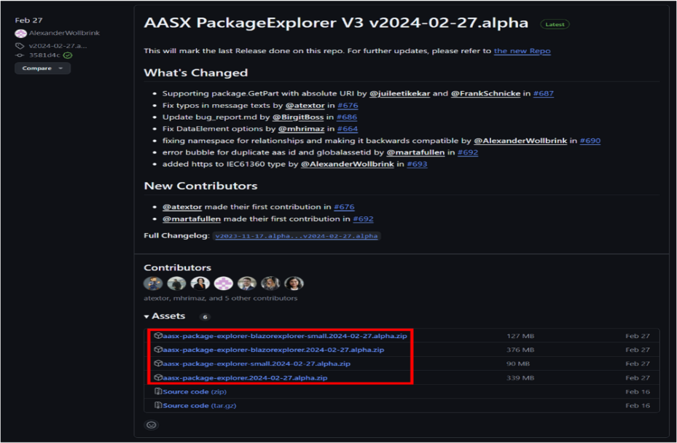
그림 17 AASX PackageExplorer 다운로드 경로
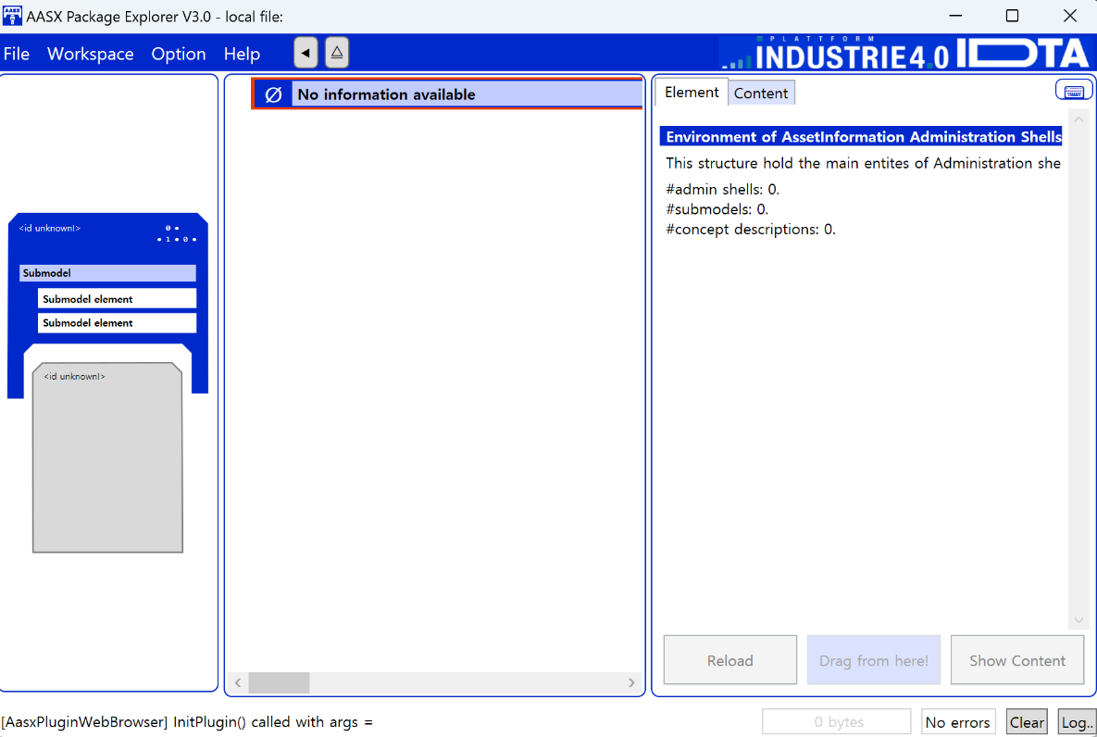
그림 18 AASX Package Explorer 파일 실행 초기화면

나. Edit 모드
○ AAS 생성, Submodel 생성 등의 기능을 수행하기 위해서 아래 첫 번째 그림과 같이 ‘Eidt’모드를 활성화시킨다. 이를 위해 아래 두 번째 그림과 같이, 상단의 작업창에서 [Workspace] - [Edit]모드를 클릭한다.

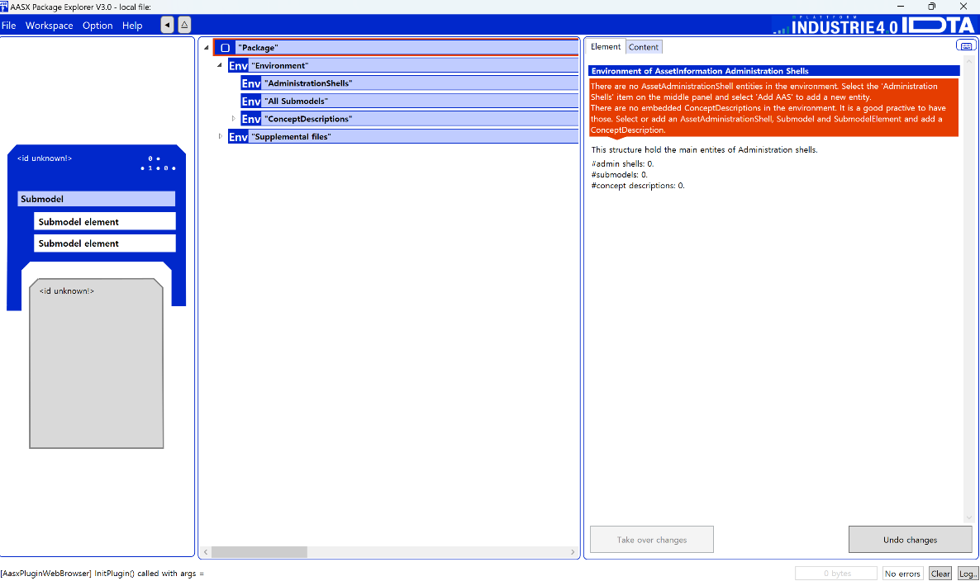
그림 19 활성화된 Edit 모드
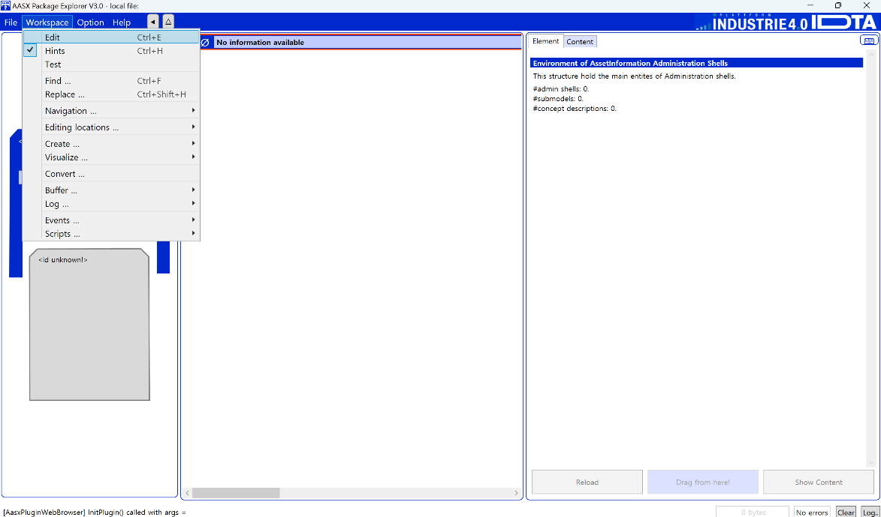
그림 20 Edit 모드 활성화 단계

다. AAS 생성
○ AAS를 생성하기 위해 앞서 Edit모드를 활성화시킨 상단의 Edit 모드 화면을 기준으로, [AdministrationShells] - [Add AAS]를 클릭하면 아래 첫 번째 AAS 생성 그림과 같은 화면이 나타난다. 아래 두 번째 AAS 정보 그림에서 오른쪽에 ‘Element’에서는 AAS 정보를 입력할 수 있다.

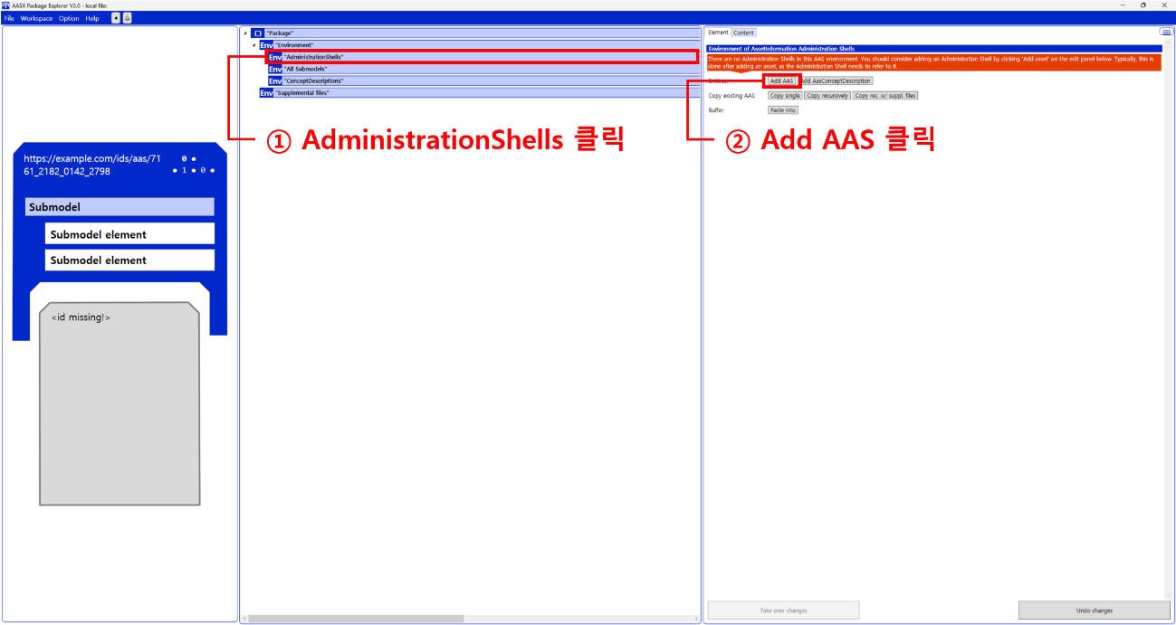
그림 21 AAS 생성

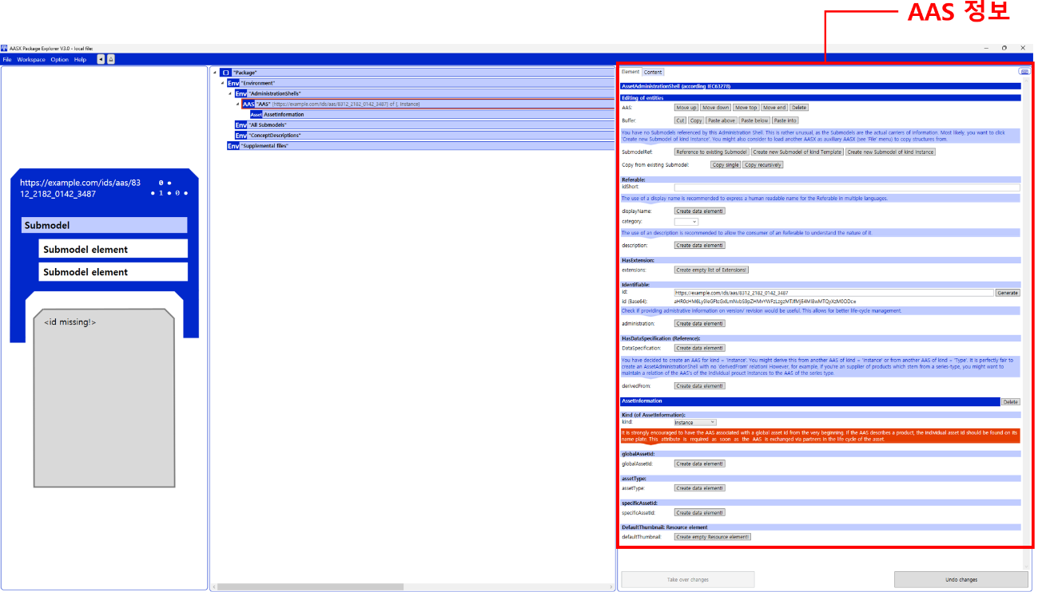
그림 22 AAS 정보

라. SubmodelTemplate을 이용한 Submodel 추가
○ 먼저, File-Open Auxiliary AAS 버튼을 통해 IDTA의 Nameplate Submodel을 추가하는 것을 예시로 설명한다. 아래 첫 번째 그림의 IDTA 홈페이지(https://industrialdigitaltwin.org/en)의 Content Hub에 게시된 SubmodelTemplate을 찾는다. 아래 두 번째 그림과 같이 찾은 SubmodelTemplate의 깃허브 주소로 이동하여, AASX 파일을 다운받아 File - Open Auxiliary AAS 버튼을 누르고, 다운받은 AASX 파일을 선택한다.

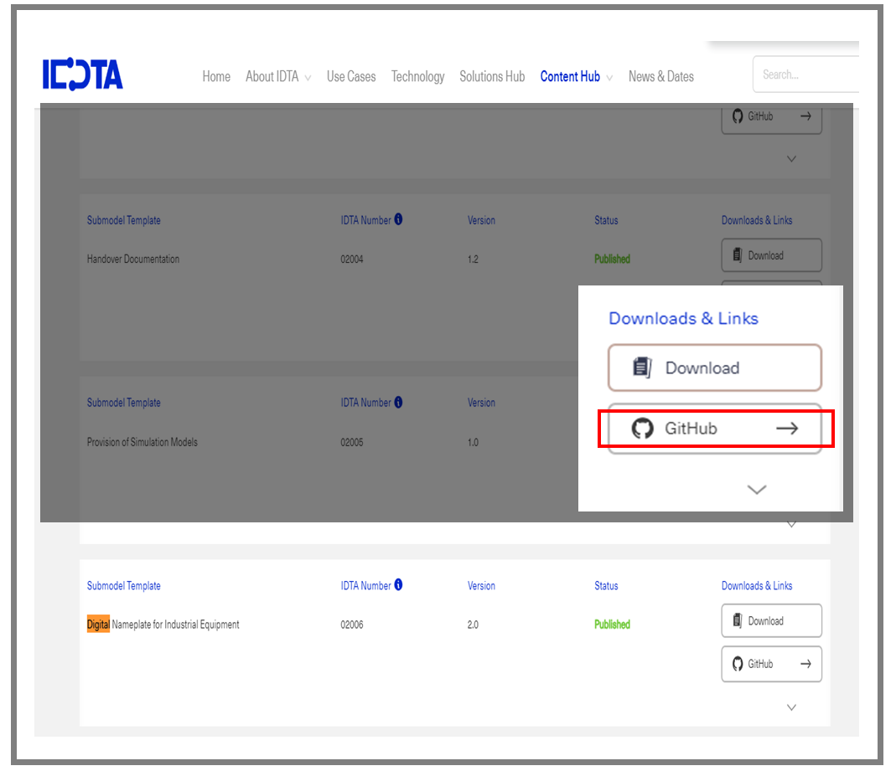
그림 23 IDTA SubmodelTemplate 다운로드

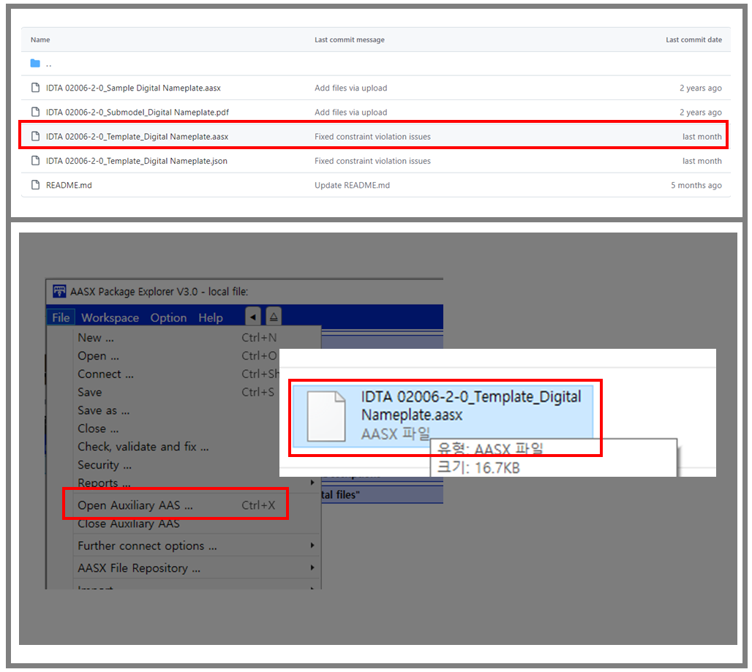
그림 24 IDTA SubmodelTemplate 파일 열기

○ 아래 그림의 상단 화면과 같이 AAS를 눌러 우측 Element-Copy from existing Submodel-Copy recursive를 누른다. 새로 표시된 창에서 추가한 AAS 모델 하위에 있는 Submodel을 선택한 후 Select 버튼을 눌러 불러온다. 아래 그림의 하단 화면의 좌측에서 불러온 Submodel을 누른 뒤 우측 Element 영역에서 Property를 추가하거나 값을 수정할 수 있다. 하위 Property를 선택하면 일부 값만 선택하여 변경할 수 있다. 변경 확인 버튼은 Take over changes 버튼을 클릭하여 반영을 완료한다.
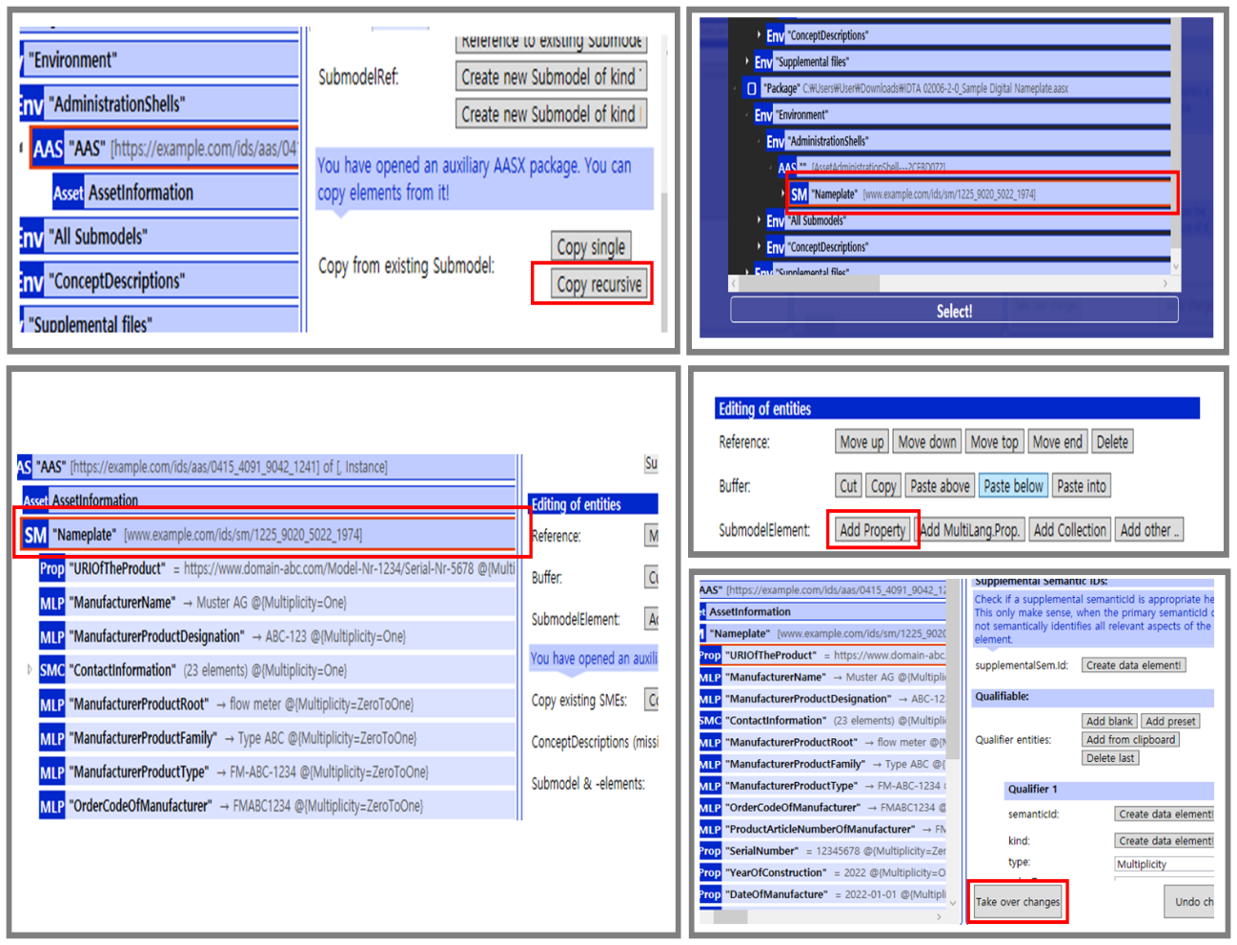
그림 25 Template 이용 Submodel 생성

○ 아래 그림은 같은 방법으로 추가한 3종(TechnicalData, HierarchicalStructures, DigitalNameplate)의 서브모델 리스트이다.

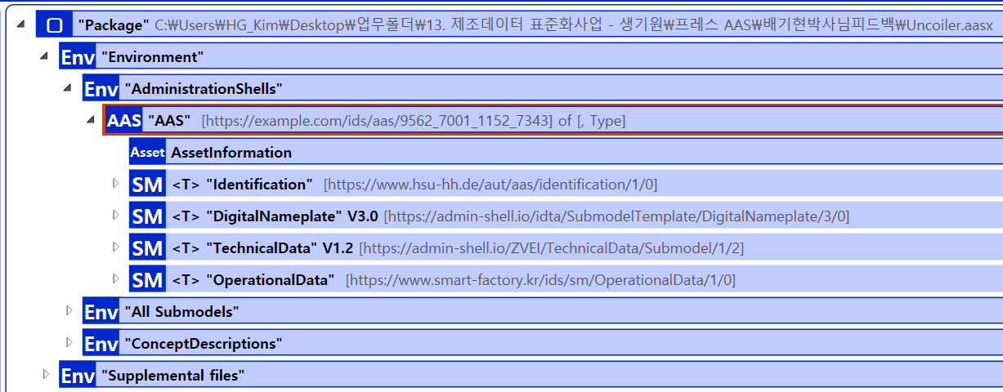
그림 26 동일한 방법으로 추가한 3종의 Submodel

마. Submodel 및 SubmodelCollection 생성
○ 참조모델에 정의되지 않은 내용은 개별적으로 작성하여야 한다. 개별 Submodel 및 SubmodelCollection을 생성하기 위해 아래 그림과 같이 이전에 생성된 AAS를 클릭한 후, 우측의 ‘Element’에서 [Create new Submodel of kind Template] 또는 [Create new Submodel of kind Instance]를 클릭한다.
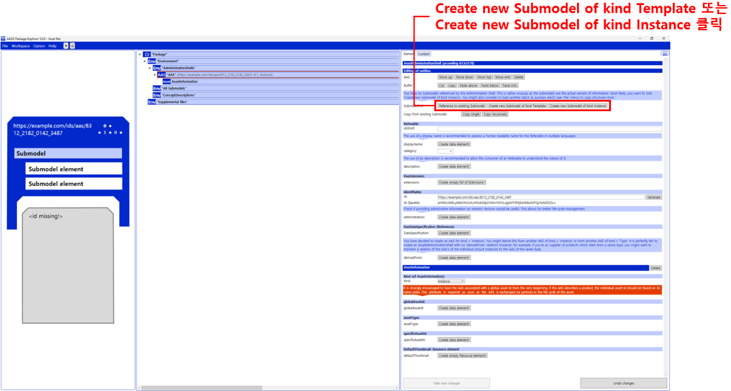
그림 27 Submodel 생성

○ 생성된 Submodel을 클릭한 뒤 아래 그림과 같이 우측의 ‘Element’에서 [Add collection]을 클릭하여 SubmodelCollection을 생성한다.

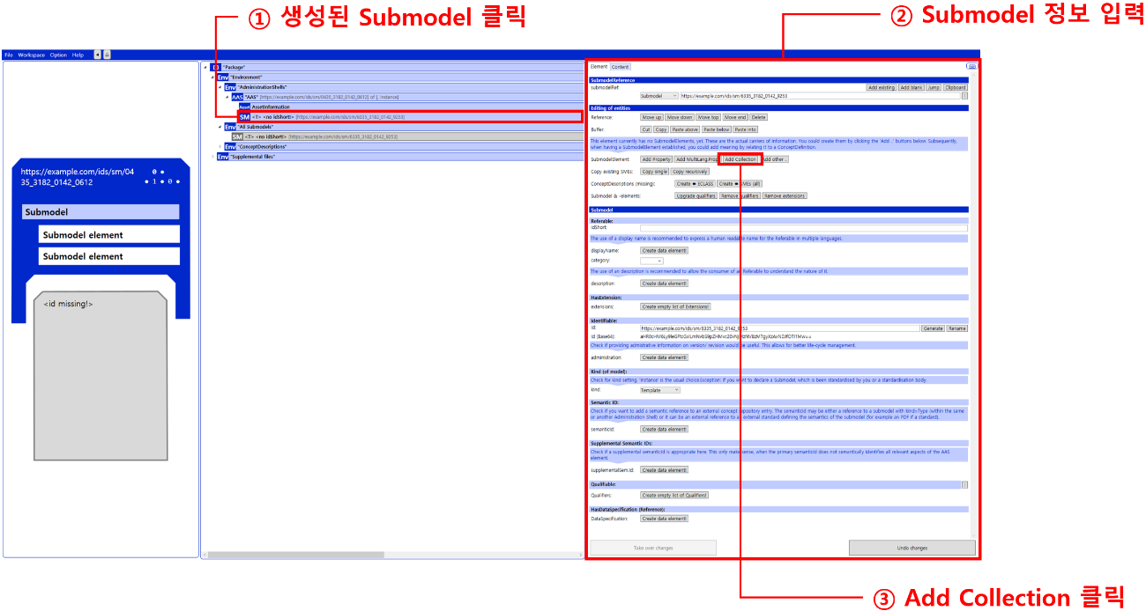
그림 28 SubmodelCollection 생성

○ 아래 그림의 오른쪽 ‘Element’에서는 SubmodelCollection 정보를 입력할 수 있다.

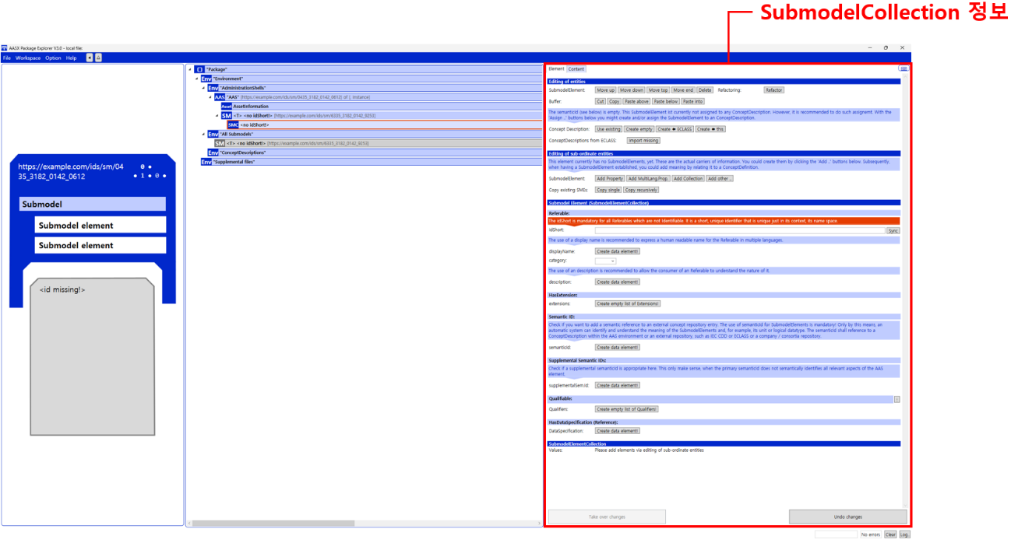
그림 29 SubmodelCollection 정보

바. Property 생성
○ 아래 그림과 같이 Submodel 또는 SubmodelCollection을 클릭한 뒤, 우측의 ‘Element’에서 [Add Property]를 클릭하여 신규 Property를 생성한다.

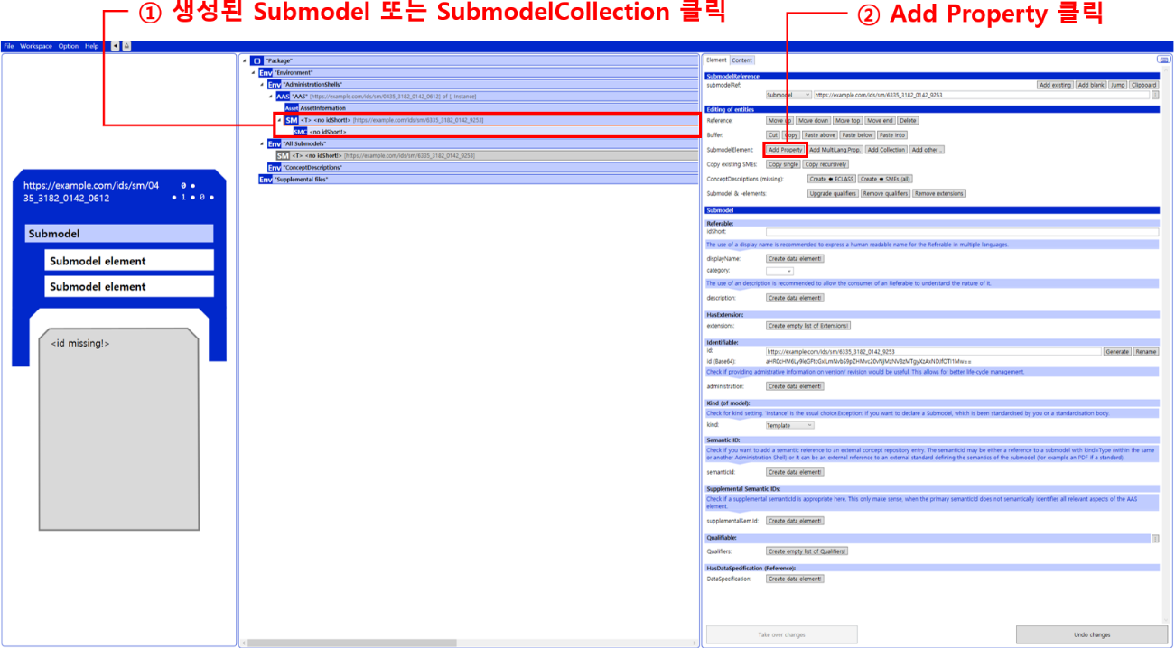
그림 30 Property 생성

3. AAS 모델(템플릿)을 실제 제품별 AAS 인스턴스로 전환
가. AssetInformation 수정
○ Edit 모드에서 아래 그림과 같이 AssetInformation을 선택 시 표시되는 오른쪽 Element 메뉴의 kind 값을 Instance로 선택한다.

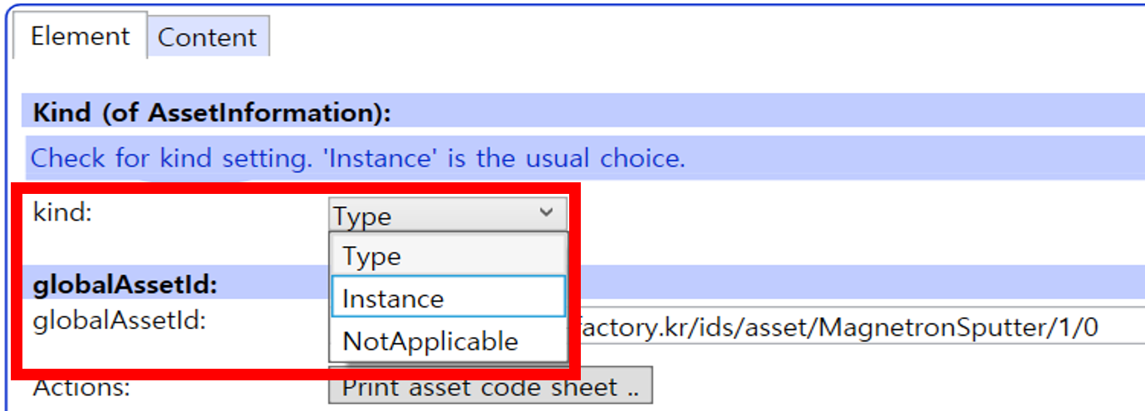
그림 31 AssetInformation의 kind 변경

○ 실제 제품의 고유한 global id(IRI 형태)를 부여하여, 이 값을 아래의 그림과 같이 AssetInformation의 globalAssetId 부분에 입력한다.
일반적으로 자산(Asset)이 인스턴스화 되면, 개별 인스턴스마다 고유한 식별정보가 부여된다. 이는 제품의 유형 및 제품 생산 기업의 내부 지침에 따라 다양한 형식으로 부여될 것이며, Asset Information 의 Global Asset Id에는 개별 제품을 구분하고 식별할 수 있는 이러한 고유 식별정보가 부여되어야 한다. 또한, 모든 Asset Administration Shell은 자산이 생산된 시점부터, 자산에 부여된 global asset id를 사용하여 대상 자산을 구분하므로, 이 식별자는 제품의 폐기시까지 변경 없이 유지되어야 한다.

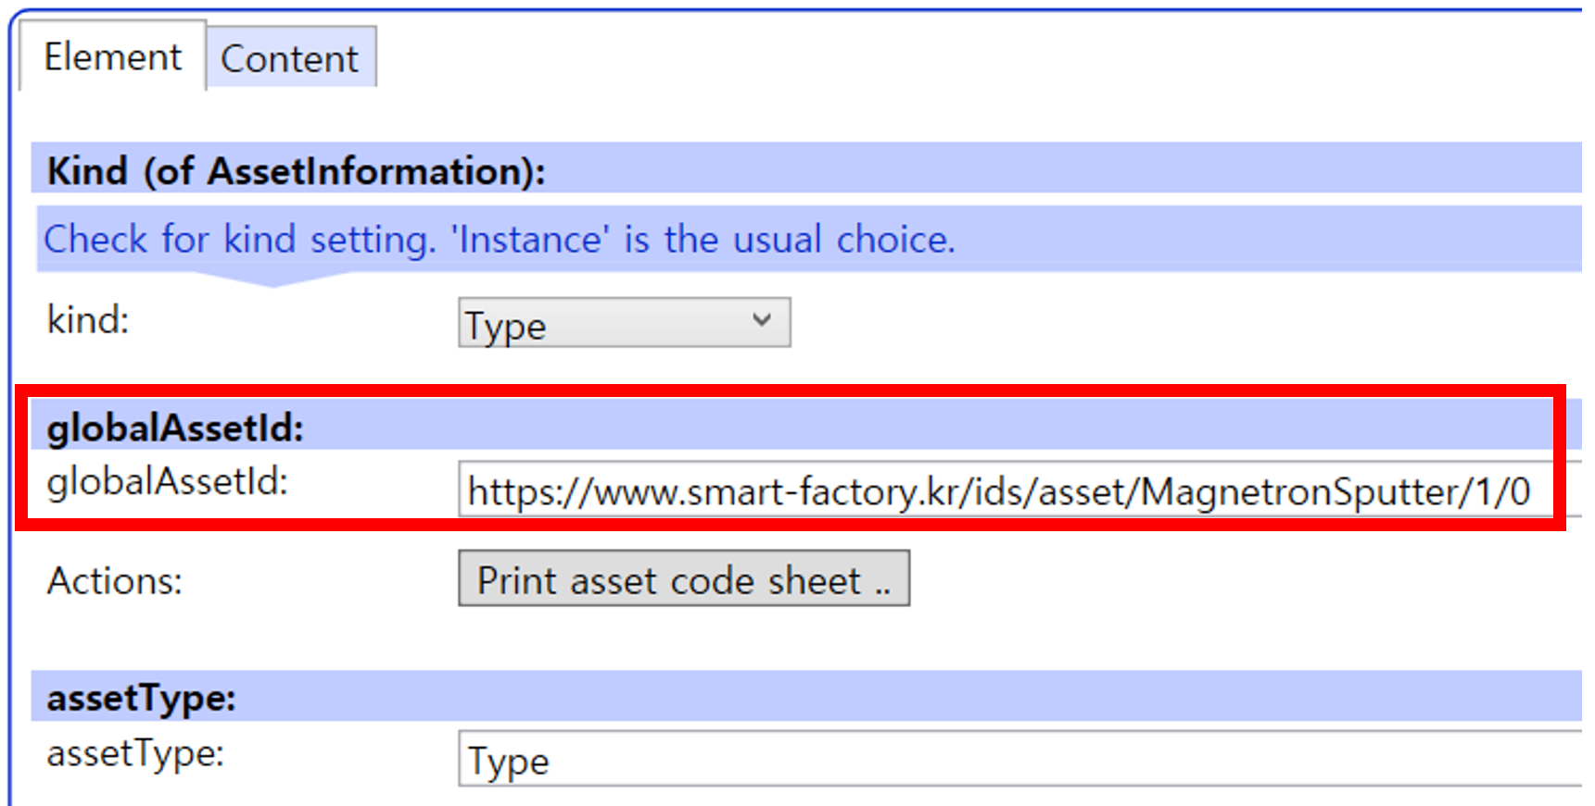
그림 32 AssetInformation의 globalAssetId 입력
○ 마지막으로, 아래 그림과 같이 AssetInformation의 assetType을 Instance로 입력한다.

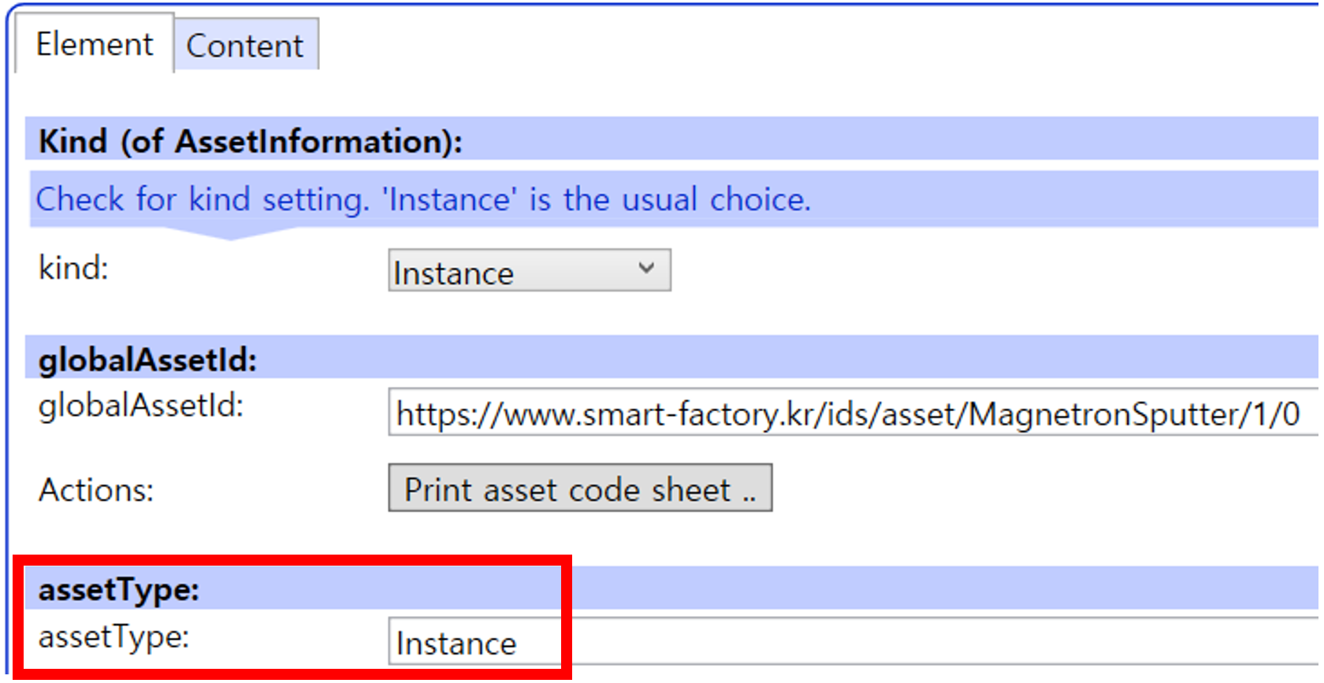
그림 33 AssetInformation의 assetType 입력

나. Submodel수정
○ Edit 모드에서 아래 그림의 서브모델의 Kind (of model) 메뉴의 Instance를 선택한다.

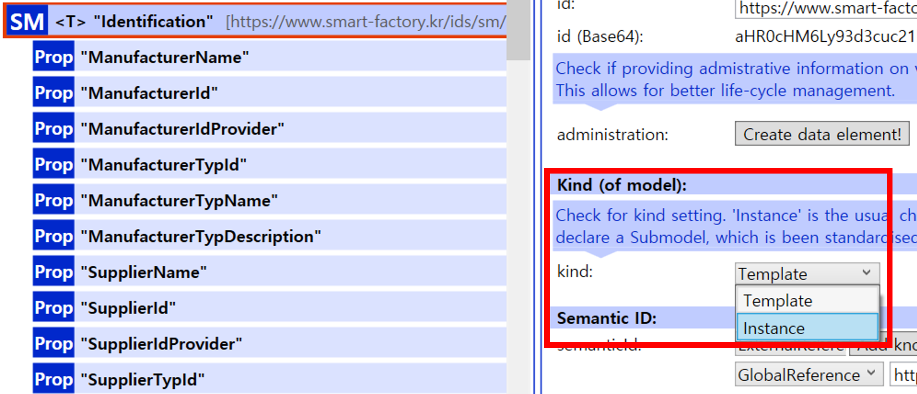
그림 34 Submodel 인스턴스

다. Property 수정
○ 서브모델에 있는 Property중에서, 개별 제품마다 변경되는 값들을 입력한다. 예를 들어 SerialNumber / DateOfManufacture / FirmwareVersion등과 같은 제품별 값들을 입력한다.

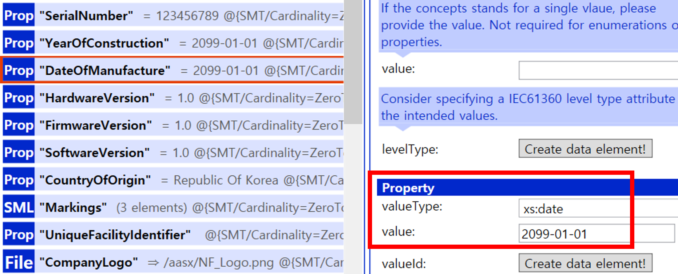
그림 35 Property 인스턴스

라. AAS 모델을 인스턴스 변환 결과
○ 아래 그림은 인스턴스 변환 결과를 비교한 화면이다. AssetInformation과 Indentificatoin 서브모델에서의 인스턴스 전과 후의 결과이다. 개별 제품별로 달라지는 이러한 프로퍼티들은, 모델에 적용된 서브모델의 종류나 프로퍼티의 구성에 따라 달라질 수 있으며, 이 가이드 문서에서는 가장 대표적인 프로퍼티를 대상으로 예시 value를 기술하였다.

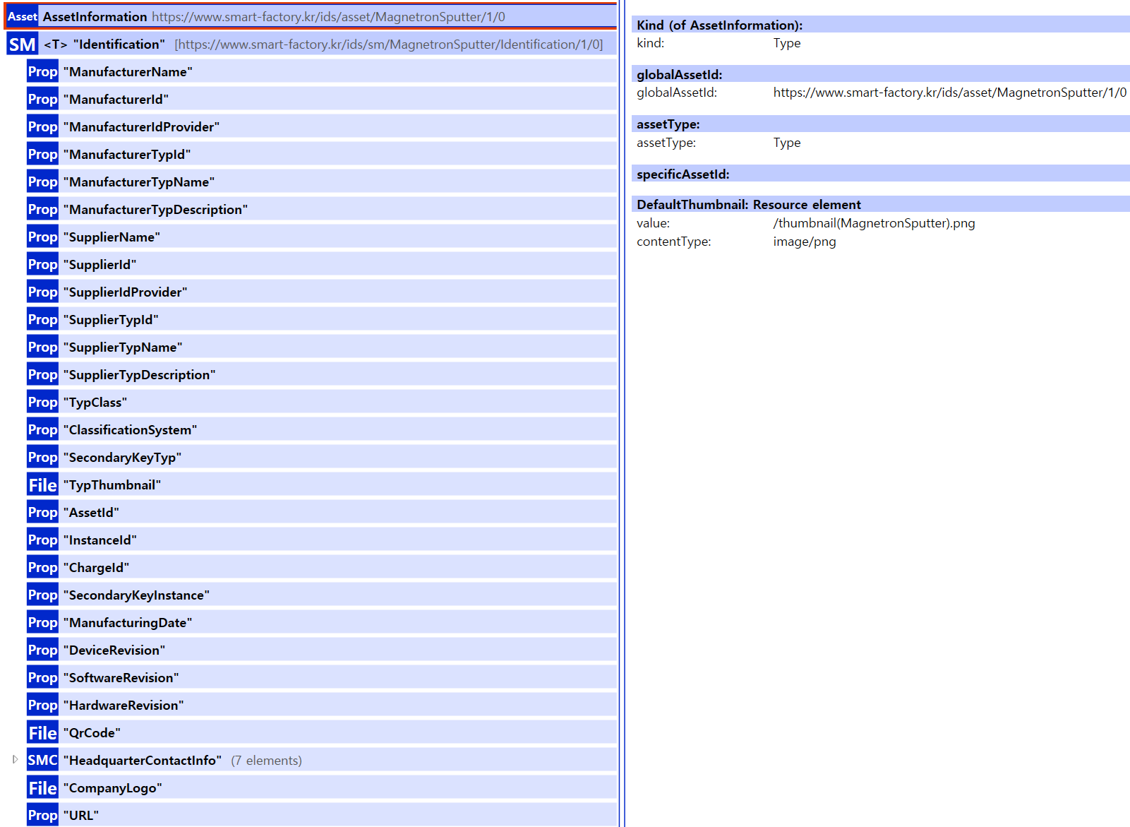
그림 36 AAS 인스턴스 변환 전 화면
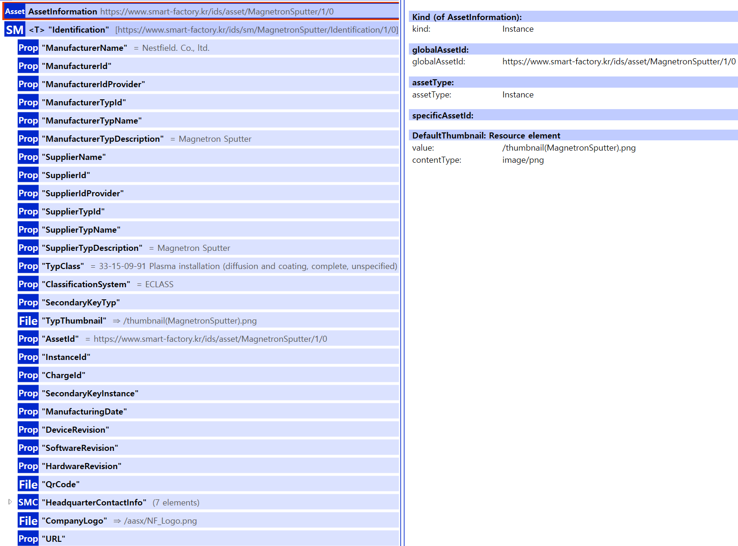
그림 37 AAS 인스턴스 변환 후 화면

4. 건식 표면처리 공정 AAS 참조모델 활용 시나리오
가. 개요
○ 건식 표면처리 공정은 플라즈마 전처리를 통한 표면 활성화, 마그네트론 스퍼터링을 통한 박막 증착, 그리고 열처리를 통한 물성 안정화 단계로 구성되는 핵심 표면개질 공정입니다. 각 장비는 AAS 표준(IEC 63278-1)에 따라 디지털 트윈으로 구현되어 상호운용성을 확보합니다.

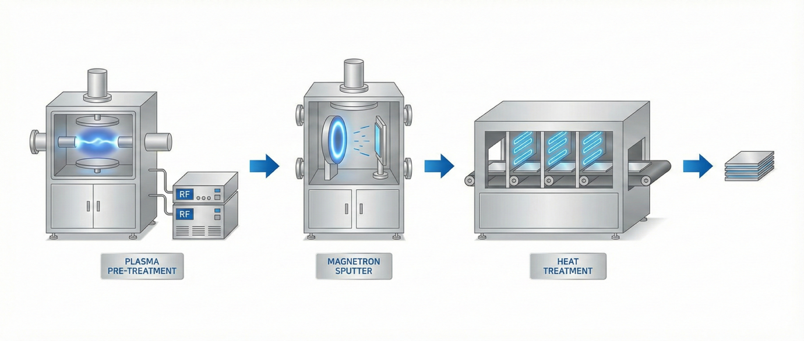
그림 38 건식 표면처리 공정 (플라즈마 전처리→마그네트론 스퍼터→열처리)

나. 주요 장비별 AAS 서브모델 구성
○ 플라즈마 전처리기: Identification, DigitalNameplate, TechnicalData, OperationalData, Predictive Maintenance, AIModelNameplate 등
○ 마그네트론 스퍼터: Identification, TechnicalData, OperationalData, ThinFilmProcessCapability(박막 공정 능력), CAD, HandoverDocumentation 등
○ 열처리기(열전도 건조기): Identification, TechnicalData, OperationalData, AIModelNameplate, PredictiveMaintenance 등

다. 시나리오 1: 실시간 공정 가시화 및 가동 상태 모니터링
○ 목적: 전체 라인의 장비 상태를 AAS 표준 속성을 통해 통합 관리하고 병목 구간을 탐지함.
○ 활용 서브모델 및 주요 속성:
- 플라즈마 전처리기 (OperationalData): DischargePower(방전 전력), GasFlowRate(가스 유량), LineSpeedSetting(라인 속도 설정값)
- 마그네트론 스퍼터 (OperationalData): VacuumPressure(진공도), SputteringPower(스퍼터링 출력), SubstrateTemperature(기판 온도)
- 열처리기 (OperationalData): ZoneTemperature(존별 온도), ConveyorSpeed(컨베이어 속도)
○ 세부 내용:
- 통합 관제 시스템은 각 장비 AAS의 OperationalData 서브모델을 1초 단위로 폴링(Polling)합니다. 스퍼터의 VacuumPressure가 설정된 임계치를 벗어나거나, 열처리기의 Zone Temperature 편차가 발생할 경우 즉시 대시보드에 경고를 표시하여 공정 불량을 사전에 차단합니다.
- 통합 관제 시스템(HMI)이 각 장비 AAS의 엔드포인트를 통해 실시간 데이터를 수집합니다. 특히, 플라즈마 전처리 속도(LineSpeedSetting)와 열처리기 컨베이어 속도(ConveyorSpeed) 간의 속도 동기화 오차(Velocity Mismatch)를 계산하여 라인 내 기판 적체 현상을 방지합니다.

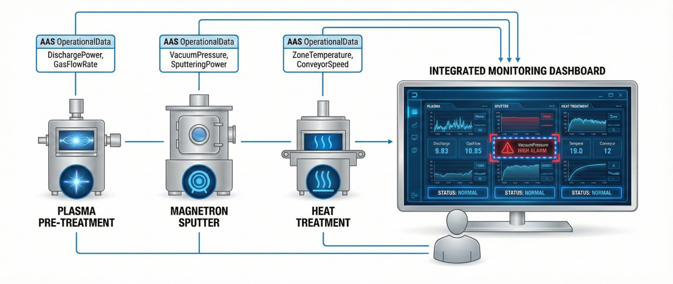
그림 39 실시간 공정 가시화 및 가동 상태 모니터링
라. 시나리오 2: 박막 품질 이력 추적 및 디지털 제품 여권(DPP) 생성
○ 목적: 생산된 제품의 품질 데이터를 장비 사양과 연계하여 고객사에게 투명한 품질 증명서를 제공함
○ 활용 서브모델 및 주요 속성:
- 마그네트론 스퍼터 (ThinFilmProcessCapability): ThicknessUniformity(두께 균일도), Deposition RateRepeatability(증착률 재현성), AdhesionStrengthGrade(밀착력 등급)
- 장비 공통 (Identification, DigitalNameplate): ManufacturerName, SerialNumber, Product InstanceUri
○ 세부 내용:
- 제품 생산 완료 시, AAS의 Identification 정보와 ThinFilmProcessCapability 내의 Adhesion StrengthGrade 데이터를 결합합니다. 이를 통해 "어떤 장비에서(SerialNumber), 어떤 품질 결과(Thickness Uniformity: 98%)로 생산되었는지"에 대한 디지털 이력서를 자동 생성하여 상위 ERP 또는 고객사의 DPP 시스템으로 전송합니다.
- 생산이 완료된 기판(Substrate)에 고유 ID(ProductInstanceUri)를 부여하고, 해당 배치(Batch) 생산 당시 스퍼터 AAS에 기록된 AdhesionStrengthGrade(밀착력 등급, ASTM D3359 준거) 데이터를 매핑합니다. 이 데이터는 클라우드로 전송되어 고객사가 QR 코드로 박막의 균일도와 거칠기를 즉시 확인할 수 있는 품질 인증서로 기능합니다.

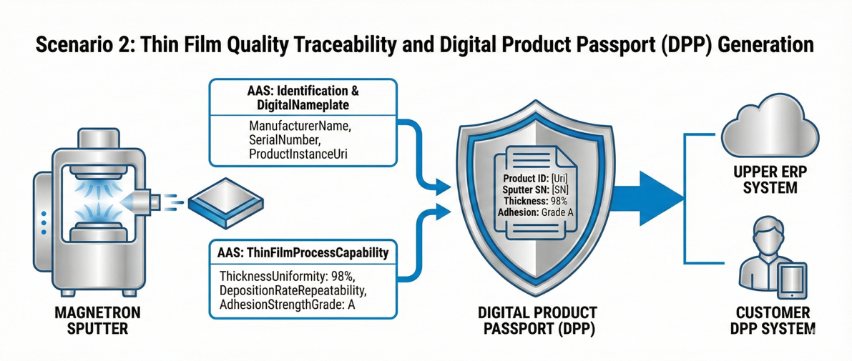
그림 40 박막 품질 이력 추적 및 디지털 제품 여권(DPP) 생성
마. 시나리오 3: AI 기반 장비 예지보전 및 잔여 수명 예측
○ 목적: 고장 징후를 사전에 포착하여 비계획 정지 시간을 최소화함
○ 활용 서브모델 및 주요 속성:
- 플라즈마/열처리기 (PredictiveMaintenance): RemainingUsefulLife(잔여 유효 수명), HealthScore (상태 점수), MaintenanceAlarm(유지보수 알람)
- 열처리기 (AIModelNameplate): ModelAccuracy(모델 정확도), TrainingDatasetReference(학습 데이터 참조)
○ 세부 내용:
- 열처리기의 AAS는 내장된 AI 모델을 통해 OperationalData의 진동 및 전류 데이터를 분석합니다. 분석 결과 HealthScore가 60점 이하로 떨어지면, PredictiveMaintenance 서브모델의 MaintenanceAlarm 속성을 'True'로 변경하고, RemainingUsefulLife가 '120시간' 남았음을 관리자에게 통보하여 선제적인 부품 교체를 유도합니다.
- 열처리기의 존(Zone) 온도 편차가 OperationalData에서 감지되면, AAS 내부에 정의된 AI 모델(ModelType)이 가동됩니다. 분석 결과 HealthScore가 40점 이하로 떨어질 경우, MaintenanceAlarm 속성을 'True'로 활성화하고 담당자에게 "진공 펌프 오일 교체 주기 48시간 전"과 같은 구체적인 정비 가이드를 전달합니다.

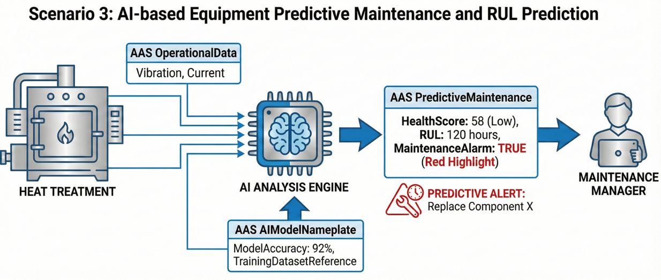
그림 41 AI 기반 장비 예지보전 및 잔여 수명 예측

바. 시나리오 4: 공정 조건 최적화 및 레시피 피드백 제어
○ 목적: 전공정(플라즈마)의 결과에 따라 후공정(스퍼터)의 파라미터를 실시간 조정하여 최적의 품질을 유지함
○ 활용 서브모델 및 주요 속성:
- 플라즈마 전처리기 (OperationalData): TreatmentTimeSetting(처리 시간 설정), PlasmaIntensity (플라즈마 강도)
- 마그네트론 스퍼터 (OperationalData): ArgonFlowRate(아르곤 유량), OxygenFlowRate(산소 유량)
○ 세부 내용:
- 플라즈마 전처리 단계에서 기판의 표면 활성화가 미흡하다고 판단될 경우( PlasmaIntensity 저하), AAS 간 통신을 통해 스퍼터의 SputteringPower를 보상 차원에서 상향 조정하거나 ArgonFlowRate를 최적화하는 피드백 루프를 구성하여 최종 박막의 밀착력을 일정하게 유지합니다.
- 플라즈마 전처리 강도(PlasmaIntensity)가 기준치보다 낮게 측정될 경우, AAS 간 통신을 통해 후공정인 스퍼터의 증착 환경을 자동 조정합니다. 예를 들어, ArgonFlowRate를 5% 상향 조정하여 기판 표면 충돌 에너지를 높임으로써, 전공정의 활성화 부족을 후공정 레시피 보정으로 상쇄하여 불량을 방지합니다.

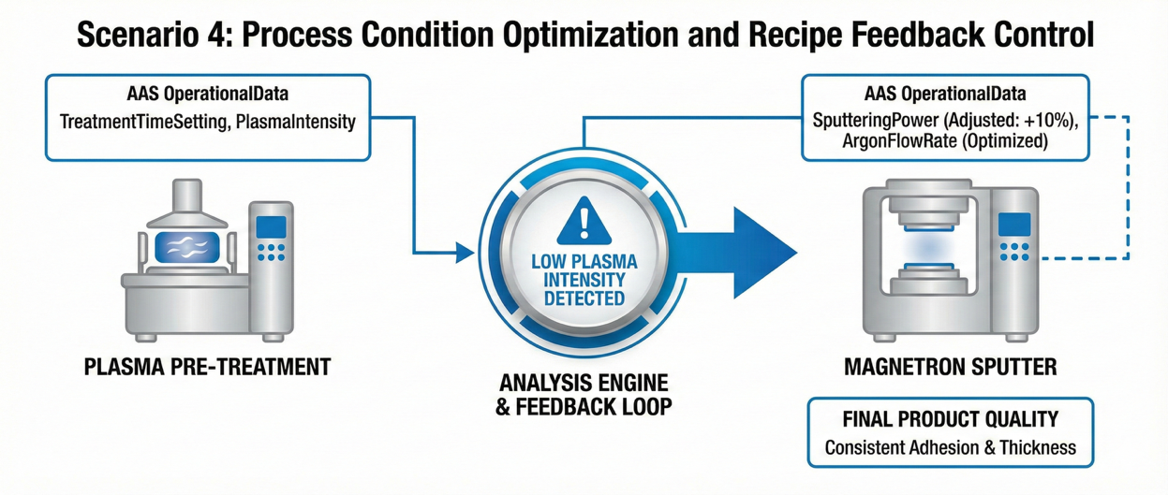
그림 42 공정 조건 최적화 및 레시피 피드백 제어

사. 시나리오 5: 유지보수 효율화를 위한 디지털 문서 및 도면 활용
○ 목적: 현장 작업자가 장비 고장 시 AAS를 통해 즉각적으로 기술 정보에 접근함
○ 활용 서브모델 및 주요 속성:
- 마그네트론 스퍼터 (HandoverDocumentation): DocumentID, VDI2770_DocumentClass(문서 분류)
- 장비 공통 (CAD): MCAD_File_Reference(3D 도면 참조), ComponentList(부품 리스트)
○ 세부 내용:
- 장비에 부착된 QR 코드를 스캔하면 해당 장비 AAS의 HandoverDocumentation으로 연결됩니다. 작업자는 VDI2770 표준에 따라 분류된 매뉴얼을 확인하고, MCAD_File_Reference를 통해 고장 난 부품의 3D 형상과 정확한 부품 번호를 확인하여 오발주를 방지합니다.
- 장비 고장 시 작업자는 AR 글래스를 통해 AAS의 MCAD_File_Reference에 접근, 실물 장비 위에 3D 도면을 투영합니다. ComponentList에서 고장 부품의 파트 번호를 확인하고, VDI2770 표준에 따라 정렬된 유지보수 매뉴얼 중 "Section 4: Cathode Replacement" 항목을 즉시 호출하여 정비 시간을 단축합니다.

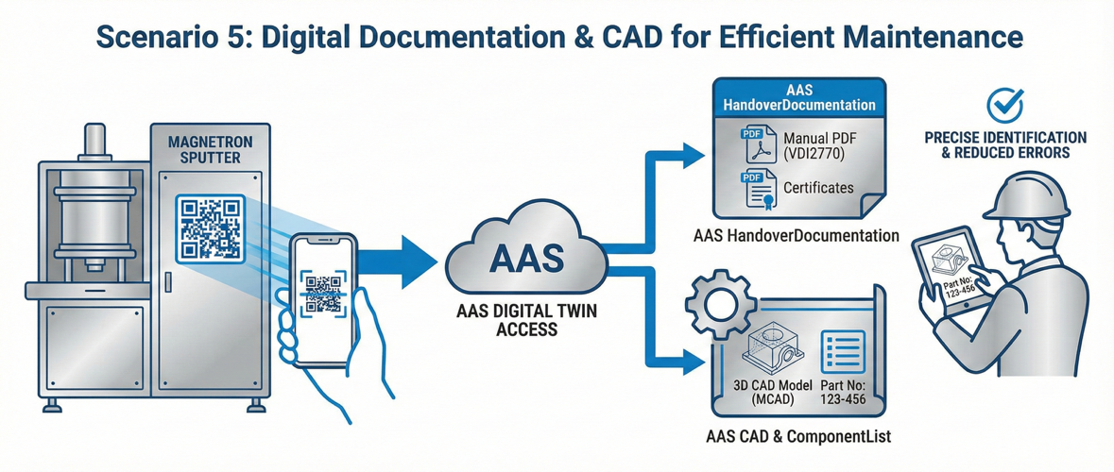
그림 43 유지보수 효율화를 위한 디지털 문서 및 도면 활용

아. 시나리오 6: 에너지 효율 분석 및 탄소 발자국 관리
○ 목적: ESG 경영 대응을 위해 공정별 에너지 소비량을 집계하고 탄소 배출량을 산출함
○ 활용 서브모델 및 주요 속성:
- 장비 공통 (OperationalData/EnergyMonitoring): CumulativeEnergyConsumption(누적 에너지 소비량), CurrentPowerConsumption(현재 소비 전력)
- 마그네트론 스퍼터 (TechnicalData): RatedPower(정격 출력)
○ 세부 내용:
- 각 장비 AAS의 CumulativeEnergyConsumption 데이터를 매 배치(Batch) 종료 시마다 기록합니다. 플라즈마-스퍼터-열처리의 전력 사용량을 합산하여 제품 단위당 에너지 원단위를 계산하고, 이를 기반으로 생산 제품의 탄소 발자국을 정밀하게 산출하여 공급망 탄소 규제에 대응합니다.
- 공정 시작(StartTime)부터 종료(EndTime)까지 각 장비 AAS의 CumulativeEnergyConsumption 차이값을 계산합니다. 이를 생산된 기판의 면적(m²)으로 나누어 제품 단위당 에너지 원단위를 산출합니다. 수집된 데이터는 ESG 공시 가이드라인에 맞춰 탄소 배출량으로 자동 환산되어 기업의 환경 지표로 관리됩니다.

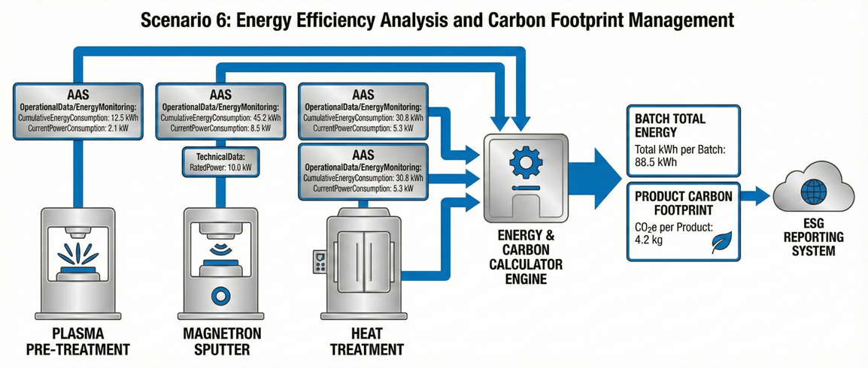
그림 44 에너지 효율 분석 및 탄소 발자국 관리

